**Apache Kafka**

This tutorial to understand

* **What is Kafka**
* **Where does Kafka come from**
* **Why do we need Kafka**
* **How does it work with high level overview.**

Ok, so without any further delay, let’s get started. So, let’s start with what is Kafka.

**What is Kafka**

Apache Kafka is an open-source distributed event streaming platform. When I say event streaming, it points to two different tasks. Create real-time stream, process the real-time stream. Let me explain these two words with an example. Ok, so I hope everyone uses Paytm in this digital world. If anyone does not know Paytm, **Paytm is an API payment method**. Let's assume I am using that Paytm application to do some payment or I am booking the flight ticket or I am just booking some movie ticket. Ok, because Paytm provides us feature to do any type of transaction. Now when I will do any transaction, that event will go to the Kafka server. But I am not the only one Paytm user who is doing the transaction at this time. Since people use this across globe, this Kafka server receives millions or billions of events in each minute or each second or even in each millisecond. So, sending the stream of continuous data from Paytm to the Kafka server is called creating real-time event stream or generating real-time stream of data. Now once Kafka server receives the data, he needs to process it. So, the Paytm team or Paytm developer created one client application which will read the data from the Kafka server and do some process.

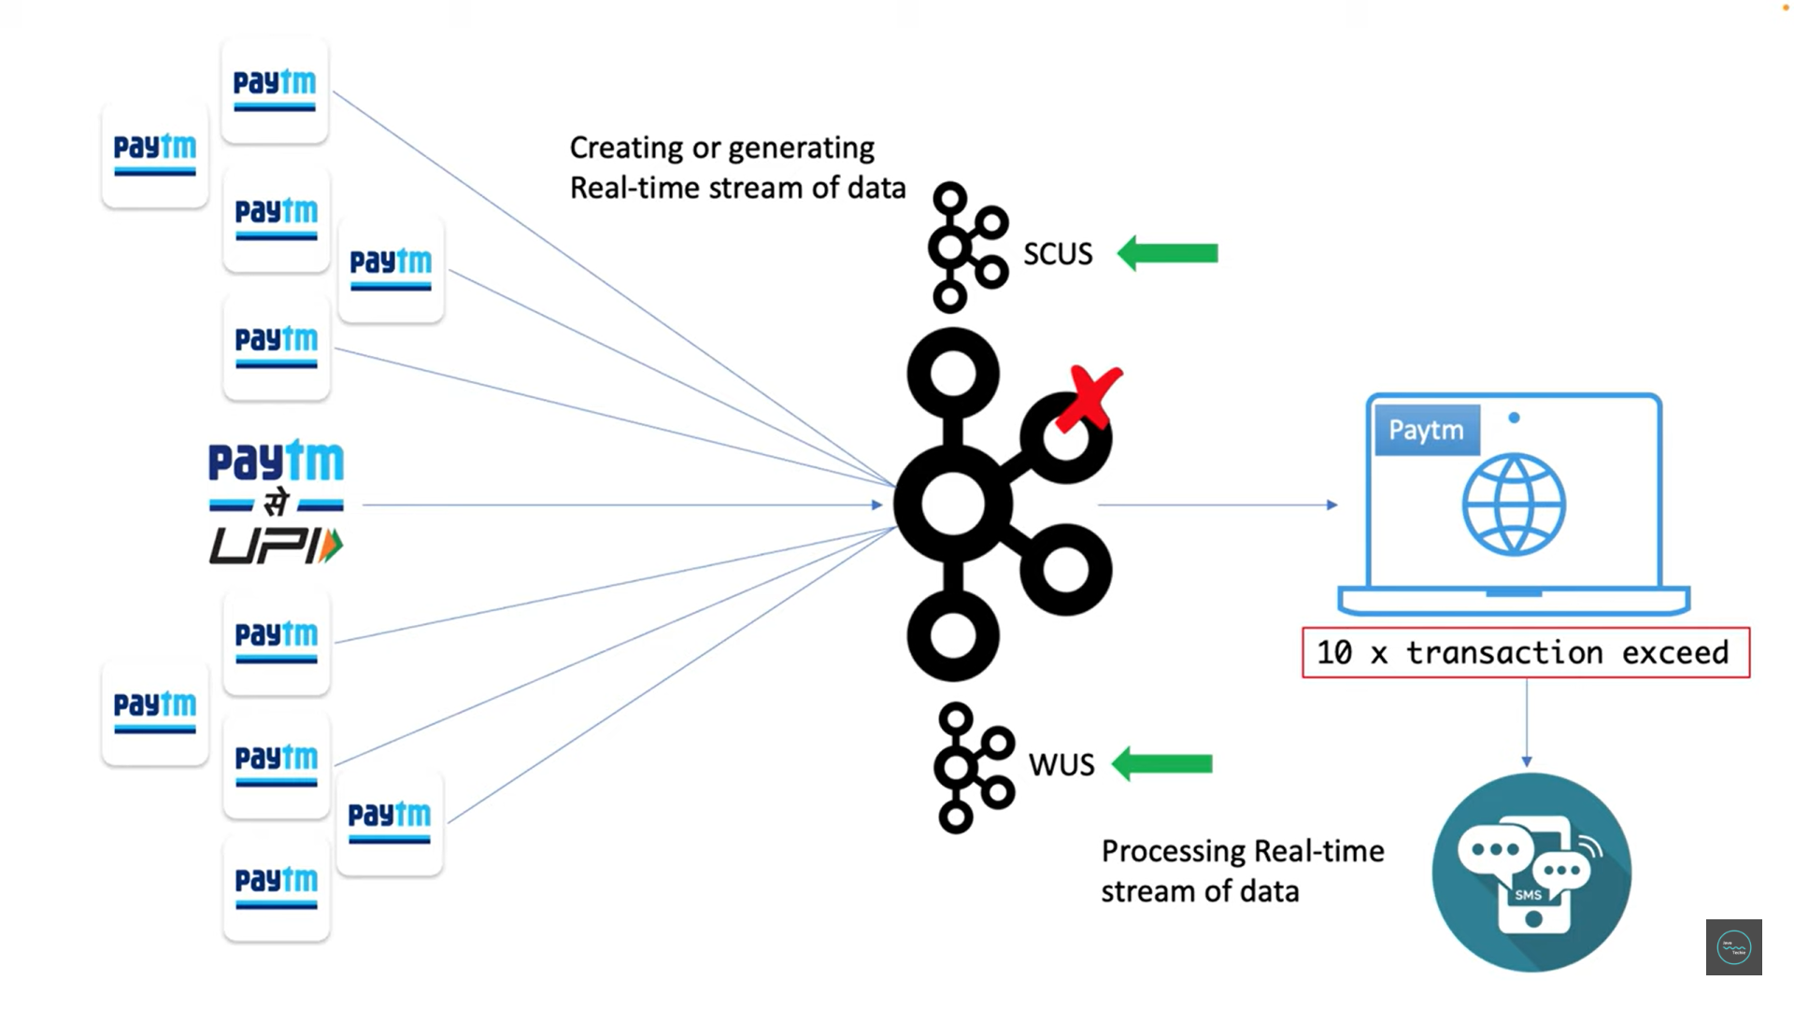

For example, let's say Paytm wants to restrict max 10 transactions per day. I mean a user can only do 10 transactions per day using Paytm method. If it exceeds the limit, then client application wants to send a notification to the user. In such scenario, my client application needs to continuously face the data and need to do the validation to check the transaction count for a specific user in each and every second or millisecond. So, this continuously listens to the Kafka messages and processes them is called processing real-time event stream. So, if you combine these two terms, this will give you the answer what is event streaming.

In simple words, continuously sending the message or event to the Kafka server and reading and process them is called real-time event streaming. Now let's move to the next word called distributed. In microservices world, distributed means distribute multiple computers to different node or region to balance the load and to avoid the downtime. Similarly, as we know Kafka is a distributed event streaming platform, we can also distribute our Kafka server. If you can observe here, we have three Kafka server running in different region to perform event streaming operation. In case if any server goes down, another server will come up to pick up the traffic to avoid application downtime. Okay, hope you understand what Kafka is or why it is called a distributed event streaming platform.

**Where does Kafka come from?**

Kafka was originally developed at LinkedIn and was subsequently open sourced in early 2011. Now this Kafka software comes under Apache software foundation.

**Why do we need Kafka?**

Let me walk you through an example to demonstrate this particular point. Let's say I have some parcel on my name. So, postman come to my door to deliver the parcel. Unfortunately, I was not there in my home and went for vacation. So, he returned back again next time he came but I'm not there in home. He tried two three attempts to deliver the parcel and every time I am not there in my home. After some day he might forget about the parcel, or he returned the parcel to the main office. In this case, I lost the data, or I was I will not able to receive the information what postman bring to my door. That parcel could contain some important information or money related stuff, but I missed it because I was not available during the period when the postman came to my door. This could be a huge loss for me. Isn't it? How can I overcome this?

**No worries. I am very smart. I have installed a letter box near to my door.**

So, when next time parcel come and postman brings for me and if he found I am not there in home or I am not available in my home then simply he can put that parcel to my letter box. So, whenever I will be back to my home it can be a day after or a week after I can go to my letter box, and I can collect the parcel or the messages what postman dropped in my letter box. In that case, I will not lost the data. Data will be there in my letter box until I pick it up. Here the letter box acts as a middleman between the postman and me.

Let's try to relate this understanding with one real time example. Let's say I have two applications. Application 1 and application 2. Now application 1 wants to send the data to application 2 but if application 2 is not available to receive the data, then again, he will lost the data like me which might impact to the business of application 2. So, to overcome this communication failure we might need to install something similar to the letter box between these two applications. That is where Kafka comes into the picture. You can add a messaging system between application 1 and application 2 and that messaging system can be a Kafka, or it can be a RabbitMQ, or it can be a Redis.

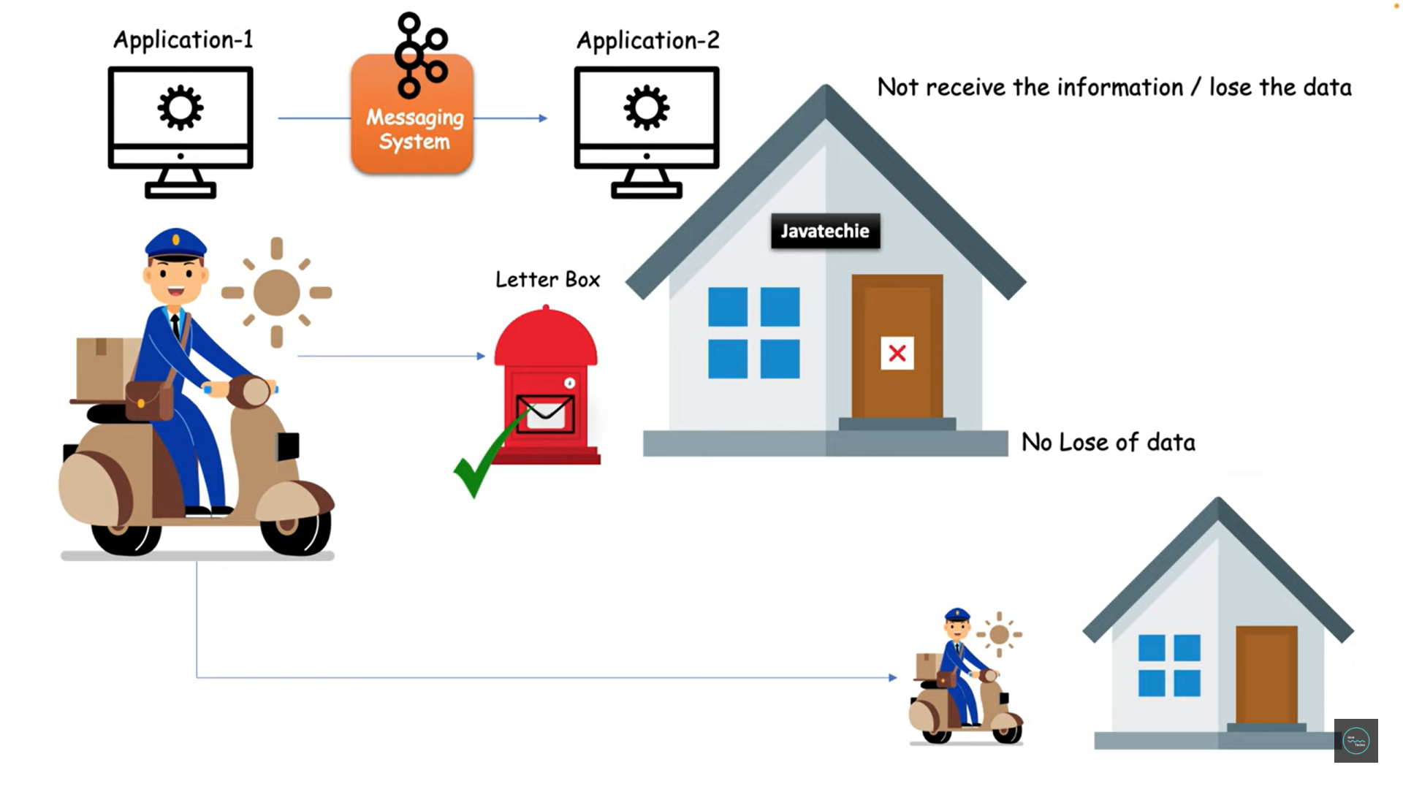

But we are going to focus on the Kafka messaging system. So, in case application 2 is not available he can collect the message from Kafka whenever he will come online. This Kafka again will act as a letter box between application 1 and application 2.That is how he won't lost the data. Right? Hope now you understand why we need Kafka or messaging system.

**Now let's understand the need of Kafka with more complex scenario.**

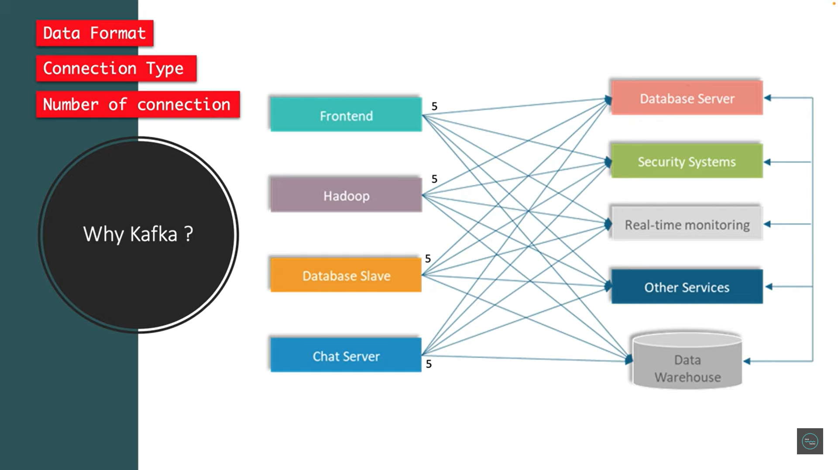

Let's say you have four applications who wants to produce different types of data to the database server. This looks simple. What is the problem here? Nothing as of now. But in future your application can grow. You might have n number of services to communicate with each other. In that situation it's really tough to manage these many connections between the services. There could be a lot of challenges. What could be the possible challenges? **Data format, connection type or number of connections.** When I say data format, this frontend app may be want to produce some different type of data to each different type of application. Maybe frontend want to send some payload structure to database server and some different payload structure to security system. Similarly, Hadoop also might to do or might to send some different type of data. There could be a complexity to handle the data format or schema. And next connection type. So, there could be different type of connection. I mean, when I say different type of connection, it could be HTTP connection, or it could be a TCP connection, or it could be a JDBC connection. Like the connection type will be complex to maintain with multiple services. And second is number of connections. When I say number of connections, if you observe carefully, frontend connect to the five different destination services. Hadoop connected to different five. Database slab connected to five. And chat server also connected to five different services. So, if you count the number of connections here, the total count will be 20. So, to just maintain, left side is four application and right side is five applications. So just to maintain nine application or to just communicate between the nine applications, we need to manage the 20 connections. In enterprise application, really, it's kind of a bottleneck situation to handle above challenges.

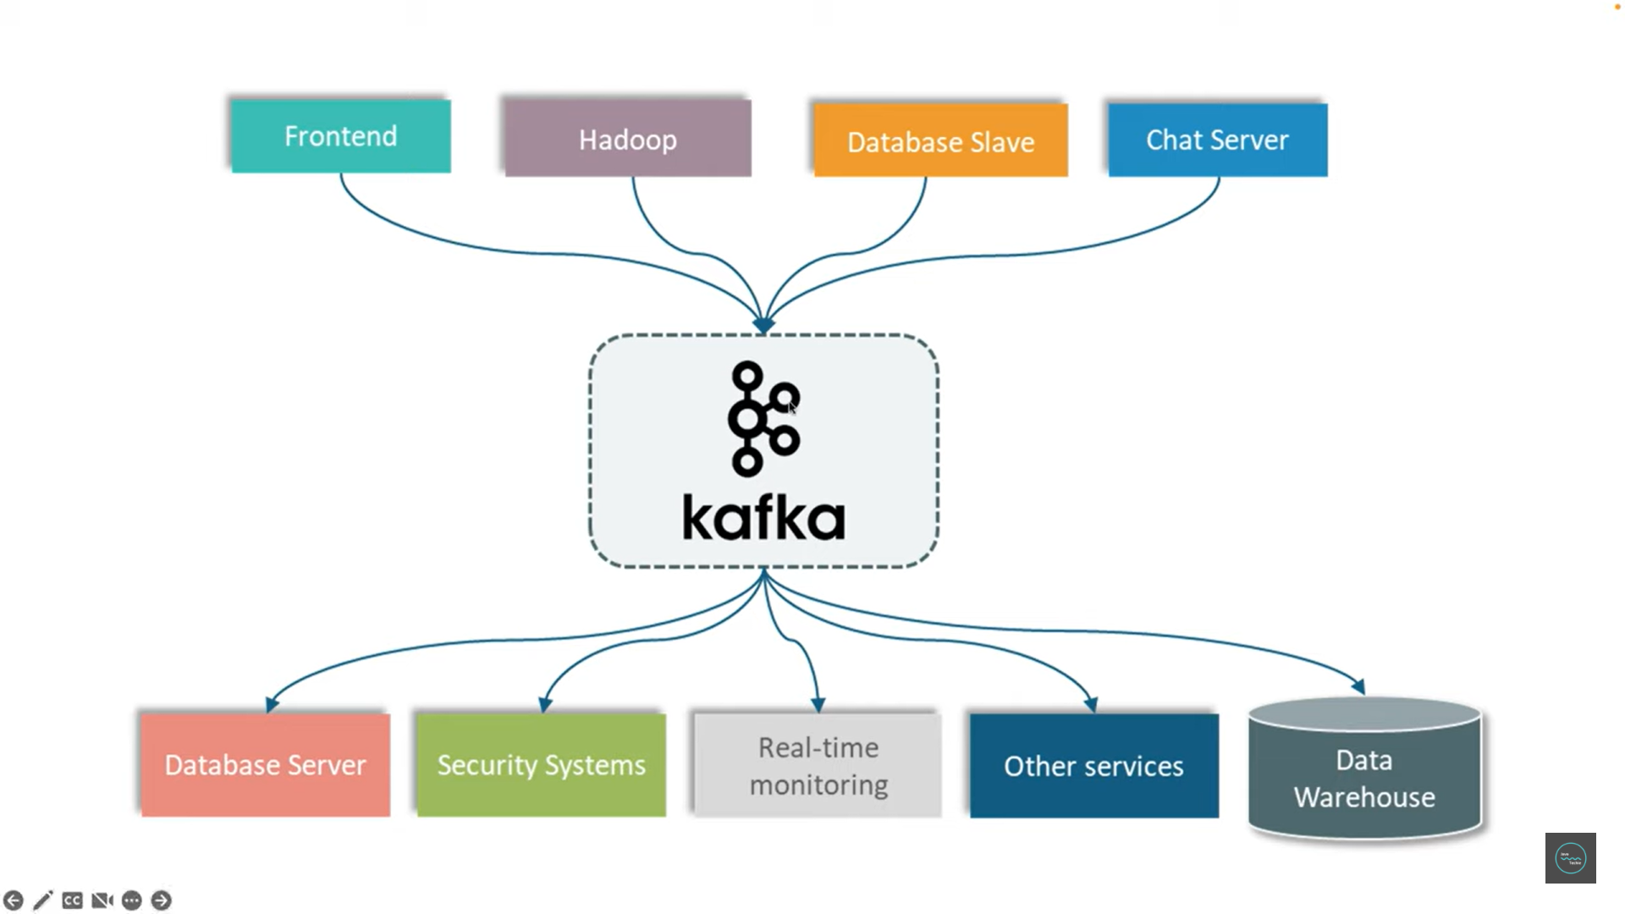

Then how to overcome it? That is where this messaging system like Kafka came into picture. So, if you observe this particular diagram carefully, now frontend, Hadoop, database slab, chat server, whatever the data type they want to send or whatever the schema structure they want to send or which type of connection they want to make, they'll simply send the payload or information to this particular Kafka server or my messaging system. Now which kind of data this data server need? You'll go to the Kafka server, and you'll directly get it from this Kafka server. Similarly, let's say security systems want to face some data given by either Hadoop or database slab. He can simply go there and check the data. What he was looking for is there or not. If it is there, he can simply get those data and he can play with those data. In this approach, we are maintaining a centralized or similar to the letterbox. All the frontend Hadoop, database slab, chat server, they will drop the messages and other five downstream services will go to those Kafka servers, and they will pick the messages as per their need. And in this approach, we're also reducing the connection count. When you observe here, the total number of connections here, 1, 2, 3, 4, 1, 2, 3, 4, 5, total nine connection. In previous approach, we found 20 connections, but when we centralized using the Kafka, we are reducing the connection count as well. So, this is the advantages of using the messaging system like Kafka. I hope you understand why do we need Kafka server or Kafka as a messaging system.

**how does it work?**

When I say PubSub, Pub stands for publisher, Sub stands for subscriber model. So usually there should be three components, publisher, subscriber, messaging system, or you can say message broker.

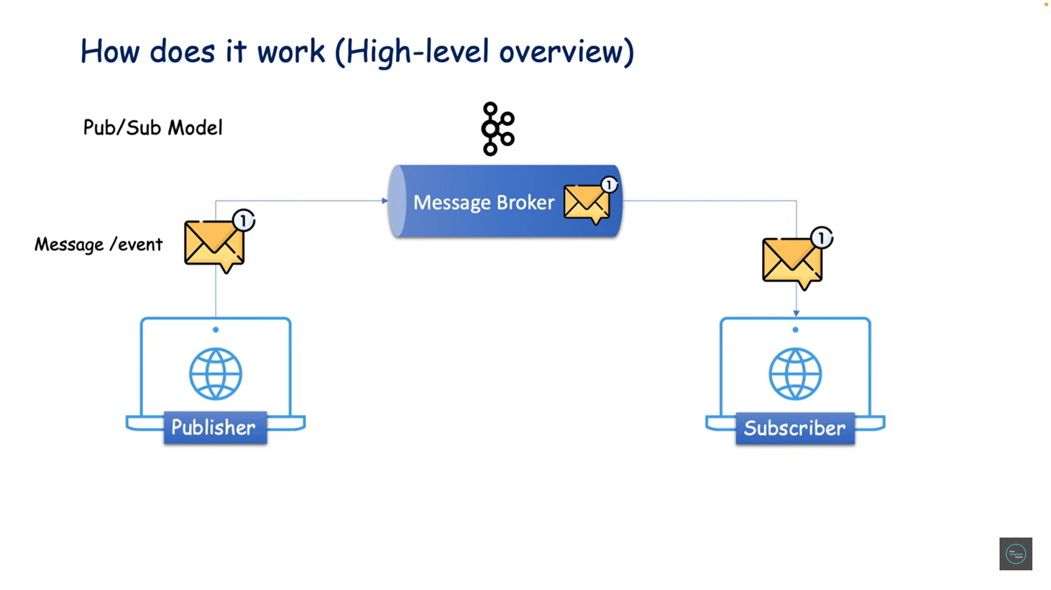

Publisher is the person who will publish the event or messages to the messaging system like Kafka. And the message will go and sit in the message broker. Now the subscriber will go to that particular message broker and will ask for the messages or subscriber will simply listen to that message broker to get the messages. Okay, so this is just 50,000 high level overviews of the PubSub model. Don't worry, we'll understand in detail how the message is getting processed inside the broker and what all components helps to process the message in my coming session. Okay, so this is just a heads-up tutorial to just get basic information about Kafka and its need in real time. Next tutorial, we'll understand Kafka architecture and its each and every component.

* **Kafka Architecture & Components**

We are going to discuss about kafka architecture and its components ok, alright if you understand the kafka terminology and its purpose then you can picturize internally how a message is going to flow from producer to the consumer via broker or kafka server.

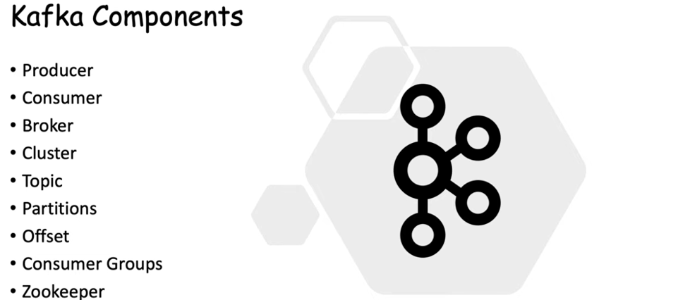

let's begin with the first one that is producer. The producer is the source of data who will publish the messages or events. the consumer act as a receiver it is responsible for receiving or consuming a messages but they won't directly communicate with each other to process the messages from producer to the consumer, there should be one middle man between them that is what called kafka server or broker, in PubSub model usually producer will publish or push the messages to the broker then broker will store that messages and then consumer will consume it from the broker in other word you can say a broker is just an intermediate entity that helps in message exchange between a producer and a consumer ok, so this is what the basic key component of your PubSub model and producer, consumer and broker.

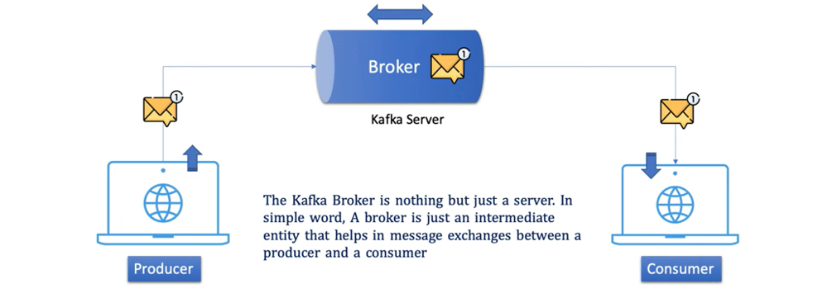

let's move to the next one that is cluster so I believe everyone heard the word called cluster if not, a cluster is a common terminology in the distributed computing system it is nothing but just a group of computers or servers that are working for a common purpose since kafka is also a distributed system it can have a multiple kafka server or brokers inside a single kafka cluster so there can be one or more kafka brokers inside a single kafka cluster let's assume your producer is publishing huge volume of data then a single kafka broker may not able to handle the load so you might need to add additional kafka server or additional broker so you can group multiple broker using a kafka cluster so next let's deep dive inside the brokers to understand what all core components it has to store the messages .

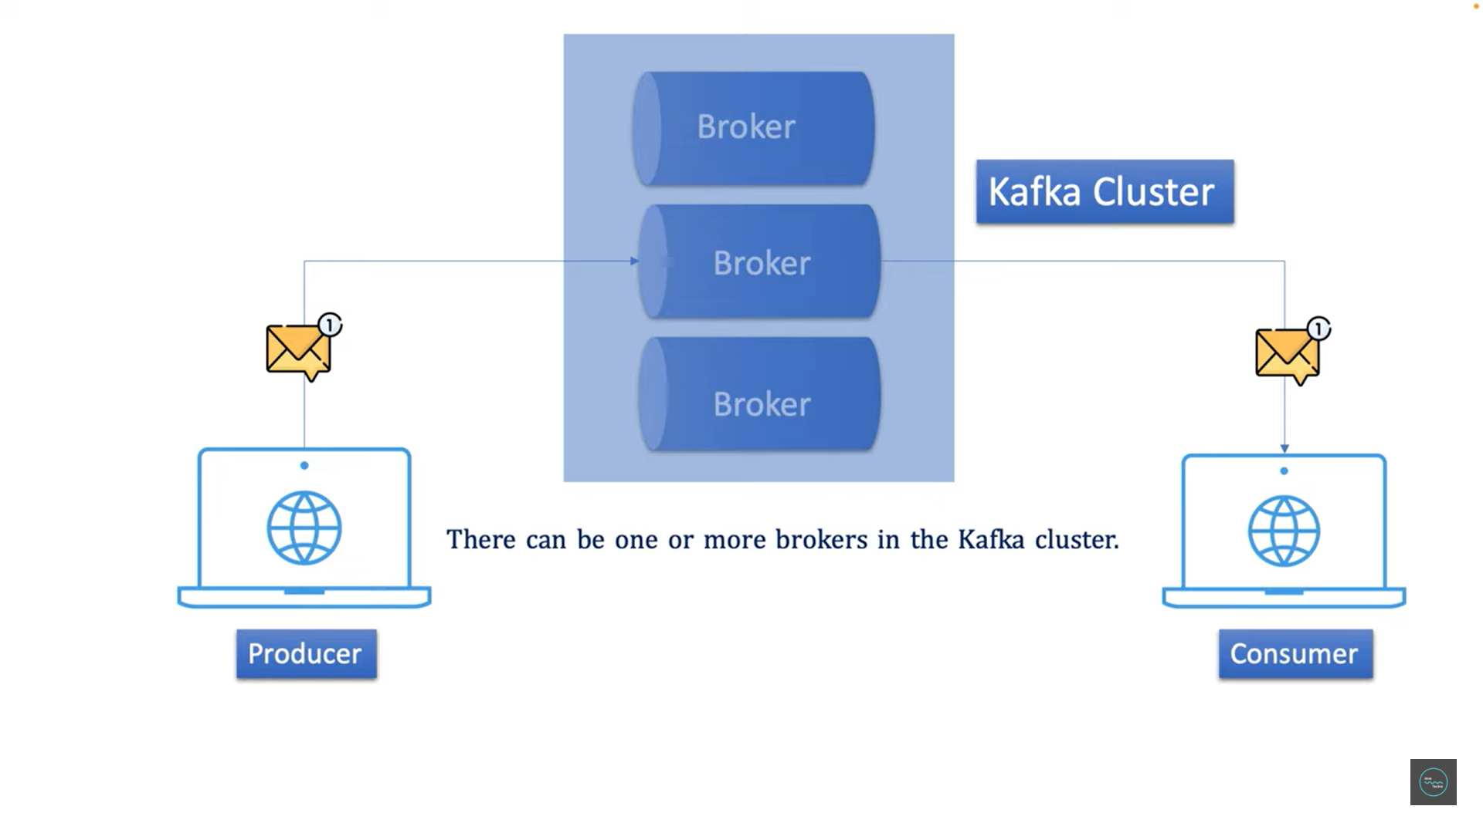

Let's deep dive inside the brokers to understand what all core components it has to store the messages.

**Topic**

let's move to the next component that is topic so before I explain the theory what is the topic let's find out why it is there inside a broker. let me walk you through the same paytm example as you understand the paytm application will keep sending different type of activity to the kafka server and the paytm client app will continuously listen the messages from the kafka server so here the left part is my producer and the right side is my consumer and the middle man is the broker or you can say kafka server so broker receives different type of messages or events here it can be a payment transaction or it can be a ticket booking or it can be a specific to the mobile recharge related message now consumer needs to read all the messages to process them so the consumer asks to the broker hey give me all the messages you have received then the broker checks his storage and replies to the consumer hey consumer I have a lot of messages with me which one you need again consumer asks hey broker give me all payment specific messages again broker attacks with the counter question hey buddy I have different type of payment messages with me which one you need now it's gone right the consumer hurts by broker counter question .

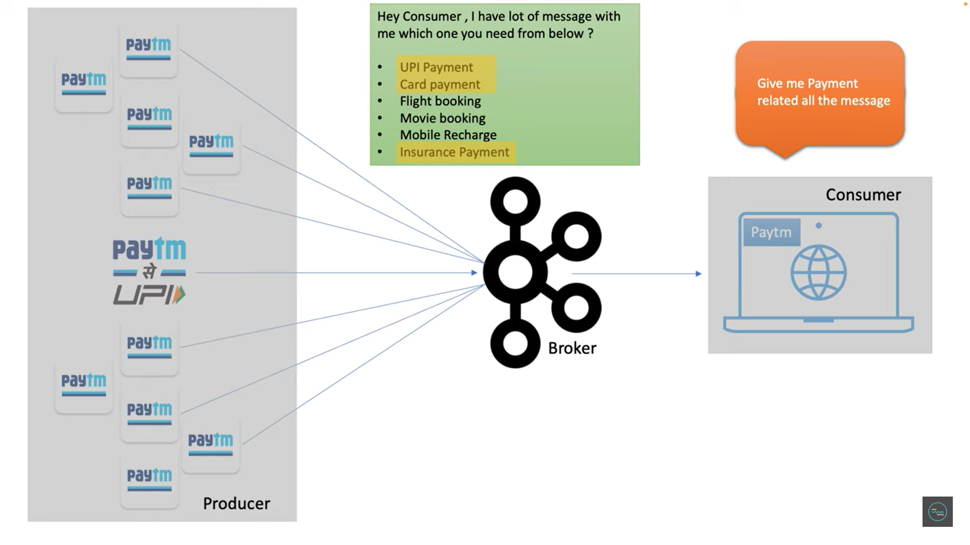

this is obvious right then how we can overcome this back and forth conversation that is where topic came into picture to categorize different type of messages so how topic can help here you can simply create multiple topic to store different type of messages even you can rename the topic payment topic, booking topic and insurance topic if producer sending payment specific messages then the message will post this particular payment topic if the message type or producer is sending booking related messages you can keep those messages inside this booking topic or similarly if producer is sending some mobile recharge specific information you can keep it separate topic this is how you can segregate different event type to different topic so here consumers have no need to have a back and forth communication with brokers whatever messages consumer want he will simply need to subscribe that specific topic for example I have a consumer who needs only the booking specific messages then I will tell him hey consumer you go and check directly in the booking topic you no need to ask to the broker to give me booking specific messages you simply go to the booking topic or you simply subscribe to the booking topic and get all the messages what you need this is very simple right.

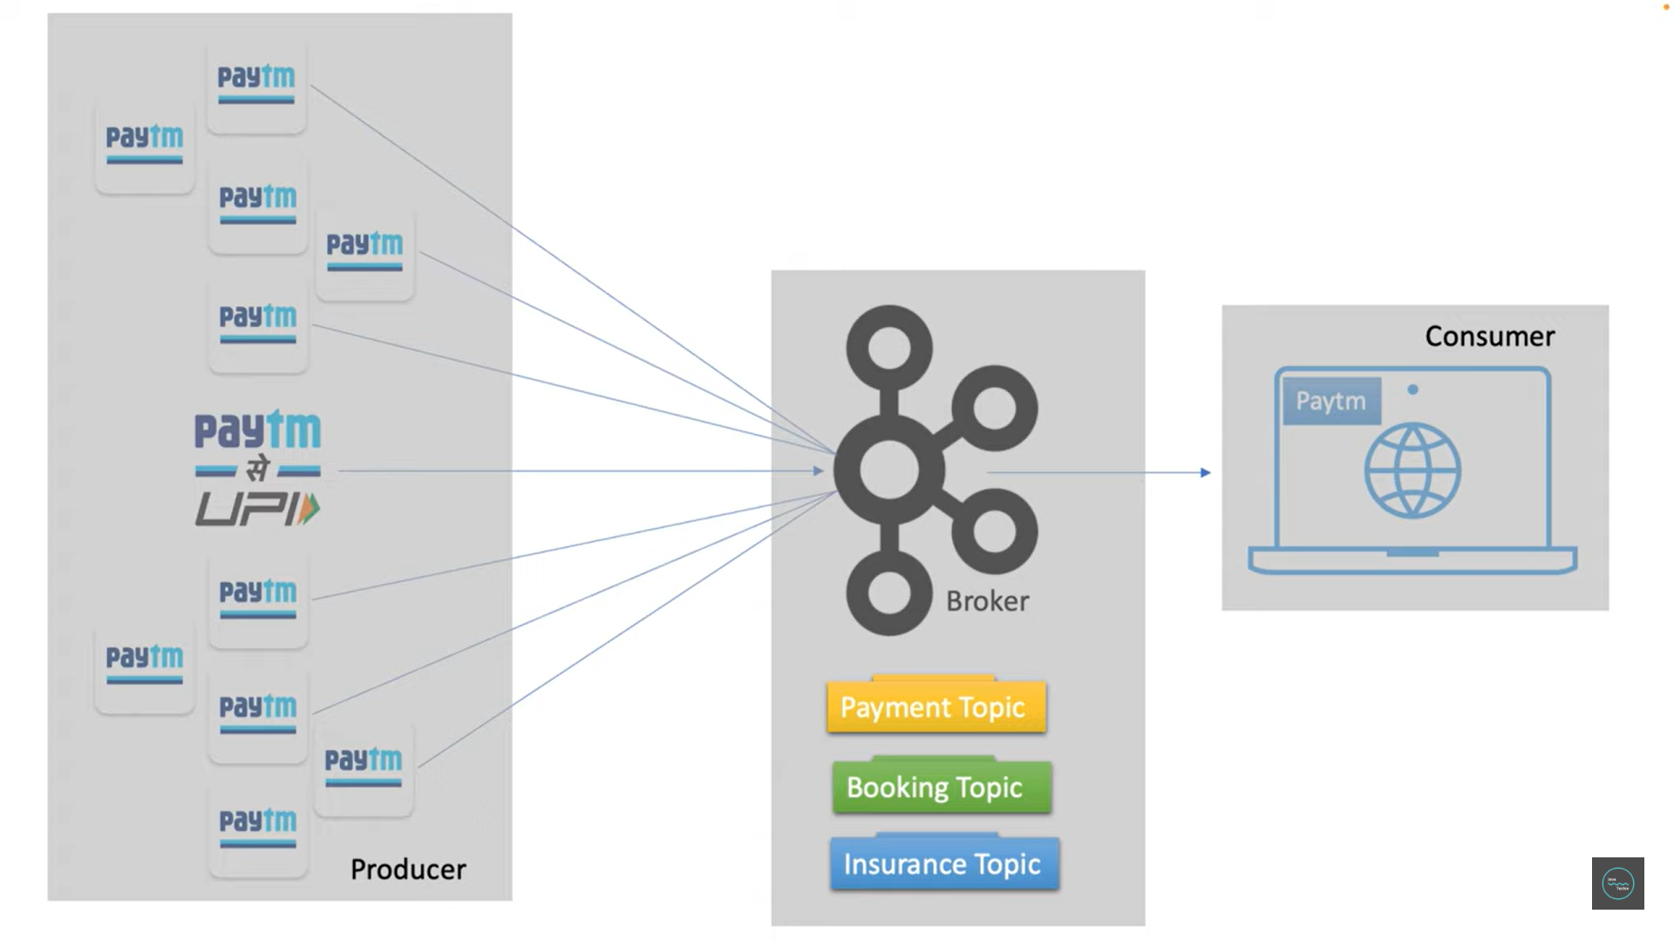

alternatively you can consider the topic act as a database table in kafka ecosystem so usually we store employee information in the employee table and payment information in the payment table in database world similarly when producer send employee specific event or messages we need to store them in the employee topic and similarly if producer is publishing payment specific information then we need to store it in the payment topic now if you have multiple consumer then they can go to a specific topic and consume the messages as per their need for example if consumer 1 wants to read all employee messages he can go and collect the messages from the employee topic directly, no need to ask to the broker hey broker give me the employee specific messages he know that employee topic contains all the employee specific messages consumer 1 can come to the employee topic and can get the info similarly all the consumers can subscribe to the corresponding topic what information they want to listen **so if you look into its actual definition topic specifies the category of the messages or the classification of the messages listeners can then just respond to the message that belongs to the topic** they are listening on so consumer 1 want the payment info he can go and listen to the payment topic that is what the need of topic or this topic play a critical role in kafka ecosystem ok.

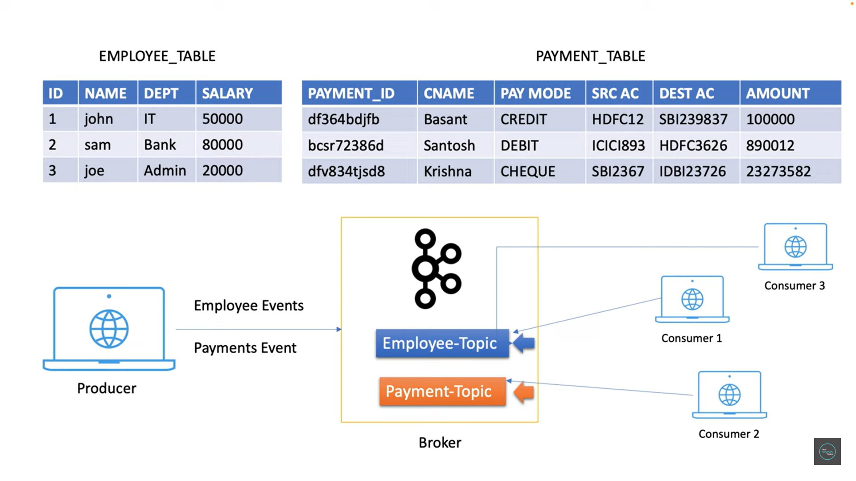

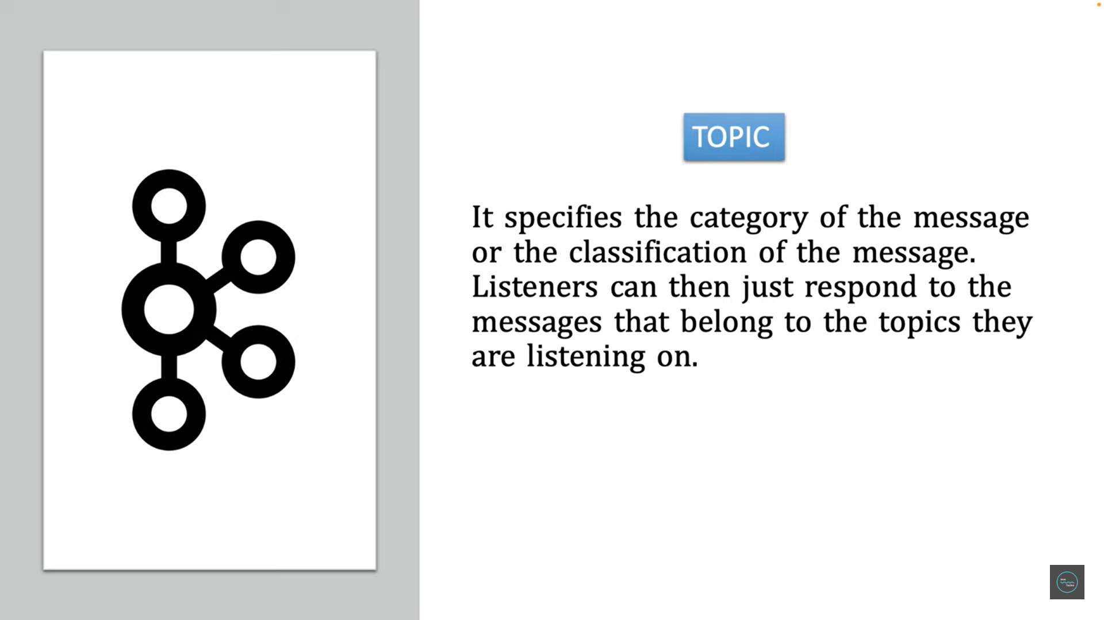

**Partitions**

Let's move to the next key component that is partition. now we know that paytm producer sends data to the broker and the broker store the message inside a topic now consider you have a huge volume of data when I say huge volume of data let's assume your producer is publishing millions or billions of messages per second to the topic then will my topic be able to handle those many messages obviously no there could be a storage challenges or it can be very challenging for the topic to store data on a single machine right then how to handle this situation solution is very simple as we already know kafka is a distributed system in such a scenario we can break the kafka topic into multiple parts and distribute those parts into different machines this concept is called topic partitioning and each part is called partition in kafka terminology ok so this partitioning will give you better performance and high availability because if you observe we split our topic to multiple partitions so when producer publish bulk messages then each partition concurrently accept the messages that will definitely improve the performance even in case if any partition goes off then other partitions are available to handle the loads without any application downtime this is the reason topic partitioning is the key aspect in the kafka ecosystem and we can decide the number of partitions for a topic during kafka topic creation ok.

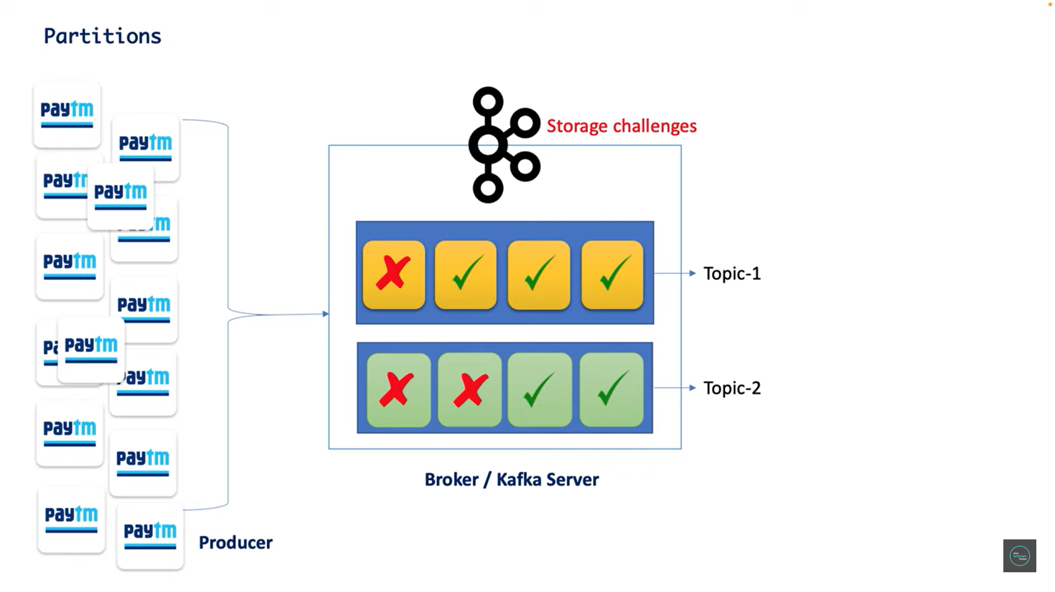

**Offset**

So now let's move to the next component that is offset so far we understand a kafka cluster can have one or more kafka server then a kafka server can have multiple topics and each topic can have multiple partitions right now when producer send a message then it will go and sit in any partition inside a topic that we don't have any control on it. it will work based on the round robin principle so if you observe as soon as message arrives in a partition a number is assigned to that message that is called offset 0,1,2,3,4,5 these are the sequence number assigned to each and every messages that is called offset so the purpose of offset is to keep a track of which message have already been consumed by the consumer.

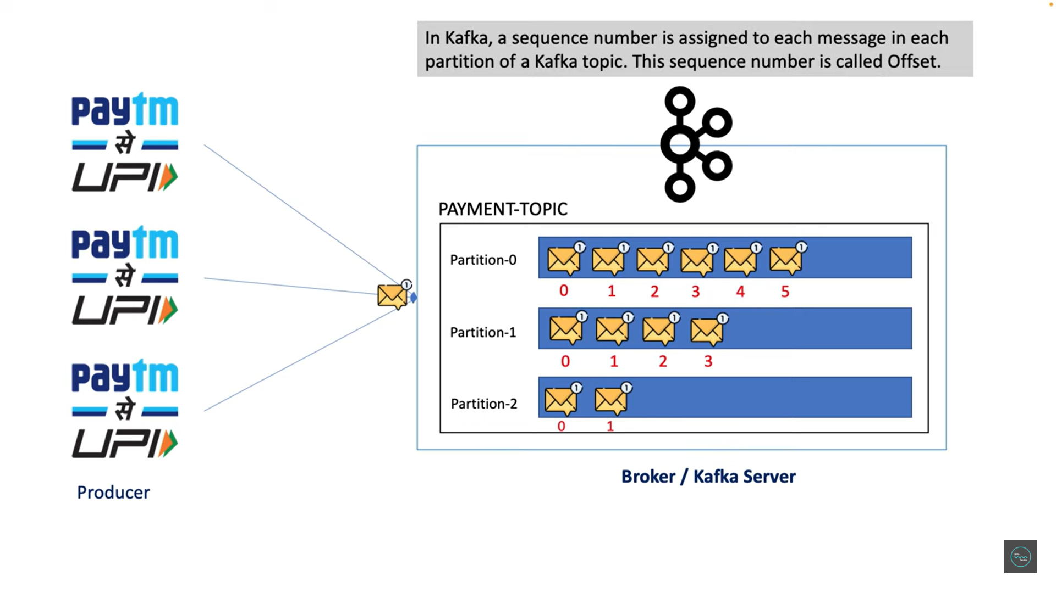

for example, let's consider after reading 4 messages from the partition consumer went down ok then when consumer will back to the online then this offset value would help him to know exactly from where the consumer has to start consuming the messages now here if you observe consumers should start reading message from offset 4 not from the 0 again right this is what the key role of offset now let's move to the next component that is consumer group.

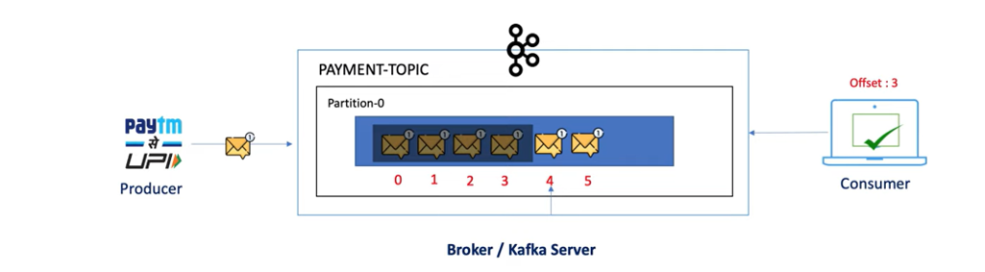

**Consumer Groups**

Let's move to the next component that is consumer group so I believe we all are clear up to this producer will push huge volume of messages to the kafka topic and message will again split to different different partitions and inside partition each message have their own identity with offset number so now let's go one step ahead who will listen to the messages from the partitions the single statement is consumer right but if you observe here I have 3 partitions and a single consumer is reading from each and every partition which will definitely leads the performance issue because there is no concurrency you can see here a single consumer is playing with all the 3 partitions so definitely it won't give us the better throughput then how we can overcome this situation it's very simple just share the workload how can I share the workload so what I will do simply I will define n number of consumer instance now I can group all the 3 consumer what I define into a single unit by specifying the group name that is called consumer group now payment consumer group have the 3 consumer instance now since I have multiple consumer with me I can divide the workload to each and every consumer to achieve better throughput so simply now my consumer 1 can read from partition 0 consumer 2 can read all the messages from partition 1 and consumer 3 can read from the partition 2 then in this approach all the 3 consumer instance read parallelly from each and every partition which will definitely give me the better performance or we can get the better response just keep a note we can't guarantee about consumer and partition order any consumer can talk to any partition that will be decided by the coordinator

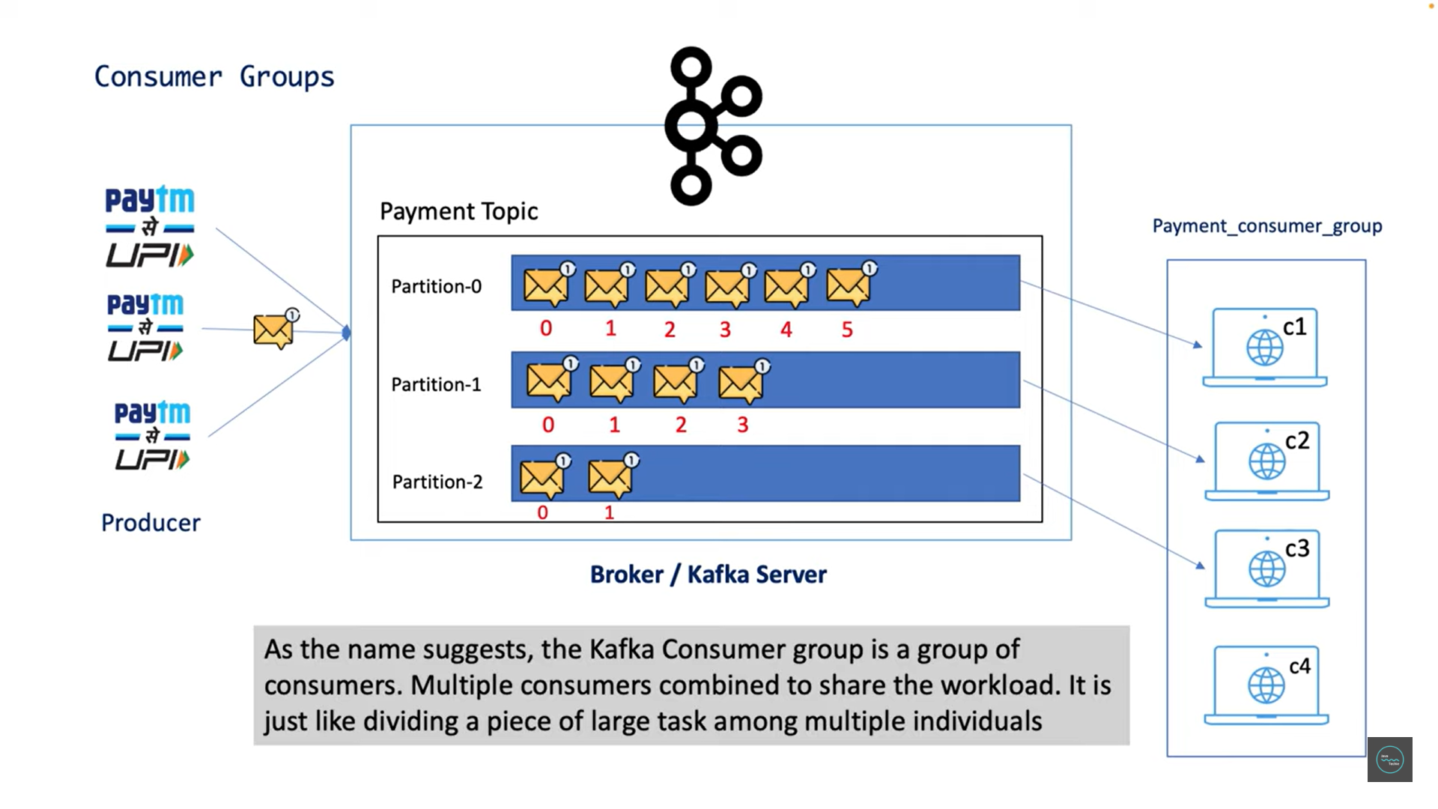

so you can say consumer 1 might listen from partition 2 or any other we don't have any control on it now you might have a question hey I have 3 partition so 3 consumer so they will talk to each other that's correct but what if I have a 4th consumer added to my consumer group then what will be the behavior of this consumer 4 what he will do right there is no change that consumer 4 will sit ideal because there is no work for him now since all the 3 partitions assigned to 3 different consumer instance there is no partition left for him so he will simply sit ideal but in case if any consumer instance is rejected or goes off then c4 will get a. chance to connect with any partition this concept is called consumer rebalancing don't worry I will cover this part in the coming session

**Zookeeper**

Now let's move to the next component that is Zookeeper Zookeeper is a key component for Kafka. Kafka is a distributed system and it uses Zookeeper for coordination and to track the status of your Kafka cluster it also keeps the track of Kafka topics, partitions, offsets and all the components of the Kafka ecosystem so in single word you can say this particular Zookeeper will act as a manager for your broker or for your Kafka cluster so this is what all the key components of Kafka we have seen the concept of Kafka architecture.

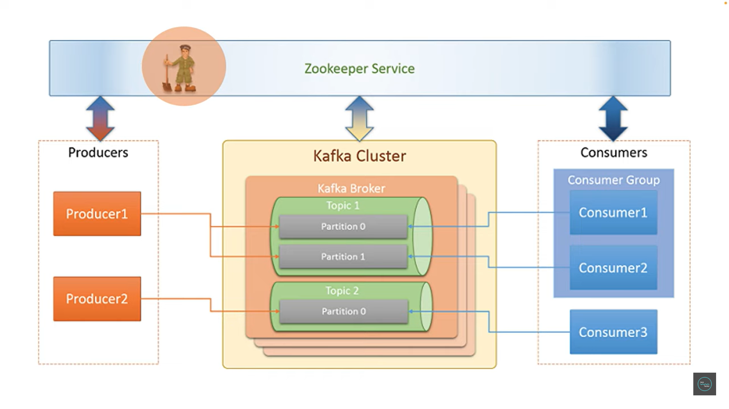

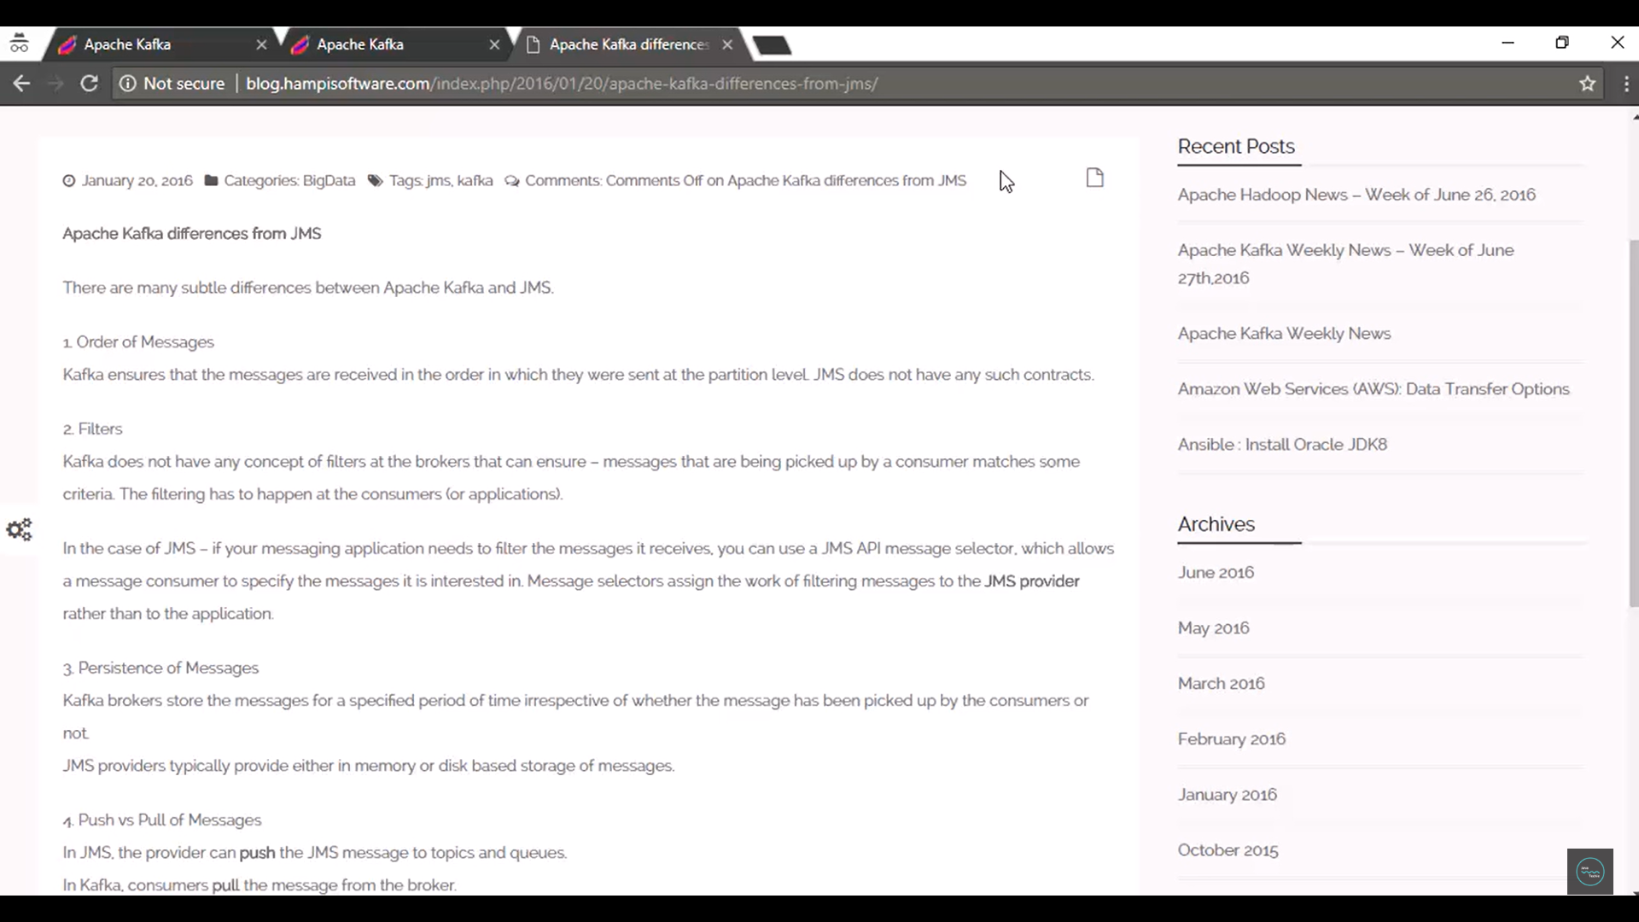

**Spring Boot Integration with Kafka for Producer & Consumer**

**If we have JMS why we should go for Kafka…??**



Got and download- [Apache Kafka](https://kafka.apache.org/downloads)

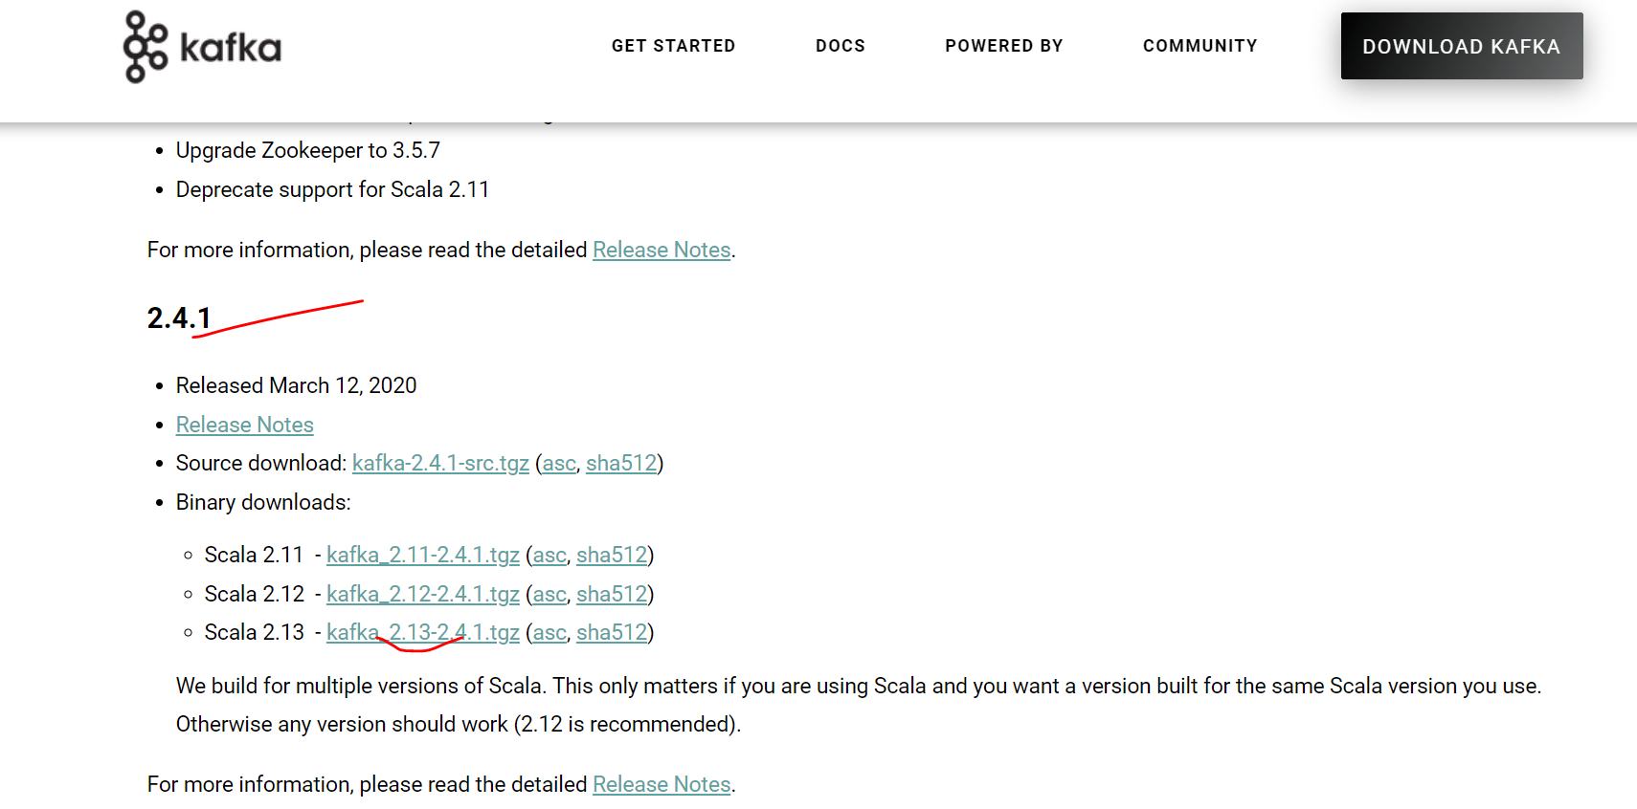

For apache kafka video go to this link: [How to Install Apache Kafka on Windows - YouTube](https://www.youtube.com/watch?v=EUzH9khPYgs)

Then extract the gz file…then rename that folder as kafka…and put into c drive…

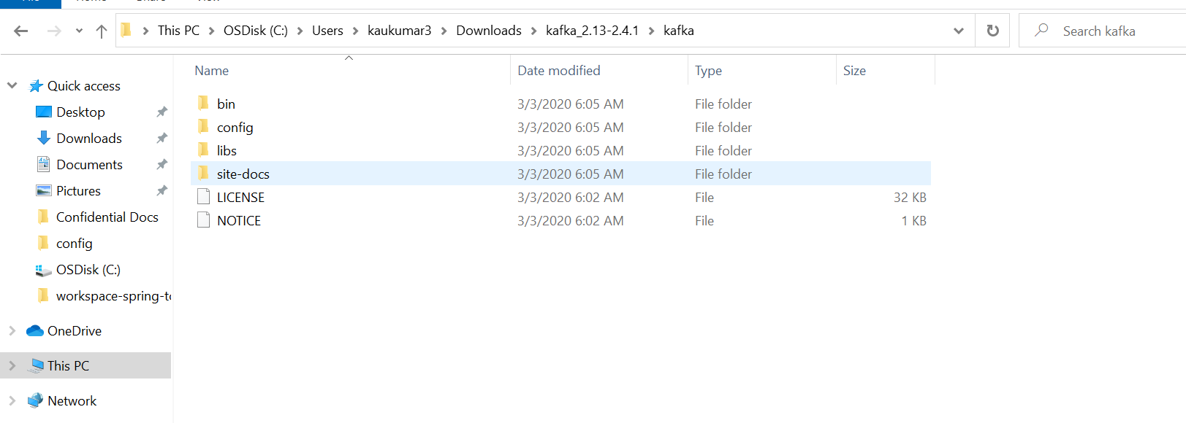

It looks like this… we have bin directory, config directory, lib and other one.

bin directory will contain all the libraries which will be used to run the kafka in zookeeper. So inside bin/windows folder there are many batch files which support to run kafka in windows environment.

There is config file which needs to configure while working with kafka.

And there are libraries available to run the kafka.

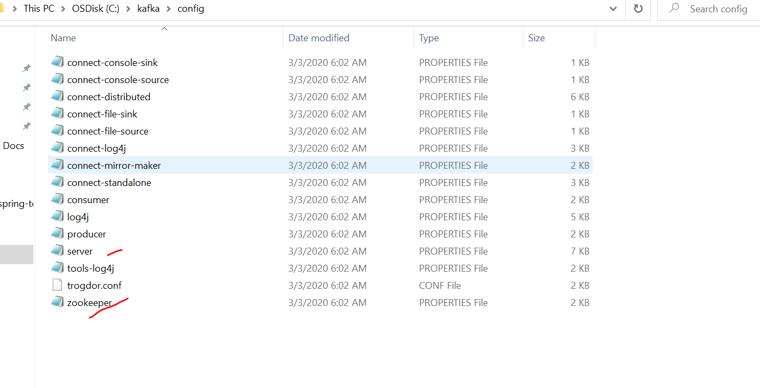

So, if u will go to the config folder u will see properties file for zookeeper and server.

So, lets change the configuration after that we will start server….so just go to server. properties.

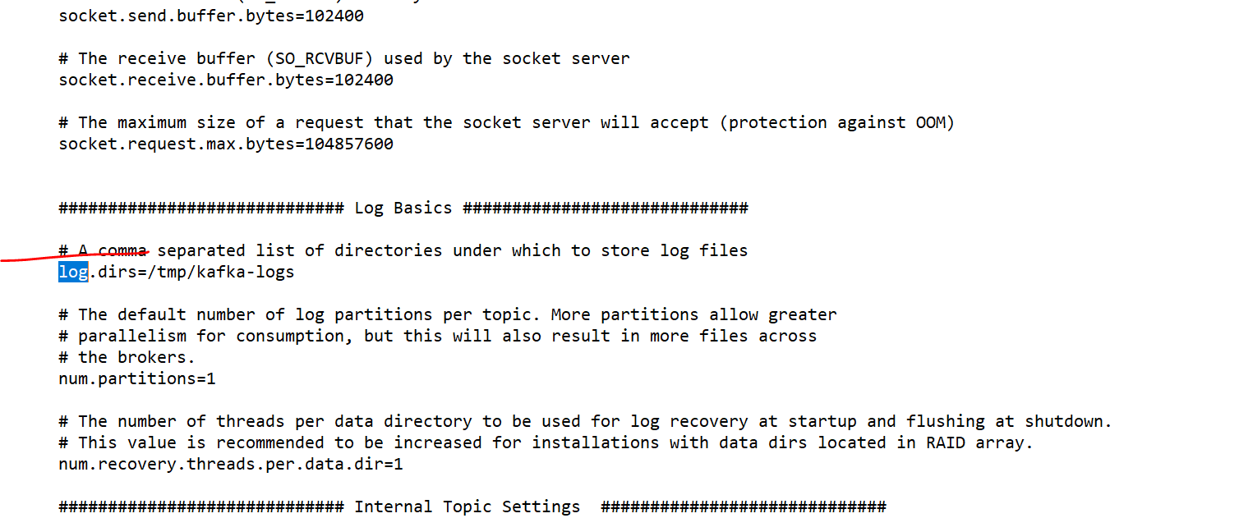

Inside server.properties we will change the log directory for apache kafka .currently its going to temp folder we will change it to C://kafka c drive kafka folder.

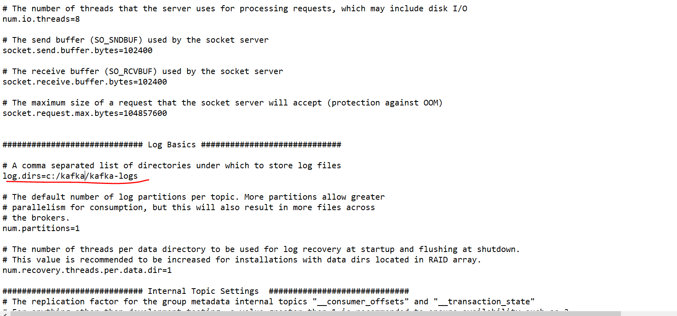

So, this is the one configuration and here another configuration is for data Directory for the zookeeper.

So, change it from tmp to c:/kafka and change the name zookeeper-data.

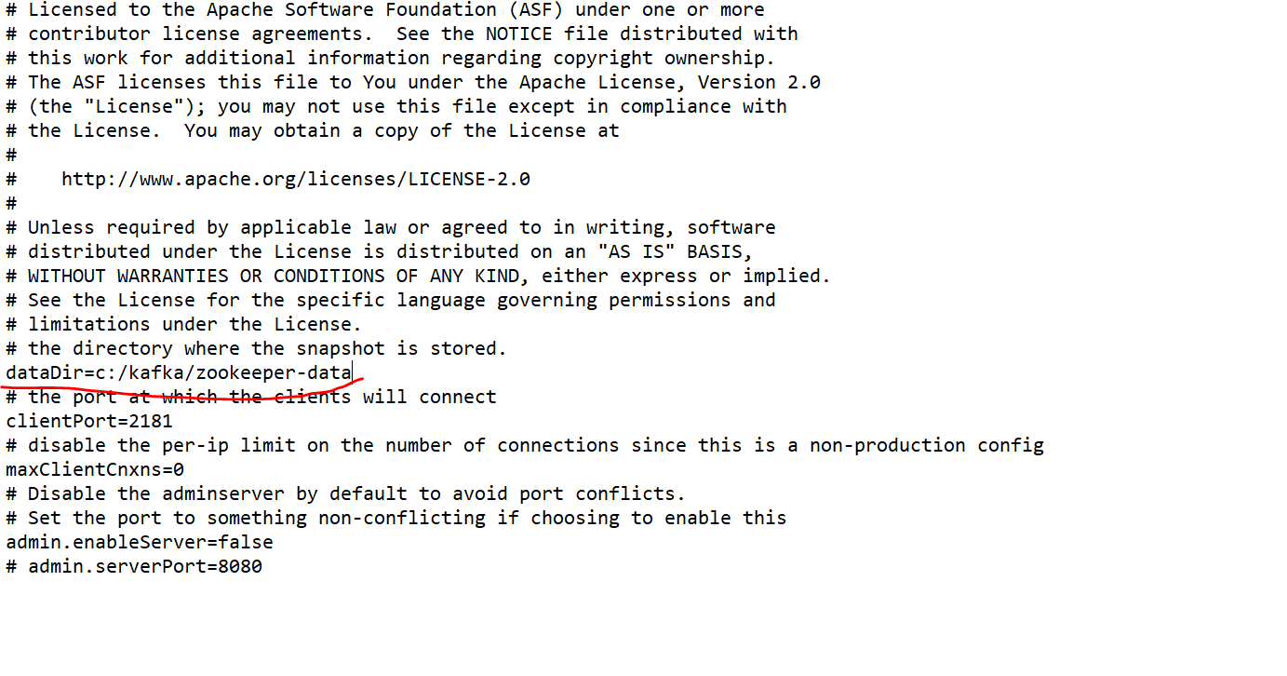

So, all our data and logs will be go into kafka folder.so all our configuration is done.so lets open command prompt and run the kafka and zookeeper.

So open command prompt and go the kafka folder. And here we need to start our zookeeper.

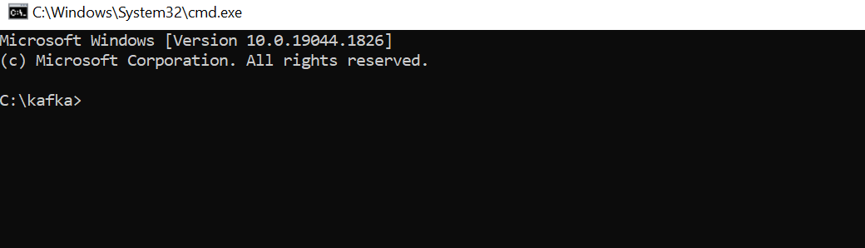

We need to start the server with config zookeeper.properties so with that properties our zookeeper will start on port 2181.

Run command **>>>>>>**

.\bin\windows\zookeeper-server-start.bat .\config\zookeeper.properties

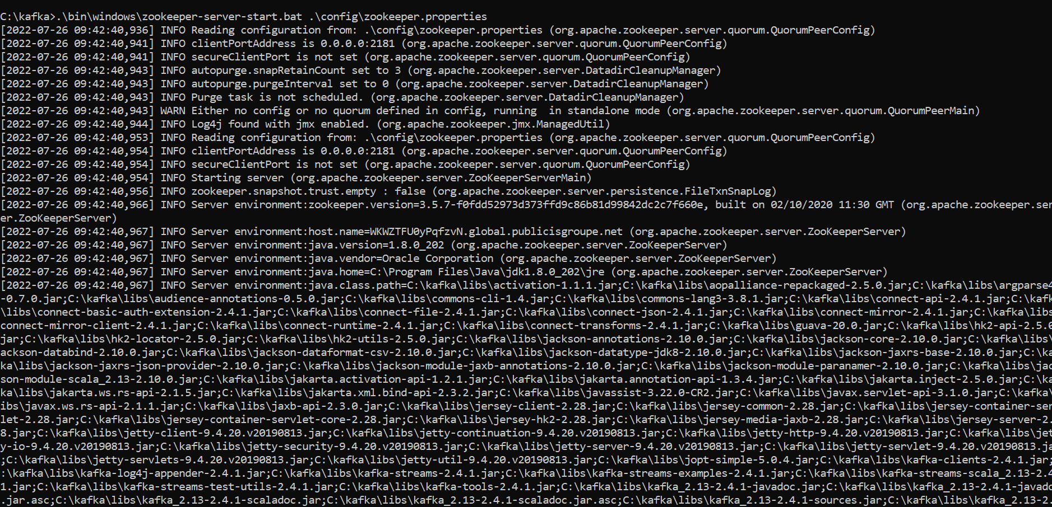

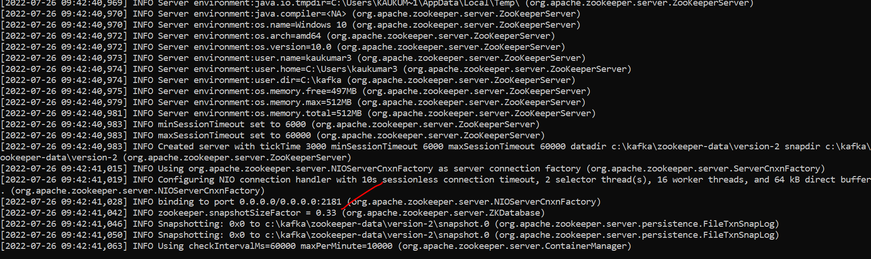

So, our zookeeper started on port 2181.

Let’s open another command prompt and let’s start apache kafka.

So, to start apache kafka again we will go to bin directory inside bin windows directory and kafka server start .bat file…and then we need to give the configuration like \config\server.properties.

.\bin\windows\kafka-server-start.bat .\config\server.properties

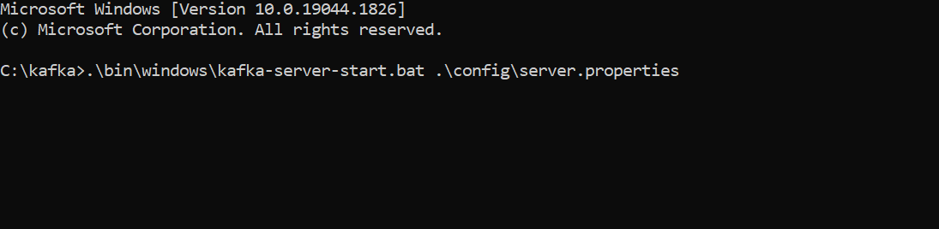

So, this way we can start our kafka.

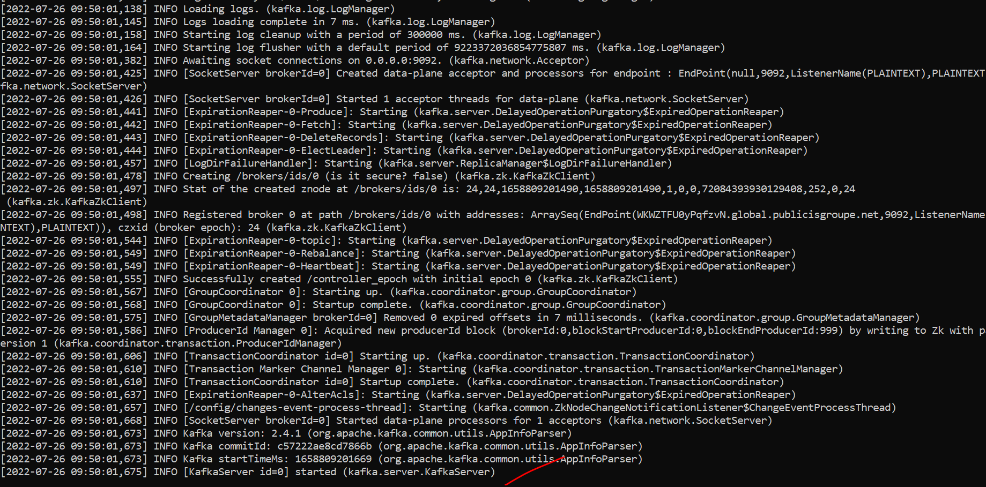

So, let’s open another terminal and let’s create topics….

So, to create a topic we need to go to bin directory windows and then kafka-topic.bat then create then zookeeper so we show like our zookeeper started at port 2181. We will add replication factor as 1 Partitions as 1 and then the topic name my topic name would be TestTopic so this is the command.

.\bin\windows\kafka-topics.bat --create --zookeeper localhost:2181 --replication-factor 1 --partitions 1 --topic TestTopic

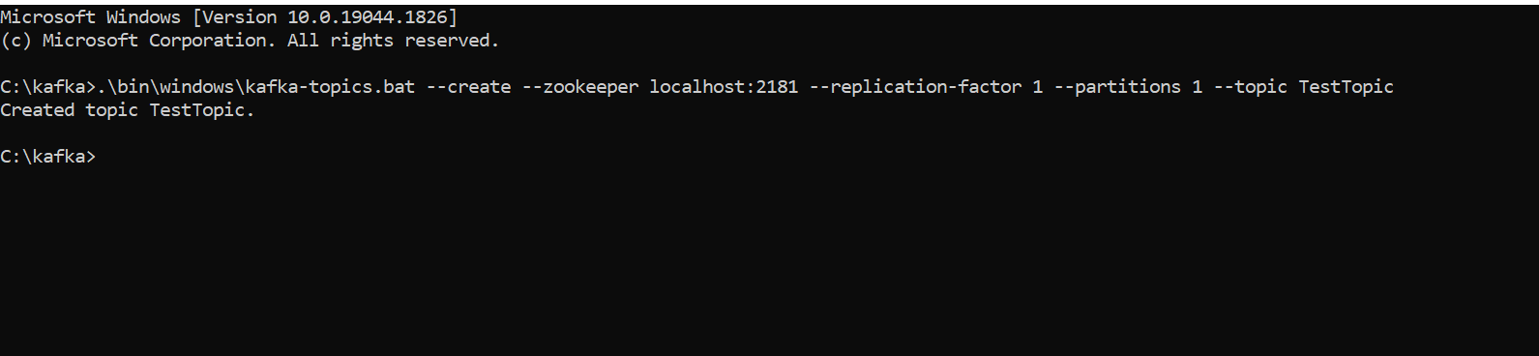

If we execute out topic will be created. We are using replication factor 1 and partitions 1 because we are not using clustered based.

Lets create one more topic we will give name new Topic.

.\bin\windows\kafka-topics.bat --create --zookeeper localhost:2181 --replication-factor 1 --partitions 1 --topic NewTopic

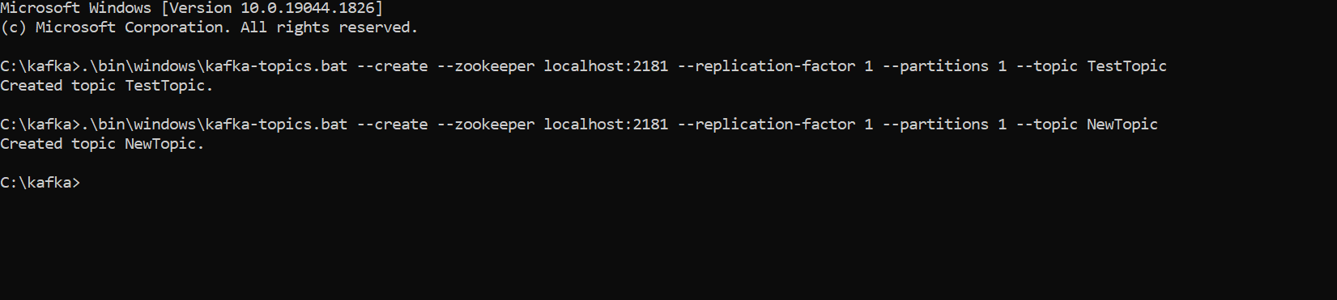

So, we created 2 topics. Now these 2 topics are available.

Now we will list all the topics which is running on local host 2181.

.\bin\windows\kafka-topics.bat --list --zookeeper localhost:2181

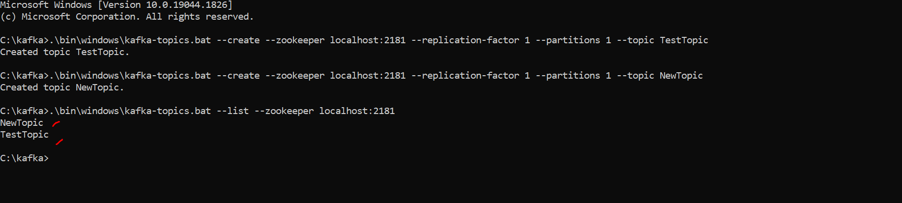

So now let’s see how we can produce and consume the messages from command prompt then will see through spring boot.

------------------------------------------ Testing purpose (producer/consumer)--------------------------------------

Here we are giving command for create the messages on to our topics. 9092 is default port for kafka. It provides one console to input the data.

Open cmd

.\bin\windows\kafka-console-producer.bat --broker-list localhost:9092 --topic TestTopic

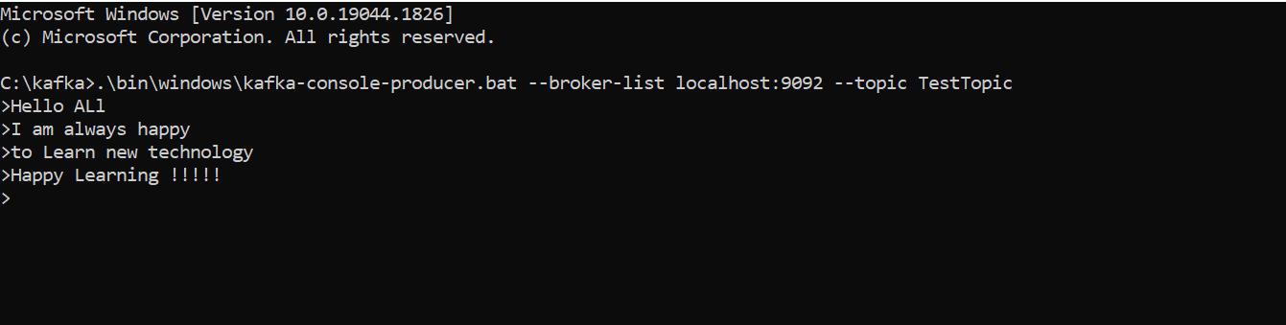

So, these all are the messages which we already produced on Test Topic. Let’s open another terminal and let’s create our consumer which will consume our all data from the TestTopic. And we will bootstrapping the server on local host 9092 and consume data from Test Topic from beginning.

.\bin\windows\kafka-console-consumer.bat --bootstrap-server localhost:9092 --topic TestTopic --from-beginning

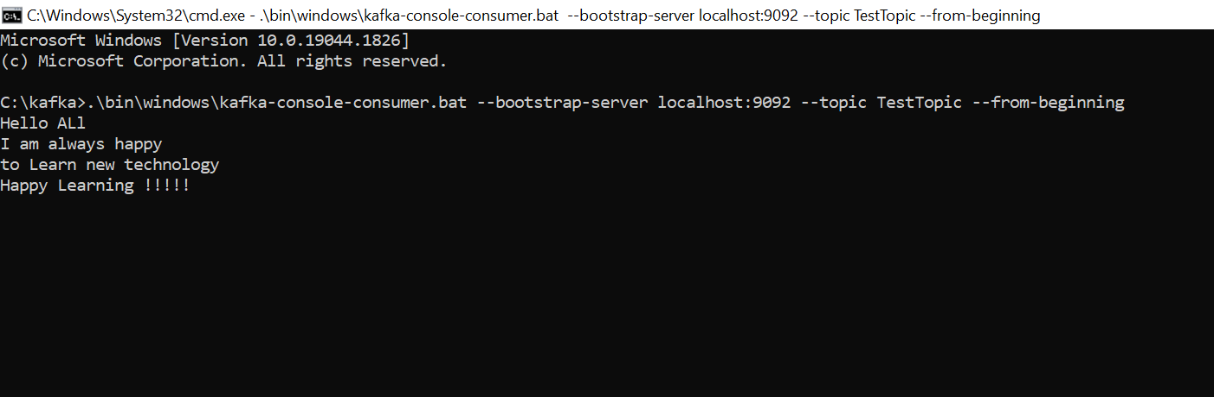

==========================================================================

All commands:

**.\bin\windows\zookeeper-server-start.bat .\config\zookeeper.properties**

**.\bin\windows\kafka-server-start.bat .\config\server.properties**

**.\bin\windows\kafka-topics.bat --create --zookeeper localhost:2181 --replication-factor 1 --partitions 1 --topic TestTopic**

**.\bin\windows\kafka-topics.bat --create --zookeeper localhost:2181 --replication-factor 1 --partitions 1 --topic NewTopic**

**.\bin\windows\kafka-topics.bat --list --zookeeper localhost:2181**

**.\bin\windows\kafka-console-producer.bat --broker-list localhost:9092 --topic TestTopic**

**.\bin\windows\kafka-console-consumer.bat --bootstrap-server localhost:9092 --topic TestTopic --from-beginning**

=====================================================================================

Now let’s start our development…lets create a spring boot application…

Application : **kafka-publisher**

Dependencies: **Devtool, Lombok, web and kafka**

Let’s expose some text message then we will expose some raw messages.

Let’s inject KafkaTemplate with key as String and value also as String message so I am taking value as Object. Use kafkatemplate.send(topic, data) .

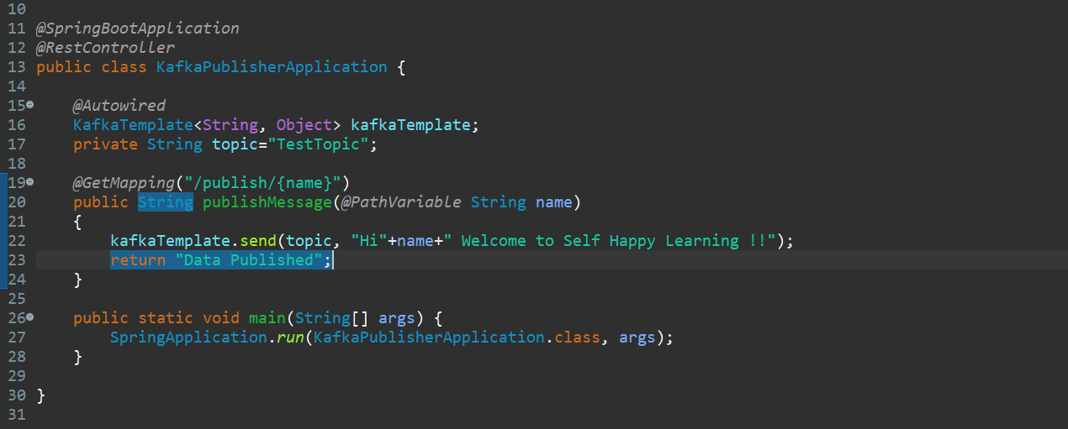

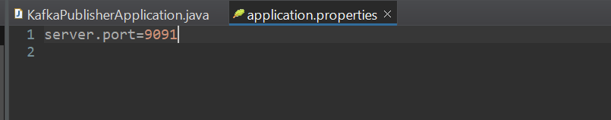

Let’s run our publisher and publish data on topic TestTopic.

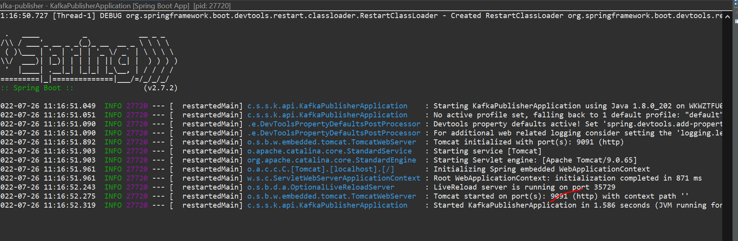

Started at 9091…. Let’s start our consumer on console and see on topic…

<http://localhost:9091/publish/Viewer>

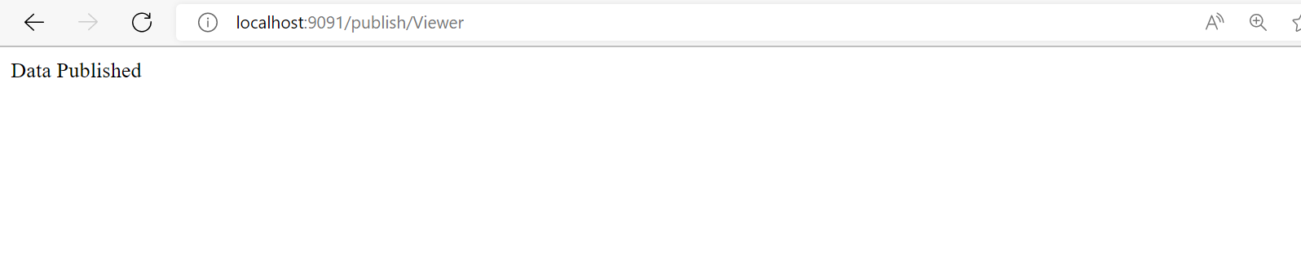

let’s run consumer and see…

.\bin\windows\kafka-console-consumer.bat --bootstrap-server localhost:9092 --topic TestTopic

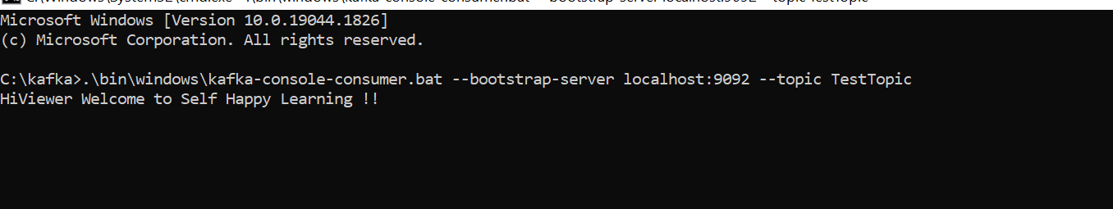



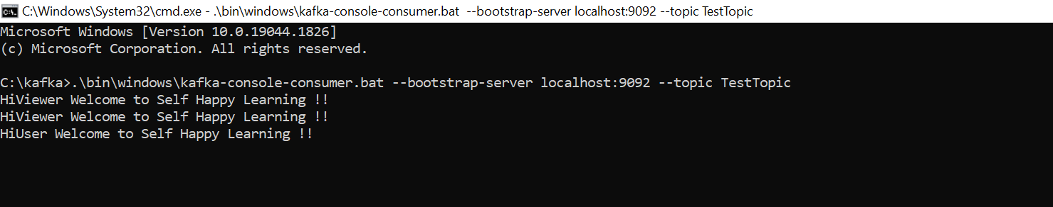

So, default port will be 9092…

This example we did for simple string publishing lets see how we can publish a raw json message.

For plain text no need to configure anything by default it takes String but for Raw Object we need to configure Key Serializer Value Serializer and server like bootstrap server.

So, let’s create a package called config.

**Let us create a User Object and let’s use Lombok provided annotations.**

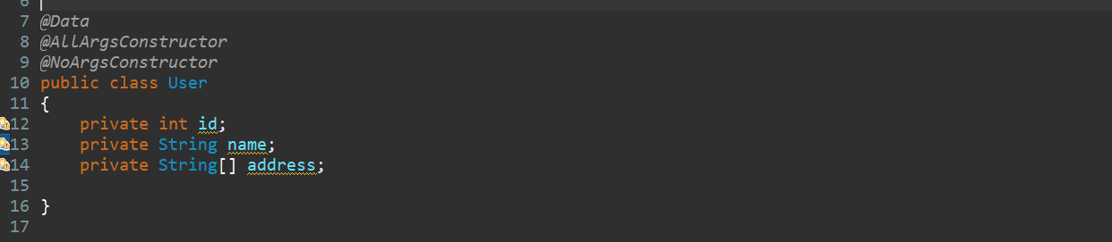

Now we have our model lets write the config….

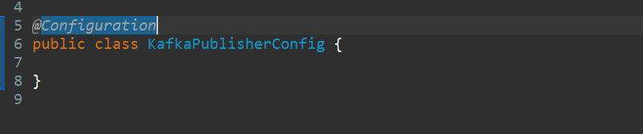

Annotate with @Configuration…

Let’s use ProducerFactory…

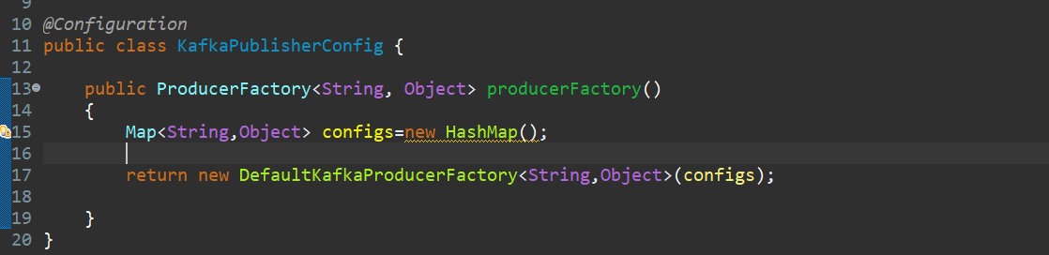

Now in config add the server detail first. Here we are using localhost and port is 9092. Bcz kafka default port is 9092. Since our key is String so providing the KeySerializer that should be come from kafka. since our value would be either object or raw object or raw json object that. similarly provide the value.

For value Serializer we are going to expose Object it can be User or it can be any model. So that’s why mentioning JSonSerializer.

Now annotate this one as @Bean

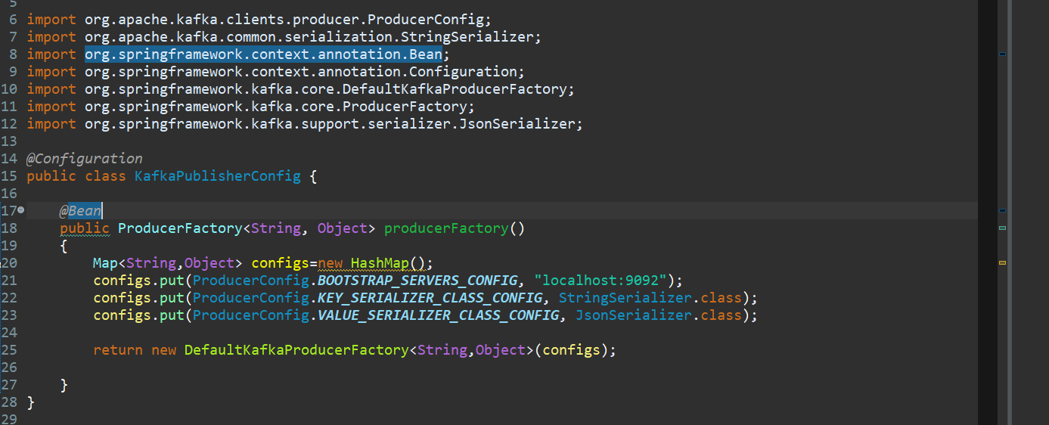

Now create a KafkaTemplate here…

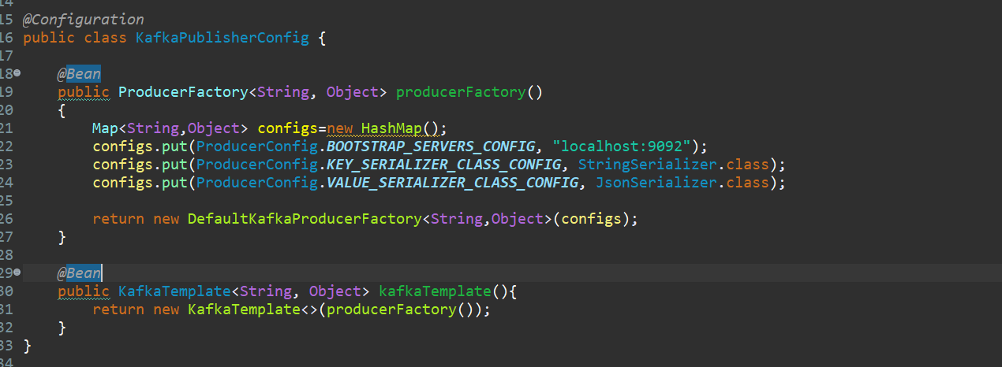

So, whenever you are working with String no need to do kafka config KafkaTemplate by default consider it as String. Whenever you are playing with raw object you need to provide the key serializer and value Serializer. And manually we need to configure the KafkaTemplate.

Now write one more method in controller where we will return the raw json message.

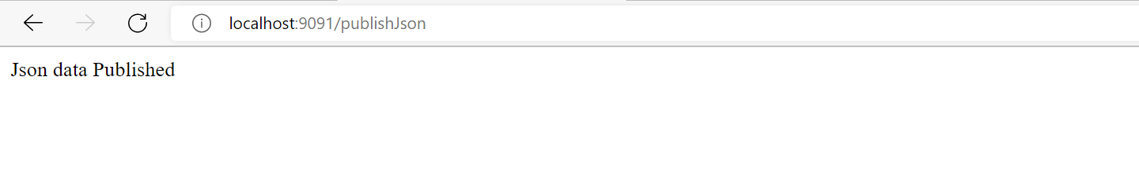

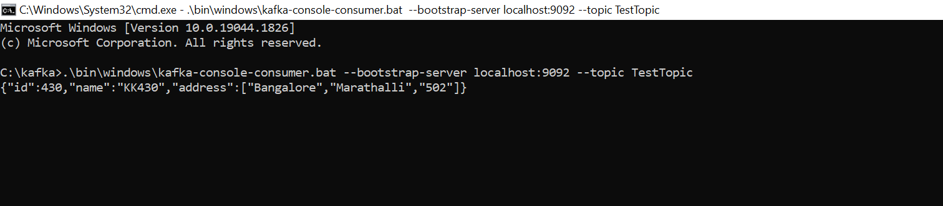

In Consumer console we can see data received in a Json Format because of Json Serializer for Valu

# Apache Kafka Consumer Example using Spring Boot

Now let’s develop a Consumer where we can consume data from the topic.

Application: kafka-consumer

Dependencies: Devtool, Lombok, kafka, web

So, let’s consume the first data then second one…

String data publish-> <http://localhost:9091/publish/Viewer>

User Object Publish-> http://[localhost:9091/publishJson](http://localhost:9091/publishJson)

To consume it we are going to use KafkaListener…

So, to consuming data we need to define a Kafka Config class where we can write a Key Deserializer, Value Deserializer and the group id. Annotate this class @Configuration. Create a Bean called ConsumerFactory…mentioned the key as String and we are going to consume the value also as a String so mentioned it. Let’s create a Map so that we can create a key value pair.

In map just add config as BootstrapServerConfig , Key_Deserializer_Class_Config and Value_Deserializer_Class_Config. Key and value both we are using as a StringDeSerializer Class and mentions a Consumer Group Id…

why we need this group bcz may be in producer there may be a chance we can consume multiple mediatype …multiple objects here we are consuming a String so for that I am specifying the groupId. For 2nd publisher we are going to consume the raw object json object so for that also I need to provide the different group Id. It’s just grouping the streams data stream. So, group id I am giving TestTopic-1. Now we need to annotate ConsumerConfig as Bean.

To Enable KafkaListener we need to annotate class like @EnableKafka

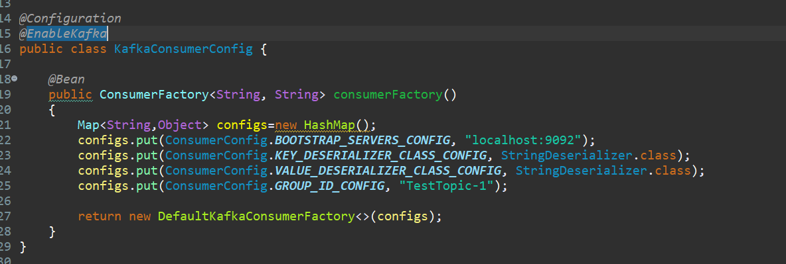

Now this KafkaConsumerFactory we need to Inject with KafkaContainerListener….

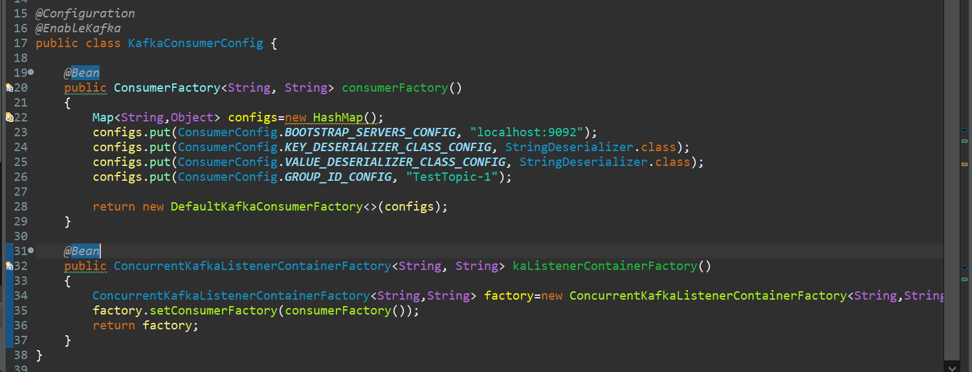

Now we did our configuration…now we will consume using KafkaListener…

So first write a Listener method which will talk to the topics. Let’s take return type list so we will consume all the messages from the topic, and we will display. So, use annotation @KafkaListener and parameter as a Group Id. And mentioned the topic name where producer is producing the data. Then mentioned the containerfactory there and mentioned the name as KafkaListenerContainerFactory.

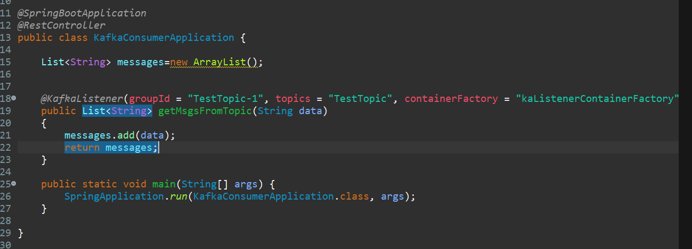

Now write our rest endpoint where we will return our list of messages.

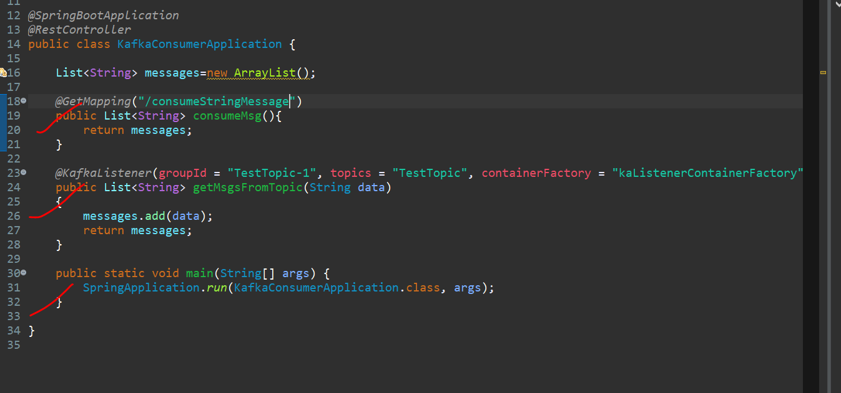

Actually, we are publishing 2 kind of data one String and another as Json….so let’s write another endpoint for consuming Jsondata.

So lets configure Configuration…..for string data we configure like this…

***@Bean***

**public ConsumerFactory<String, String> consumerFactory()**

**{**

**Map<String,Object> configs=new HashMap();**

**configs.put(ConsumerConfig.*BOOTSTRAP_SERVERS_CONFIG*, "localhost:9092");**

**configs.put(ConsumerConfig.*KEY_DESERIALIZER_CLASS_CONFIG*, StringDeserializer.class);**

**configs.put(ConsumerConfig.*VALUE_DESERIALIZER_CLASS_CONFIG*, StringDeserializer.class);**

**configs.put(ConsumerConfig.*GROUP_ID_CONFIG*, "TestTopic-1");**

**return new DefaultKafkaConsumerFactory<>(configs);**

**}**

***@Bean***

**public ConcurrentKafkaListenerContainerFactory<String, String> kaListenerContainerFactory()**

**{**

**ConcurrentKafkaListenerContainerFactory<String,String> factory=new ConcurrentKafkaListenerContainerFactory<String,String>();**

**factory.setConsumerFactory(consumerFactory());**

**return factory;**

**}**

Let’s configure for another type Json Data… just change the method name 1st one for String and second one for Object. Everything will be same only we need to change the group id and second one is like here we are not going to Deserialize the String we are Deserializing the Json…that’s what just change it to JsonDeserialize …

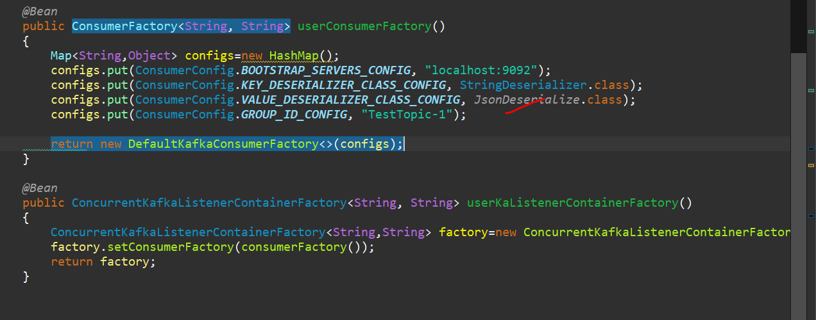

Our ConsumerFactory model will contain User type value. Change the value as user Object.

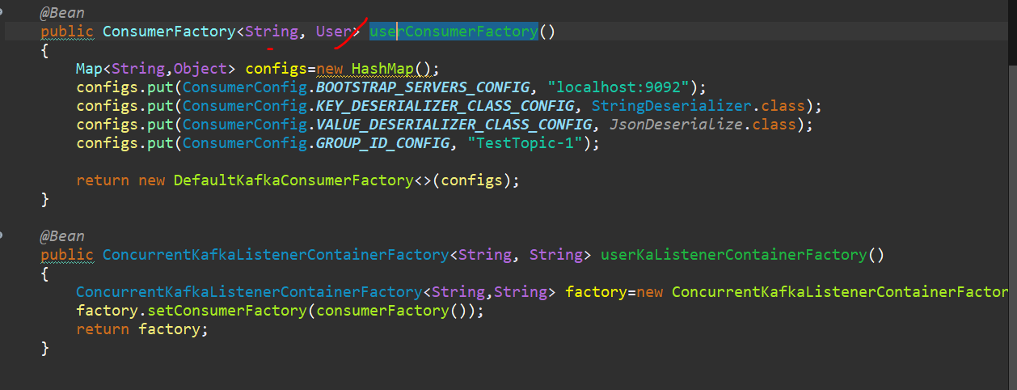

Here In ConsumerFactory along with config map we need to map the Key StringDeserializer and value JsonDesrializer…like below example build in method…

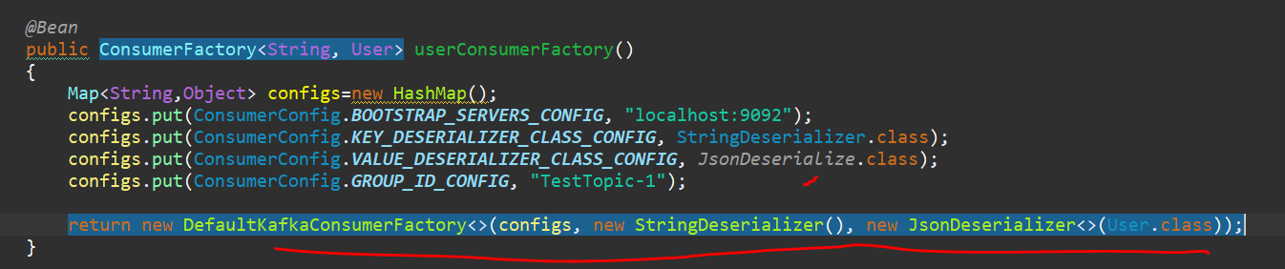

Same in ConcurrentKafkaListenerContainerFactory also need to change as User type…

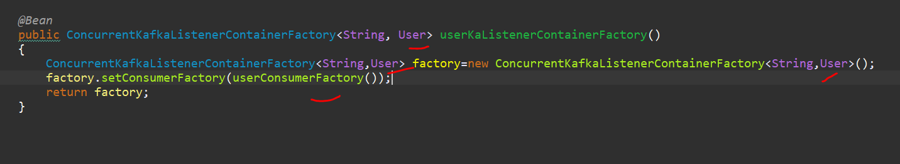

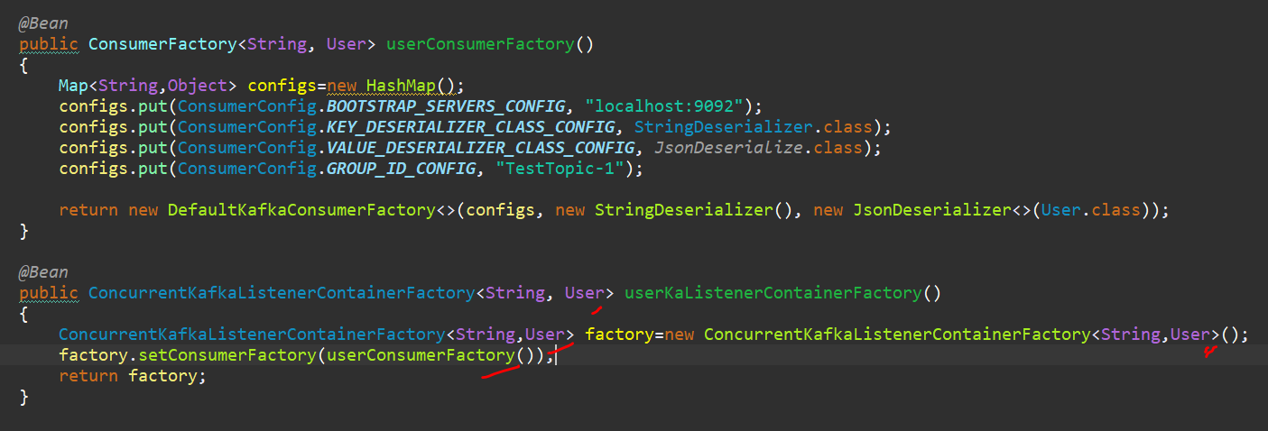

So let me create another KafkaListener which will read Json data and we will change group Id…

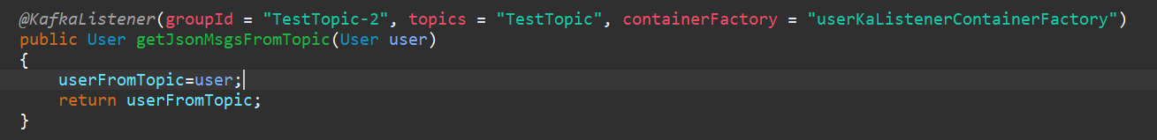

Let’s create another rest endpoint. Actually, normally In kafka we should not write the rest endpoint.

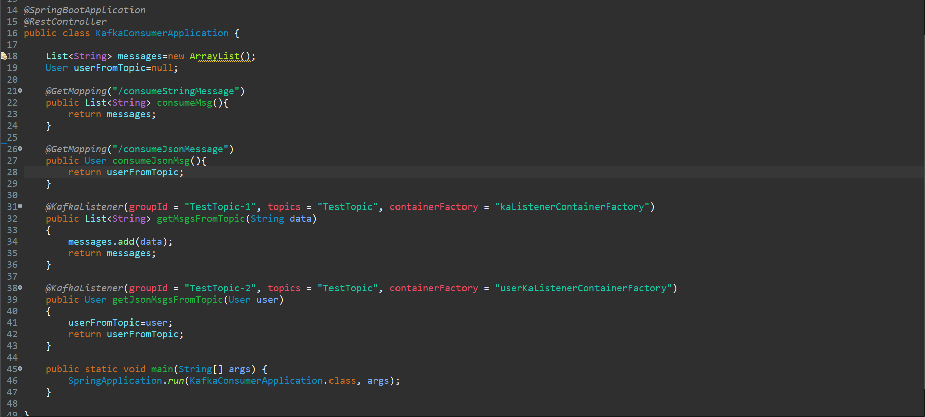

And Consumer config for String and Json Types of data….

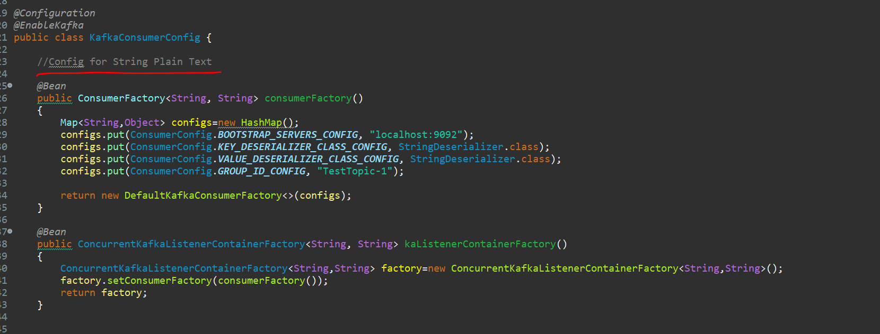

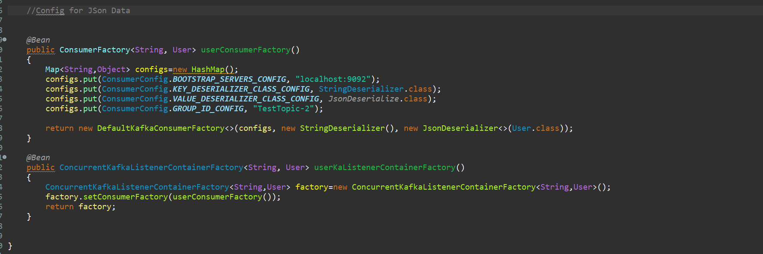

So before run our application we will up first our zookeeper, then kafka – server, then we will publish the data and then we will consume from the kafka consumer.

>> .\bin\windows\zookeeper-server-start.bat .\config\zookeeper.properties

>> .\bin\windows\kafka-server-start.bat .\config\server.properties

>> .\bin\windows\kafka-topics.bat --list --zookeeper localhost:2181

**Now let’s run our publisher and then we will consume the message one for String and another for User Object.**

**Producer is up on port 9091…and there are 2 rest endpoints.**

**Now let me run our consumer.**

**Docker**

**Docker - Dockerizing your Spring Boot Application**

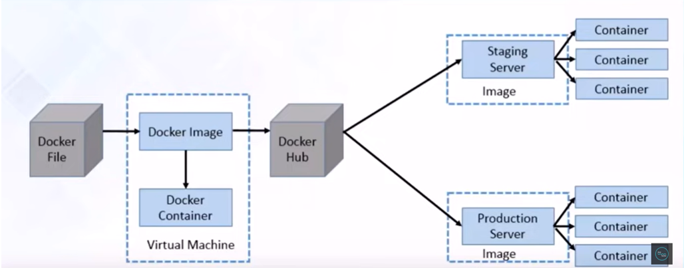

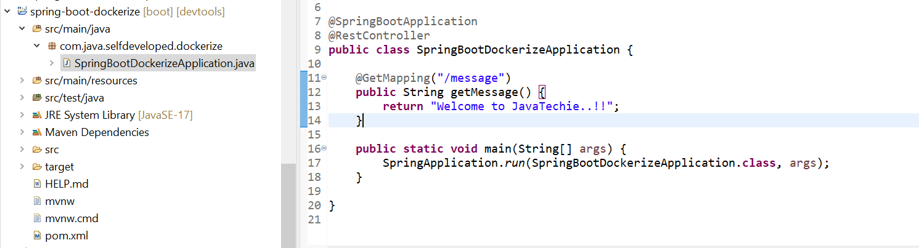

how we can dockerize our spring boot microservice.

this is the typical docker workflow as we discussed in my previous tutorial as a developer, we need to write the docker file and then with the help of docker command we need to create the docker image and there is a docker container which is the running instance of your docker image so writing this docker file and creating the docker image and run it upon docker container this entire process is called dockerize.

create a spring boot application and we'll write a docker file then with the help of docker command we will create the docker image and will be deployed on top of docker container ok so let's go.

we need to do we need to write the docker file so right click on your project directory create new file ok type docker file so we need to make the file name as docker file with d caps ok so this naming convention we need to follow so click finish ok so this is my docker file so here we need to add few component so let's start to write the docker file so the first one we need to specify **FROM**, **FROM** in the sense start with a base image containing with our java run time so here in case from we are going to write the jdk related things ok so open jdk 8. so this open jdk 8 image is available in our docker hub so this is what we are writing from open jdk 8 ok so the next one **EXPOSE** give some port something like I am giving 8080 ok so the mean of this expose make port 8080 available to outside the container ok so that's why we are specifying one port so the next one is **add** so here we need to add our jar of this spring boot docker ok so here first specify the path where we can get the jar target so we didn't create the jar yet so later we will add the jar details ok so the next one is **ENTRY POINT** all character should be capital so entry point here we need to specify the command to run the jar ok so how we can run the jar java then comma hyphen jar then here also we need to specify the jar name ok so till now we didn't create the jar so let's create the jar first go to our pom.xml let's specify the jar name here type your final name give the name of your jar I am giving one simple name spring boot hyphen docker ok so with this name my jar will be created so let me copy this let's add this in our docker file

**Let’s create the jar first**

In our pom.xml lets write <**finalName**>

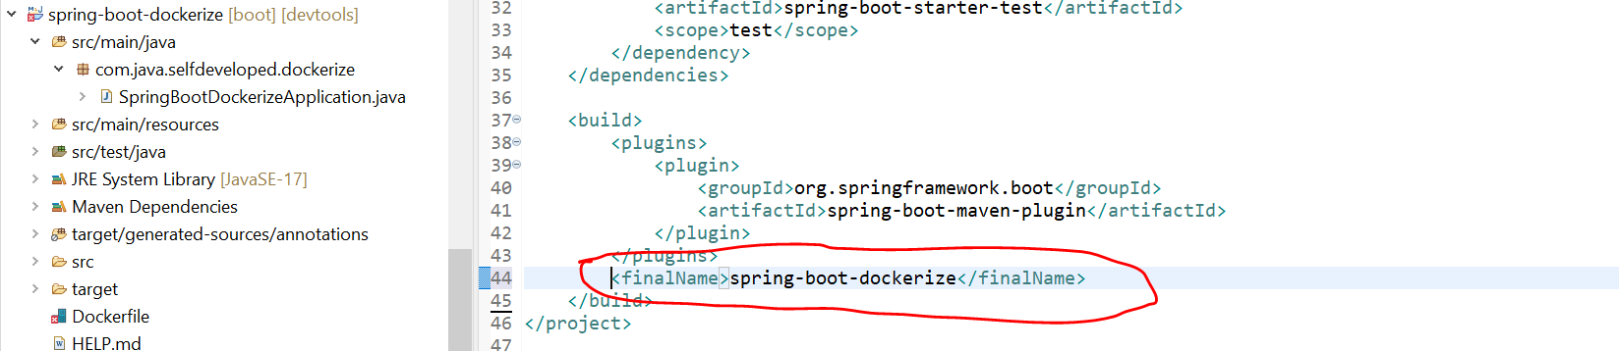

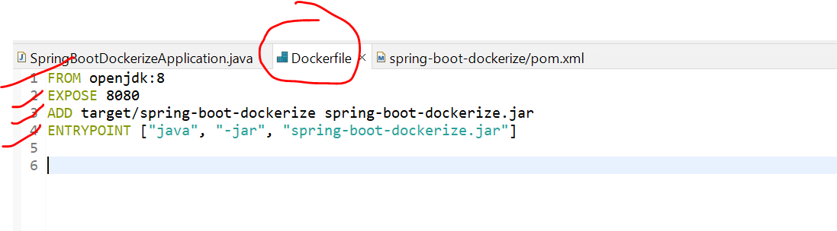

**Run As-> Maven Install**

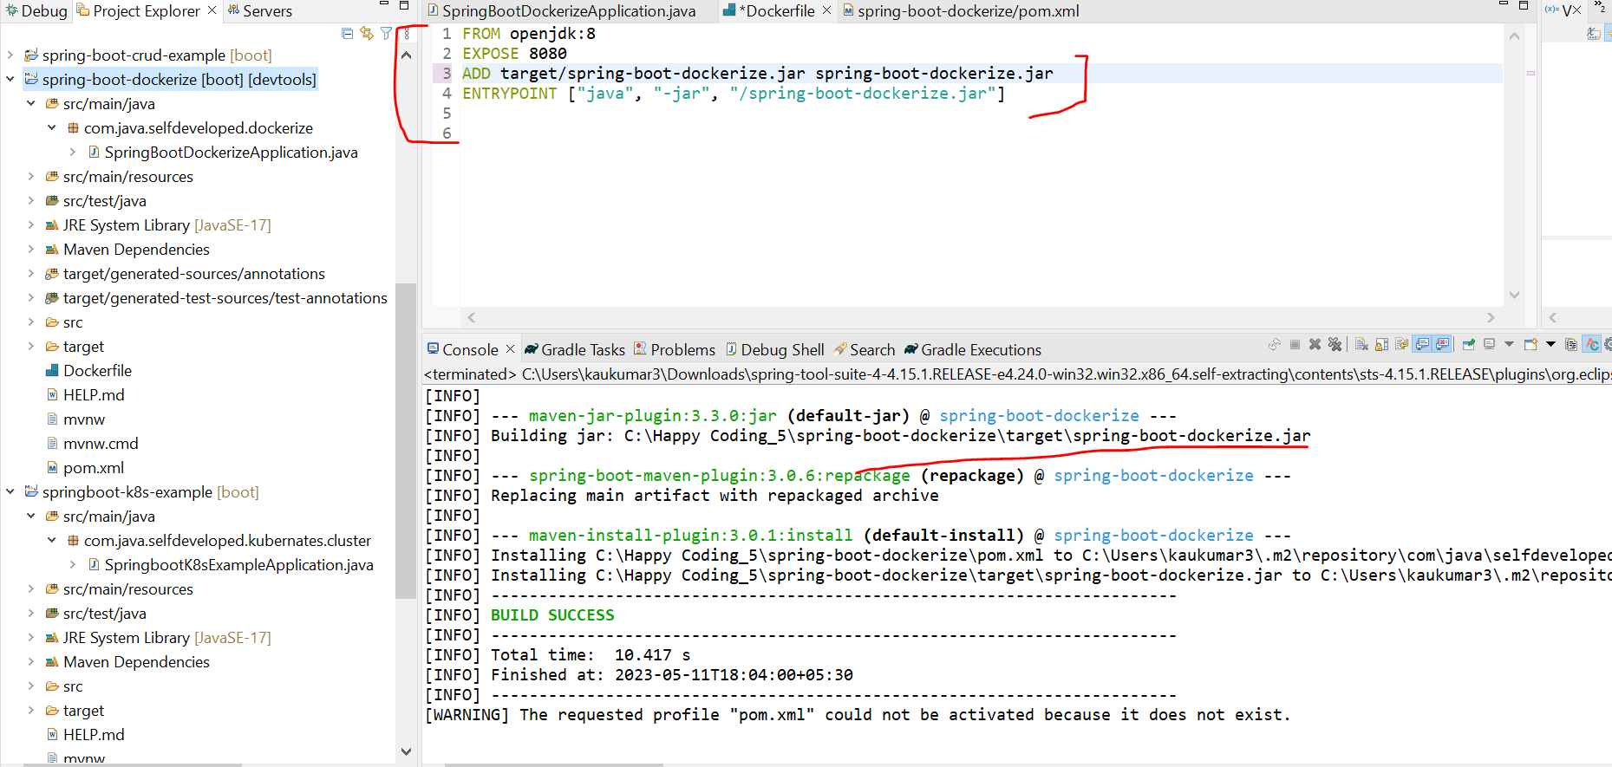

If u observe it generated the jar with

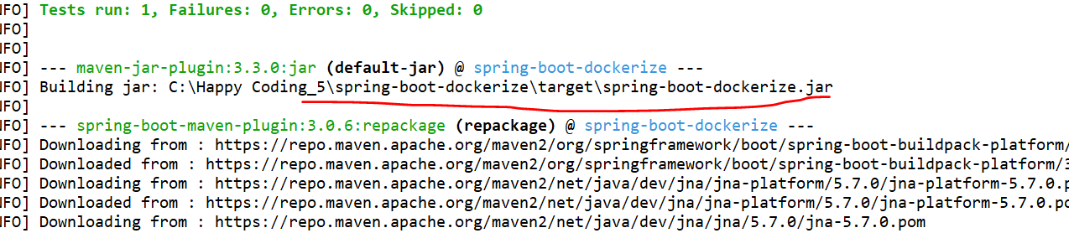

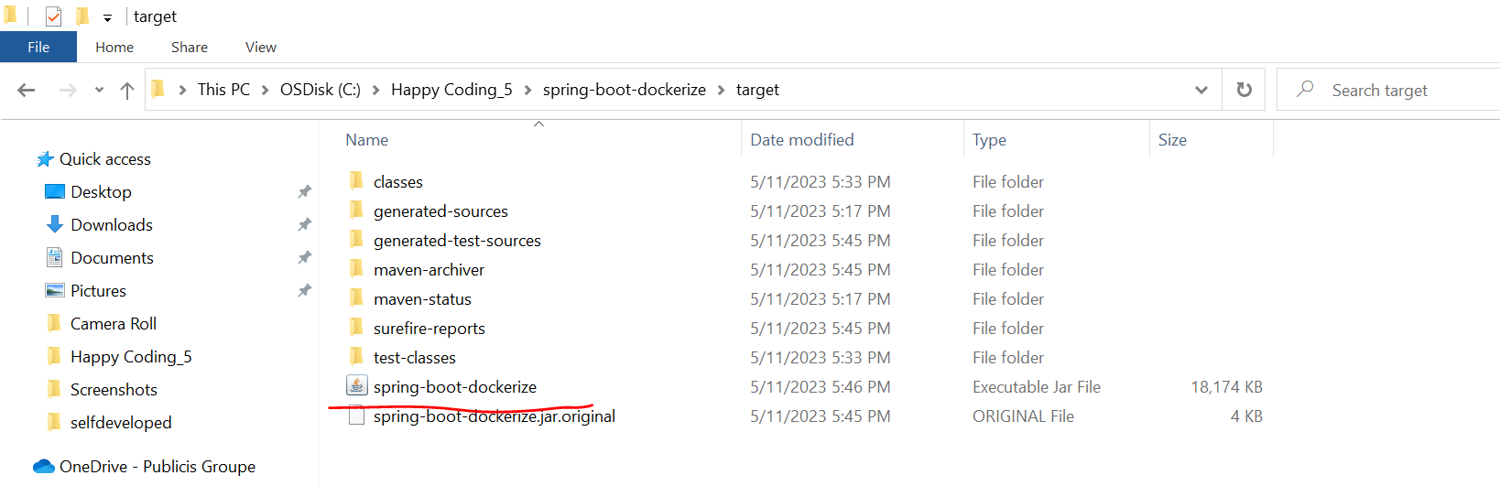

**To create the docker image we need to write the docker command**

**-> docker build -t spring-boot-dockerize.jar .**

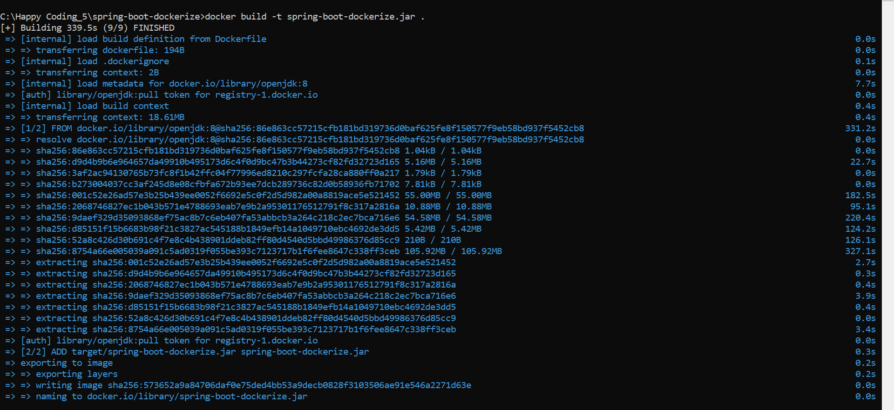

here docker image created successfully, to check the list of docker image command is:

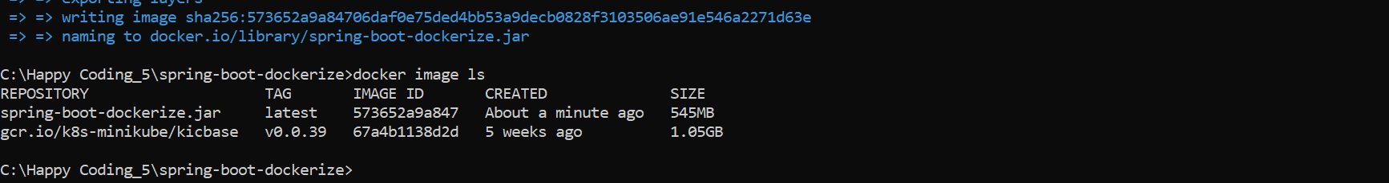

Now we need to run this docker image

* **-> docker run -p 9090:8080 spring-boot-docker.jar**

this is our **spring-boot-docker.jar** docker image name.

now we need to run this docker image ok so to run this docker image we need to type docker run with port I am giving something like 9090 and this is my local port 8080 which we mentioned in our docker file to expose, so this port 9090 will be run on container we can able to see we can able to access our rest api then give your docker image spring boot docker dot jar so if you observe spring boot docker jar is my docker image name, so docker run port then 9090 container port and this is my local port ok then spring boot docker dot jar is my docker image name so let's run it first let me go down you can see here this is the spring banner so the local application our spring boot microservice application is up now ok you can able to access in your local port

with 8080 and even you can able to access it with the container one 9090 ok so if you observe by default it will run on 8080 with which port we are exposing it ok so now once this docker image is deployed in container we can able to access it ok with the port 9090 let's check it let's go to the browser type here http localhost 9090 then our URL of the rest api let me check the URL

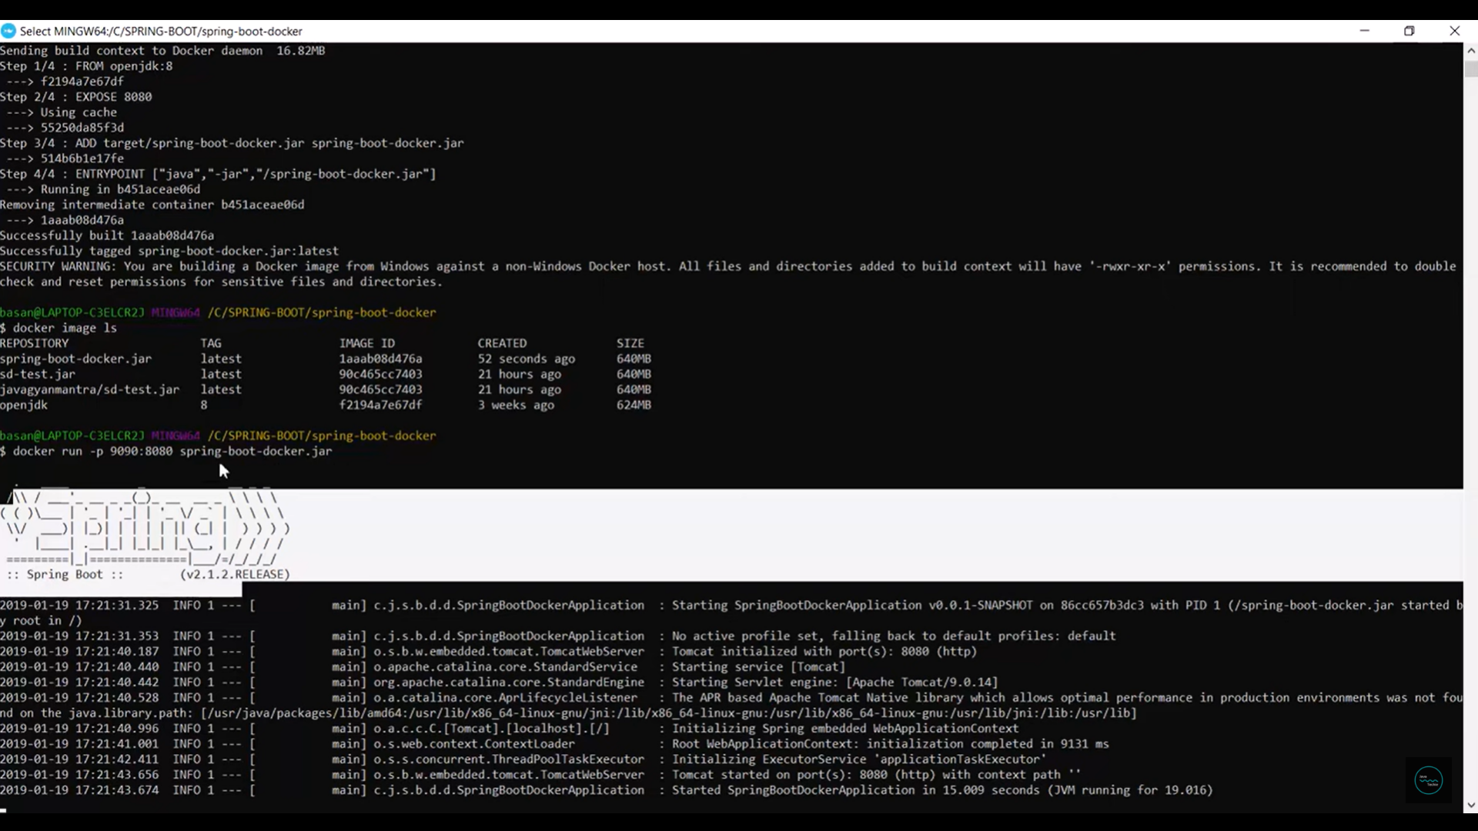

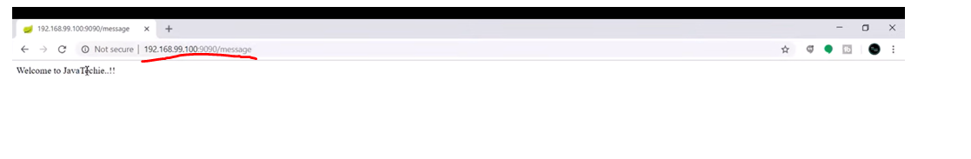

first we have the URL message ok so let me copy it here so http localhost 9090 is our port but here instead of localhost we need to provide the IP address which we configured at the time of installation ok so if you observe in your docker terminal the first statement is docker is configured to use the default machine with the port 192.192.100 this is the from range we provided right so let's do that so go to browser once again ok here change the localhost to the IP address ok 192.168.99.10 ok then our actual port now hit the URL we are able to access our API welcome to JavaTechie ok

similarly as the default port is 8080 with which we are exposing our rest API go to the localhost 8080 slash message ok we are able to access with our local URL local port as well ok so this is how we can create the docker image and we can run in the docker container ok so that's what the docker is and we did the we dockerize our spring boot application ok so let me go to the workflow again this is the docker workflow we created docker file and we created the docker image and we up our instance in our docker container and we are able to access it with the port 9090 ok so this is what the dockerization ok so in my next tutorial we will push our docker image to docker hub and we will do the pull from the different server ok so we only cover this part and push your docker image to hub and again pull it

**Kubernates**

Kubernates is an open-source container orchestration-engine or **container management tool** it automates deploying, scaling, and managing containerized applications.

So, if u observed the term container management tool this is self-explanatory that Kubernates will manage your containers at run time.

Explanation-

**Container**- as we know Docker is a Container where you can run any application like java, node js or angular. Kubernates will manage those applications which is running on your docker container.

**Management**- When I say Kubernates manages the applications it means Kubernates will take care of deploying, scaling, scheduling, and load balancing your applications which is running in our docker containers. That’s why this is called as a container management tool or container orchestration engine. This is what the containers activities deploying, scaling, scheduling, and load . on behalf of you Kubernates will take cares these activities if you are running your application on container platform.

**Tool**-

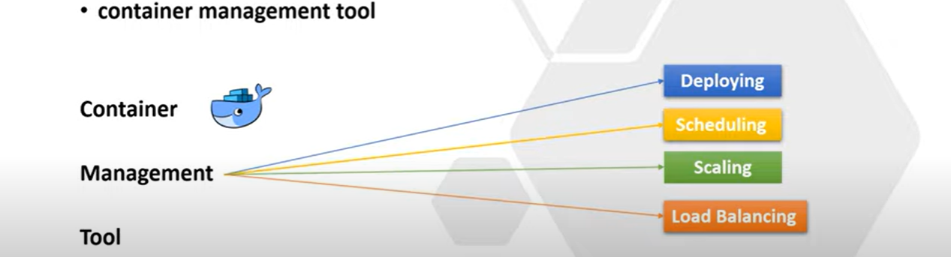

**Use Case**- why Kubernates came into picture.

Let’s say I have 2 microservices **Microservice**-**1** and **Microservice**-**2** and each microservices connect to their own databases. Both the microservices can communicates with each other using kafka messaging queue and now I want to run the entire application in a container like docker. So what I need to do.

-> first, I need to Dockerize the Microservice-1, since this is my spring boot application, so I need to create the docker image of microservice-1 which is nothing the dockerizing the microservice-1. Then I will deploy the microservice-1 in a **container-1**.

-> similarly, I need to Dockerize the Microservice-2 then I can run it in a **container-2.**

-> Then I can take the pull of kafka Image from Docker Registry or Docker Hub. Then I can run the kafka instance in **container-3**.

->Similar way I can take the pull of Database image from Docker-Hub, and I can run this particular database instance in **container-4**.

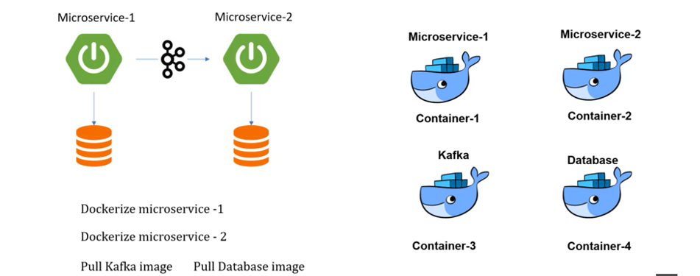

So, this is how I can run and deploy the multiple applications to multiple containers. Here I can able to manage the containers as well bcz the count is very less. But practically in real time we are not playing with only 4 containers. We are using n number of containers for each application. If you consider any Ecommerce application like Walmart, flipkart or amazon they use multiple containers to ensure availability so there is no application down time. Scalability to achieve the high performance. They must need to use multiple containers and its not easy to manage that much containers manually. When I say manages means it includes deploying, scheduling, scaling, load balancing, monitoring and batch execution all these things is difficult to manage manually.

That’s why Kubernates came into picture. You just write your code and push your image into container like docker then everything Kubernates will take care.

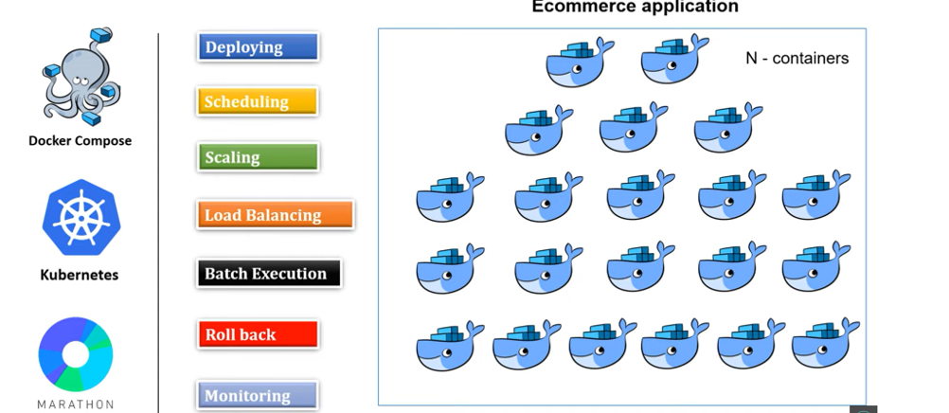

In the above tutorial, we just discussed the basic introduction of Kubernetes, right? Where you understand what is Kubernetes and why we need it in the microservice world So now let's move one step ahead and deep dive into components of Kubernetes.

Before we start let me tell you this is very important session You must need to know each component before you start working with Kubernetes.

**K8S Components Explanation**

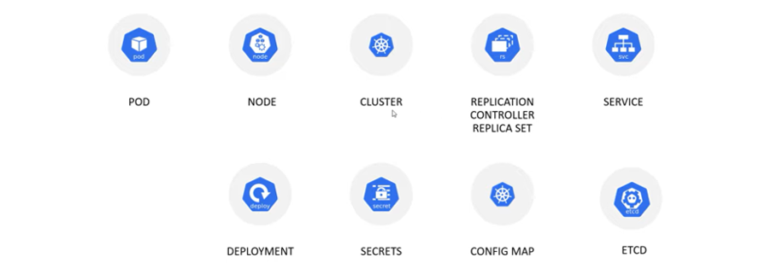

So, these are the Kubernetes components **pod, node, cluster, replication controller and replica set Service, deployment, secrets, config map and etcd**. Okay. So, these are the Kubernetes components

**POD & Node & Cluster-**

I will explain each and every component. Let's begin with what is pod and node Okay in Kubernetes, we are not interact with container directly. The containers are wrapped into a functional unit that is called pods Okay And a pod can have a single container or it can have multiple container inside it and each pod associated to a single IP address That's how one pod can talk to another pod and there is another virtual or physical machine where all pods wrapped into it that is called node Okay, so a node can have a single pod or it can have a multiple pods okay, now again multiple node wrapped into another physical unit that is called cluster so cluster either can have a single node or it can have multiple node .Kubernetes cluster are comprised of one master node and a number of worker nodes. These nodes can either be a physical computers or virtual machines depending on the cluster you created Okay, now if you'll try to understand from backward direction we have a cluster and inside the cluster we can have a single node or multiple nodes and inside each node you can have a single pod or multiple pods and inside a pod either you can have a single containers or multiple containers Okay, so far at high level we understand what is pod, node and cluster Right

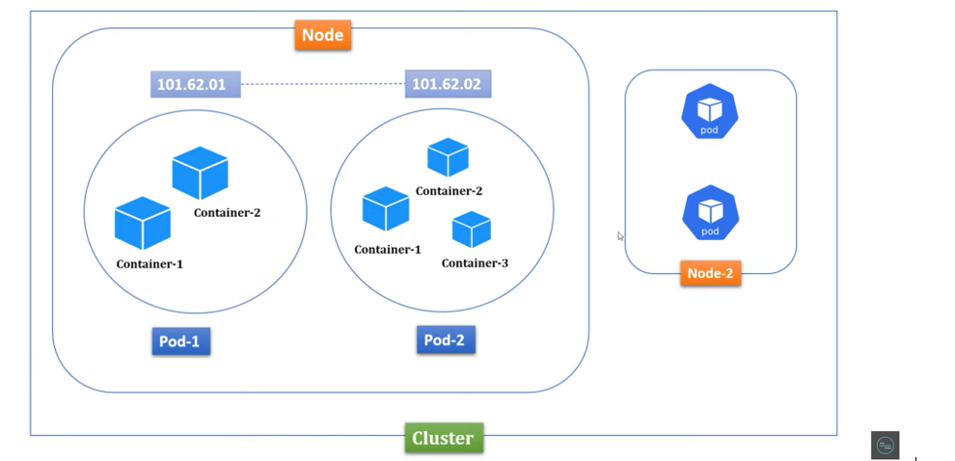

**Replica Sets-**

As you understand in previous slide that pods are running inside a node and each pod associated to a unique IP address Now let's assume I have pulled database image and running that containers inside a pod so let me name this pod as a database pod Okay, as you know each application always need to interact with database But let's assume due to some memory or CPU problem my database pod got crashed Now how my application will handle all the traffic which is coming to this database pods Which is not running, it may leads huge cost impact to my application, isn't it? So how to overcome this or how can I ensure that there is no application downtime That's where replica set component came into picture Which will act as a replica or backup of your pod For example, let's say I created three replica for my database pod When any of your pod will crash Immediately Kubernetes will bring up the new pod from replica set And it will assign a new IP to that specific pod You can create as many replica you want for a specific pod And these things you need to specify at the time of creating the deployment object I will talk about deployment object in a moment So far we understand how this replica set works, right?

If there is any pods goes down or some pod got crashed Immediately it will replace a new pod with a new IP address .

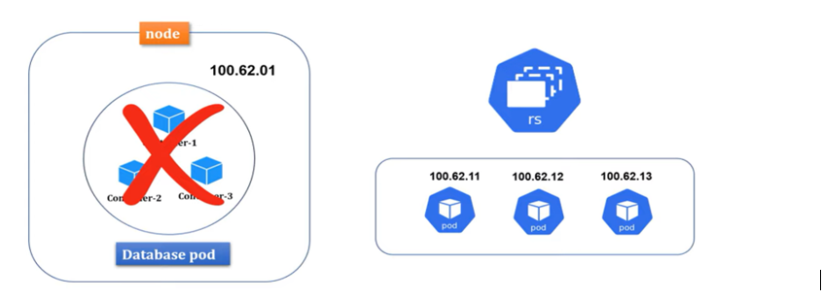

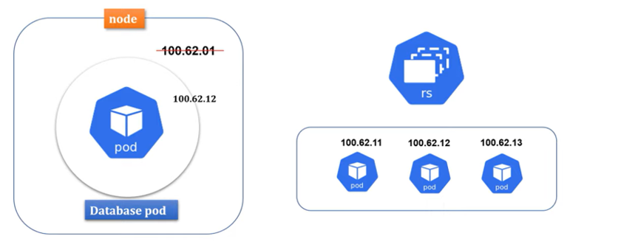

**Service-**

Now let's move into the next component that is service So as you know inside a node, we can have multiple pods. Let's name this pod as a front-end pod where my angular or client application is running and another pod I will name it as a back-end pod Where my server-side code or spring boot application is running and each pod assigned to an unique IP address That's how they can connect to each other, right?

Front-end pod can talk to the back-end pod using the IP address Also we understand if any pod die Then immediately replica set will bring up a new pod with new IP address but what if this will keep going? I mean due to some problem pods are keep dying and replacing with new pod with new IP address In such kind of situation my front-end pod can connect to the back-end pod Because IP is keep changing, right? That's where service came into the picture Now each pod will associate to one service or multiple pods can group together into a single service with label and selector I will talk about this label and selector in my future session with an example But for now let's assume one pod associate to one service, ok? Where service will provide a static IP and DNS name So going forward each pod can talk to each other using DNS name Rather than using the IP address, ok? Let's say if back-end pod down Then under the replica set will replace a new back-end pod It won't impact to the front-end pod Because front-end pod still can able to connect to the back-end pod With service DNS name Because the life cycle of pods and service completely different That's pretty cool, isn't it? Apart from managing the service discovery role Service also play the role of load balancer Where traffic coming to your pods will be handled by service Then service will redirect to available pods based on your loads There are different service type used in Kubernetes Like cluster IP, node pod and load balancer This service differ by how you expose your pods internally or externally And how you handle the traffic So I am not going to deep dive types of service now We will understand this in our coming session with an example So I hope you understand enough information about service component.

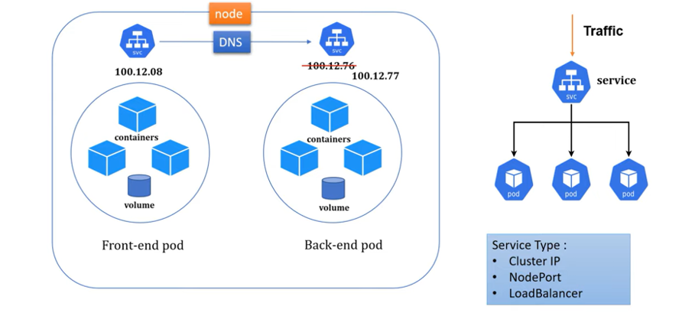

**Deployment-**

Now let's move into the next component which is deployment. Deployment are Kubernetes object that are used for managing pods. You can scale your application by increasing the number of running pods or you can update the running application using deployment object Also you can configure number of pods, CPU, memory, everything Through this particular deployment object If you can observe below command

**kubectl create deployment first-deployment -image=<DOCKERIMAGE_NAME> --port=8080 --replicas=4**

Here we are telling to the Kubernetes that create a deployment object With name first deployment Then pull image from local docker repository or from docker hub And then create an active pod with 4 replica pods Which you can consider as a just a blueprint or backup of your actual pods So instead of using this command to create deployment object You can also use the YML file which is nothing Deployment.yml file and you can create a deployment object with that. So in an example when we will do a Spring Boot cloud application I will show you how you can create the deployment object Using both command prompt as well as the YML file approach.

**Secrets & ConfigMap**

Now let's move into the next component which is secrets and config map First of all both secrets and config map use to store sensitive information of your application Like password, secrets key or API key Let's say I deployed one Spring Boot cloud application to Kubernetes Usually we do configure our database properties in Spring Boot application.properties file Or application.yml file Which is not secure If any changes done in configuration Again you need to rebuild your docker image Then you need to deploy it to the container Which is kind of rework for a developer Why not we will separately manage this sensitive info outside of our application Since we are using containerization platform Why not we will directly use Kubernetes component to store my sensitive information That's why to manage secrets and configuration of your application Kubernetes provided two components Secrets and config map These two are placed outside of pods If you observe Secrets and config map present outside of the pods So that inside a node if there is multiple pods They can point to the same secrets and config map They can reuse the secrets which they configured in the secret object

And the main purpose of using two different components to store sensitive information Is that where in secret you can add sensitive information with encrypted format However in config map it will store as a plain text Let's say for example you are configuring your data source properties Then only the password you can configure inside the secret And rest other URL, driver class name and user name You can configure inside the config map object .

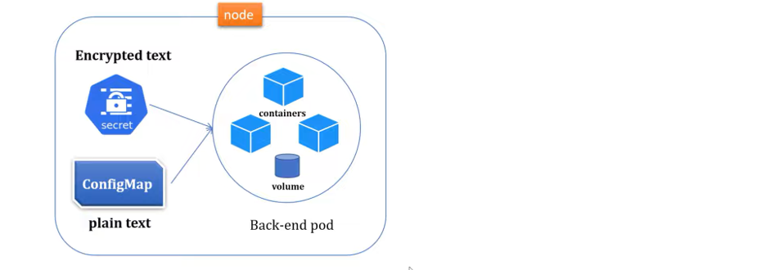

**ETCD-**

Now let's move into the next component Which is etcd, Kubernetes used etcd as a key value database It store the configuration of the Kubernetes cluster inside the etcd Also it stores all the secrets and config map data inside etcd database And the max limit is 1 MB to store secrets So this is what all about etcd, config map and secrets We will discuss more about these three components When we will deploy a cloud application to Kubernetes So I believe you understand good amount of context about components of Kubernetes So what all components we will learn today In my coming session we will demonstrate all with real time example.

**Kubernetes Basics & Architecture**

In the previous tutorial, we understand components of Kubernetes. Let me give you some basic overview about pod, node and cluster what we discussed in our last tutorial. As you know, in Kubernetes, we are not interact with containers directly. The containers are wrapped into a functional unit that is called pod. So, a pod can have either a single container or it can have multiple containers and each pod associated to a unique IP address that's how one pod can talk to another pod. And there is another virtual or physical machine where all pod wrapped into it that is called node. Okay, so a node either can have a single pod or it can have a multiple pod. Now again, multiple nodes wrapped into another physical unit that is called cluster. So, in a cluster, it can have either a single node or it can have multiple nodes. So, this is what we understand about pod, node, and cluster in our previous tutorial. Right. Now in this tutorial, let's discuss basic architecture of Kubernetes. Before we start learning the architecture of Kubernetes, you must have basic knowledge about its components.

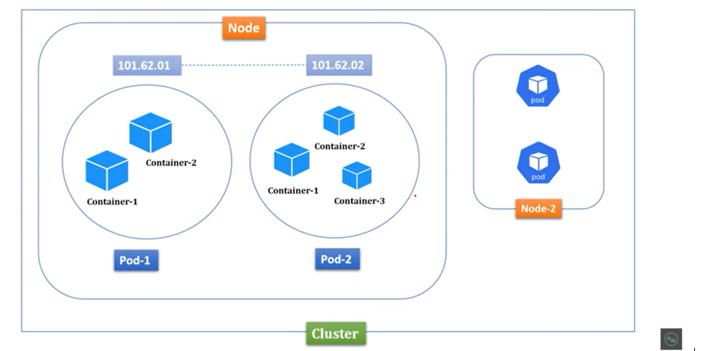

let's go through a simple example.

In an organization, there is a manager who usually manages multiple projects and each project assigned with multiple developers. Right. Now what is the role of manager here? Manager will monitor all the projects whether it is running smoothly or not. Also, manager will check whether all developers are working or not. Apart from that, if any developer left from the project, immediately manager will assign a new resource to that specific project. Similarly, if any project getting closed or completed, then all the resource from that existing project manager will tag them to a new project. Right, this is what a manager does. Now let's link this term to Kubernetes component.

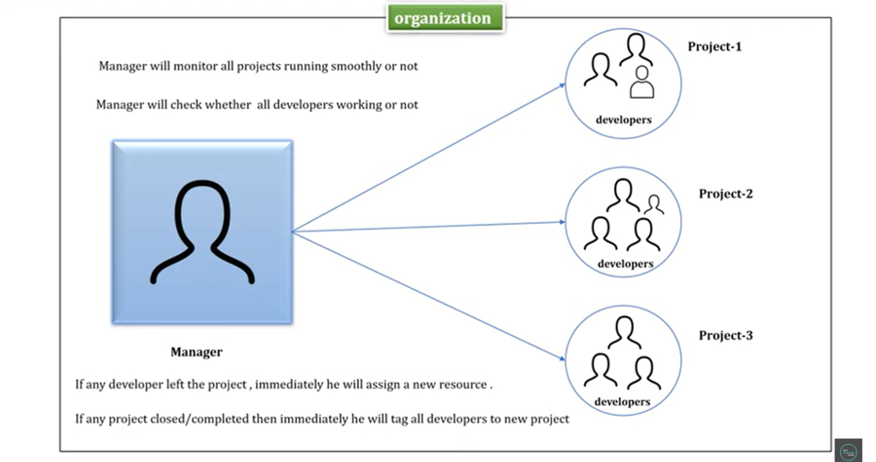

So, this organization, you can consider it as a cluster. And as you know, inside a cluster, we can have multiple nodes. So, you can consider manager as a master node and projects as a worker node. And also, we know inside a node, we can have single or multiple pods. Right, So you can consider developers as a pod inside a worker node. Okay. Since master node act as a manager, what you will do? Master node will monitor all the nodes whether it's running smoothly or not. It will monitor their health, resources, and memories. Master node will check whether all the pods are working or not. Similarly, if any pods are down inside a node, immediately he will assign a new pod with a new IP address. In case if any nodes are down, then immediately he will tag all the pods from the existing node to a new node. So, this is what all master node does.

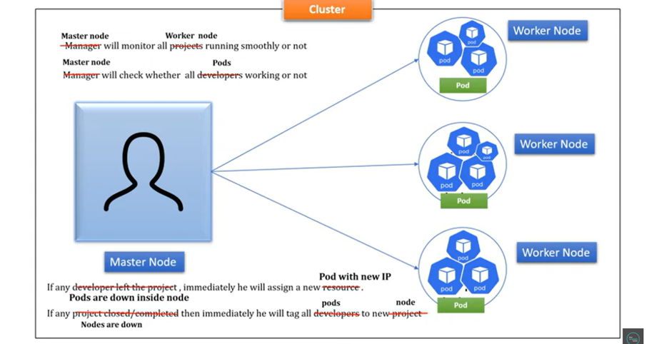

In Kubernetes, there should be a minimum single cluster and inside a cluster, there should be at least one master node and one worker node. Hope this concept is clear for you. This is what the basic architecture of Kubernetes. Now let's go deeper to understand more about components of master node and worker node. And also, we'll understand how master node will communicate with worker node.

**Master node and its components**

As you understand, master node manage the cluster and it basically monitors node and pod inside a cluster. Master node has four components, API server, scheduler, controller manager, and etcd database. We'll discuss each component one by one. Let's begin with API server. So, this API server will act as a cluster gateway. Each request coming to your cluster will first serve by API server. Basically, API server expose few API to access all the operation going on inside a cluster. You can access API server either using command line tool, which is kubectl or you can use Kubernetes user interface. Let's say I want to check health of my pods or nodes. Then simply I can run the kubectl command kubectl get nodes or kubectl get pods. Once I run this command, request will not go directly to your worker node. Just the request will be intercepted by API server. Then API server will check all the worker node and pod running inside it. Then it will give you the status of your pods and nodes. Okay. So, this is what the API server does in master node. It will just act as a cluster gateway, or it will just act as an entry point of your master node. Okay. Now the next component is scheduler. Scheduler usually plays a critical role in a master node. It usually schedules pods across multiple nodes. For example, let's say you have two worker nodes, and you want to scale up your application. So, for that, definitely you have to increase pod count, right? That's where the scheduler helps you. What scheduler does, it will go and check memory and CPU usage of each worker node and based on availability, it will schedule pods to that specific node. And if you observe the first worker node utilized 90% of its CPU and the second worker node already utilized 30% of its CPU, then the scheduler will schedule the pod inside the worker node 2, not inside worker node 1 because this worker node 1 already used 90% of its CPU and this worker node 2 is free here, right? It only used 30%. That's how scheduler take the decision on which node new pod should be scheduled.

Now you might have a question. How does the scheduler know all the information about node and pod, right? As you know, Kubernetes internally use an etcd key value pair distributed database. It stores all the information about your cluster and its states and from etcd, API server fetch all the cluster info and you share that information to the scheduler. That's how the scheduler works. Now the next component is controller manager, which is another crucial component. So, what controller manager does is it detects cluster state change like pod crashing or node crashing. When a pod crashed, then immediately Kubernetes bring up a new pod from replica set and then controller manager will talk to the scheduler to schedule a new pod to a available nodes. Okay. And again, controller manager manages to the multiple controllers like node controller, replication controller, endpoints controller, service account and token controller, where node controller monitor and respond all nodes activity, replication controller monitor health of pod. If any pod goes down, then immediately you'll take the action. Endpoints controller is responsible for manage all service and their communication. Similarly, service account and token controller is responsible for maintaining account, API access and namespace. So these are four components of master node. Usually, they keep monitoring the health of your cluster. We'll practically understand this when we deploy our first application to Kubernetes.

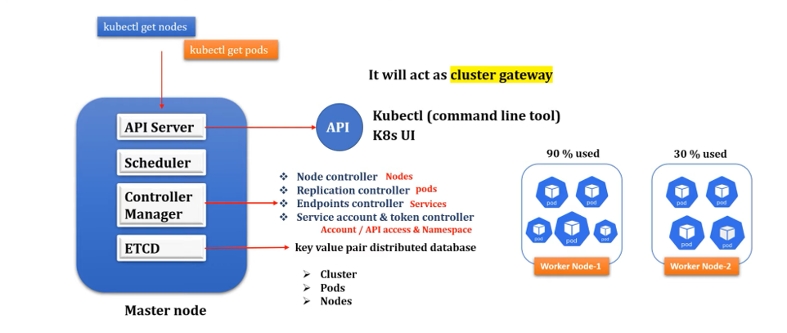

**Worker Node & its component**

As you already know, a worker node is nothing. It's just a virtual or physical machine. And inside a worker node, we can have multiple pod and each pod can have either single containers or multiple containers inside it. Right. Worker node has three components, kubelet, kubeproxy and container runtime. Let's discuss one by one.

Kubelet is an agent running on each node and kubelet communicate with master node using API server. The kubelet works in terms of pod spec. A pod spec is a YML or JSON object that describes all about your pods. So, what kubelet does, it takes a set of pod spec that are provided through various mechanism, and it ensures that the containers described inside those pod spec are running healthy. Okay, and this kubelet only manage the containers which was created by Kubernetes only.

Now the next component is kubeproxy. kubeproxy is a network agent which runs on each node and it is responsible for maintaining network configuration and rules. These rules allow network communication to your pods from inside or outside of your cluster. Basically, it helps you to expose your services to the outside of your world. kubeproxy also communicate with master node using API server.

Now the next component is container runtime. A container runtime also known as a container engine, and it helps to run containers which is running inside a pod. As you know in Kubernetes, we can't directly access the containers. So, all the containers are wrapped inside a functional unit called pods. That's where our application is running. Right, and these containers engine provide runtime support to all the containers which are running inside a pod. So, these are the basic component of Kubernetes worker node.

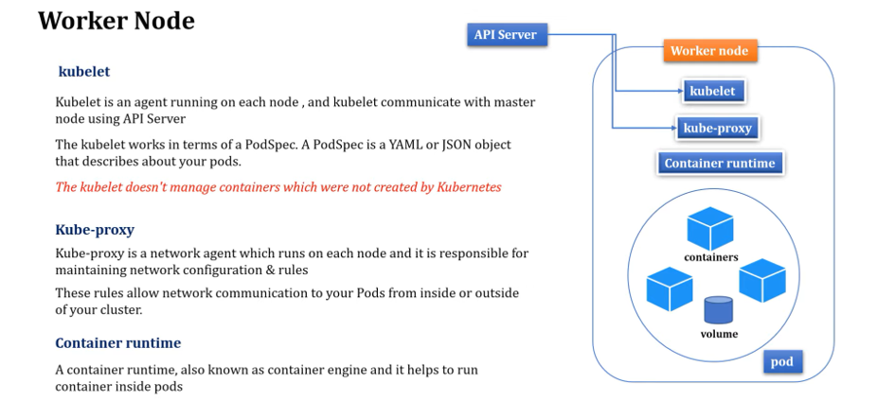

Now you understand what is master node and also you understand what is worker node. Right. And master node can communicate with the worker node with the help of API server. So, this kubelet and kubeproxy from worker node will communicate to the API server and they can share the information about all the worker nodes. OK So, this is what the basic architecture of Kubernetes. So, I hope you understand good amount of knowledge about Kubernetes components and its architecture.

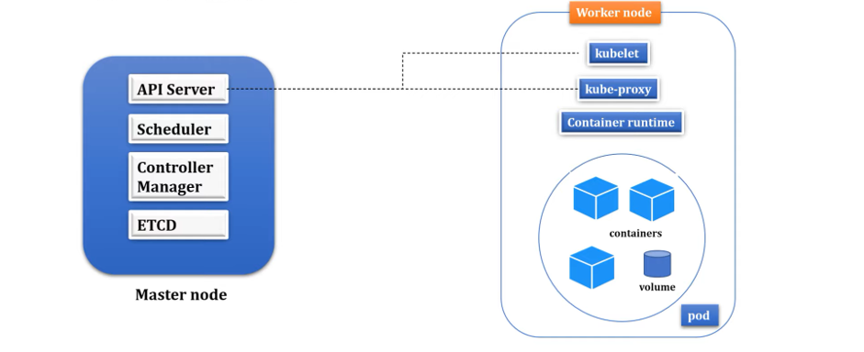

**Setup Kubernetes in Windows & Run Spring boot application on k8s cluster**

**Minikube Installation**

**>> What is Minikube**

**>> Minikube Installation in Windows**

**>> How to deploy first Springboot application to Kubernates Cluster.**

How to install Minikube in Windows operating system and also, I will demonstrate how to deploy your first spring boot application in Kubernetes cluster.

Before we install this Minikube, first let's understand what this Minikube is and why we need it. So let me quickly brush up the basic architecture of pod, node and cluster to explain you why we need Minikube. As we know, In Kubernetes, we have a cluster and inside this cluster, we can have either single node or we can have multiple nodes and inside this node, we can have a single pod or we can have multiple pods inside this node and again inside this pod, either we can have a single container, or we can have multiple containers and this container is the platform where you can run your application. The application can be spring boot, or it can be angular or any technology specific application, you can run inside containers which is present inside pods.

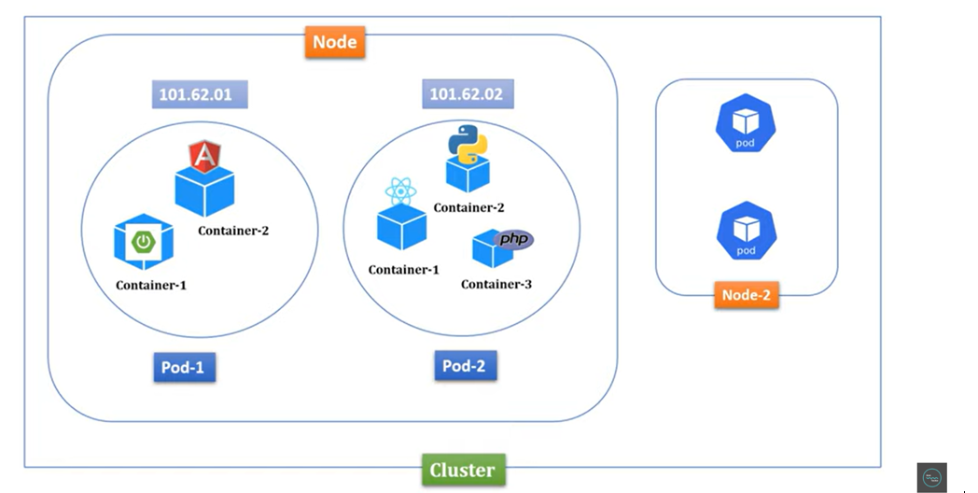

Now if you understand this basic architecture to run an application in Kubernetes, you need this cluster infrastructure like you need pod nodes in your machine. How will you get this infrastructure? That's where this Minikube utility or tool came into picture. To run Kubernetes cluster in your local machine or computer, you need to install this Minikube tool. Minikube runs a single node Kubernetes cluster on your machine so that you can try out Kubernetes for your daily development work. So, if you install Minikube, then you will get a cluster and node, then you can host any containerized application inside it. So, let's try this out.

**install kubectl**: https://kubernetes.io/docs/tasks/tools/install-kubectl-windows/

**install Minikube** : https://minikube.sigs.k8s.io/docs/start/

**install Docker Desktop** : https://docs.docker.com/desktop/install/windows-install/

First step, we need to install Minikube. So let me walk you through the steps of installation process. So, install and set up kubectl.

So, what kubectl does, kubectl is a command line tool. Using kubectl, we can connect to Kubernetes cluster from our local machine. So that's the reason first we need to install this kubectl command line tool. And for Windows, you can directly download the latest release version. Just click on this. It will download the kubectl.exe. Now next step, you need to install the Minikube utility for Windows. So just click on this Windows. This is what installing Minikube. Just click on this. Now if you scroll down, you can find this Minikube Windows AMD64. Just right click on it, open it in a new tab. Now if you scroll down, for Windows, yeah, this is for Windows, right? Minikube Windows AMD64.exe. Just download it. Once you download this, then as per the documentation, rename it to the Minikube.exe. So let me go to the download folder. And I'll just rename this to the Minikube.exe. Just click on the rename. And I'll just add Minikube. So, I can remove everything here. Fine.

Now the next step, Minikube and kubectl, these are the two exe files you downloaded. Now let me copy these two files. Then I'll create a separate folder inside any directory. So, I'll just create a folder inside C. Now I'll just create a folder with name. Let me open the folder. I'll just name it Minikube. Inside this particular Minikube folder, I'll paste these two exe files. Now go to the download. I just want to delete these two. Now if you go inside the C, inside the Minikube, we have these two exe files, kubectl and Minikube. Now to access these kubectl and Minikube directly from the command prompt, I need to set this path to my environment variable. So just copy this and just type in command prompt environment. You can see here, edit environment variable for your account. Just click on this. Then click on path. Click on edit. Just add a new. Just paste it. Okay. C colon Minikube. Now click on OK. Click on OK. Let me close this. Now let me open a command prompt. Then here I'll just type Minikube version. So, if you observe, this is what the Minikube version we just installed. Right And we can able to see that particular version. Now we are done with the Minikube setup in Windows.

**First you need to download the kubectl**

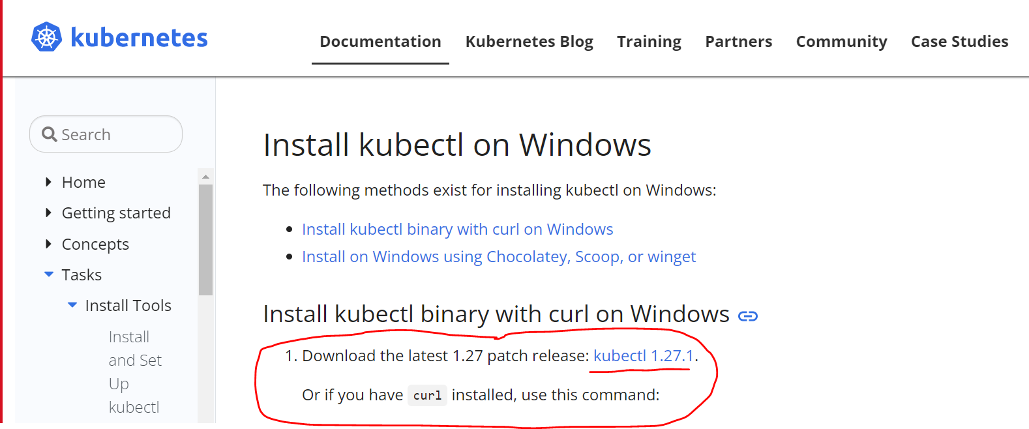

**Next you need to download the Minikube Utility for Windows**

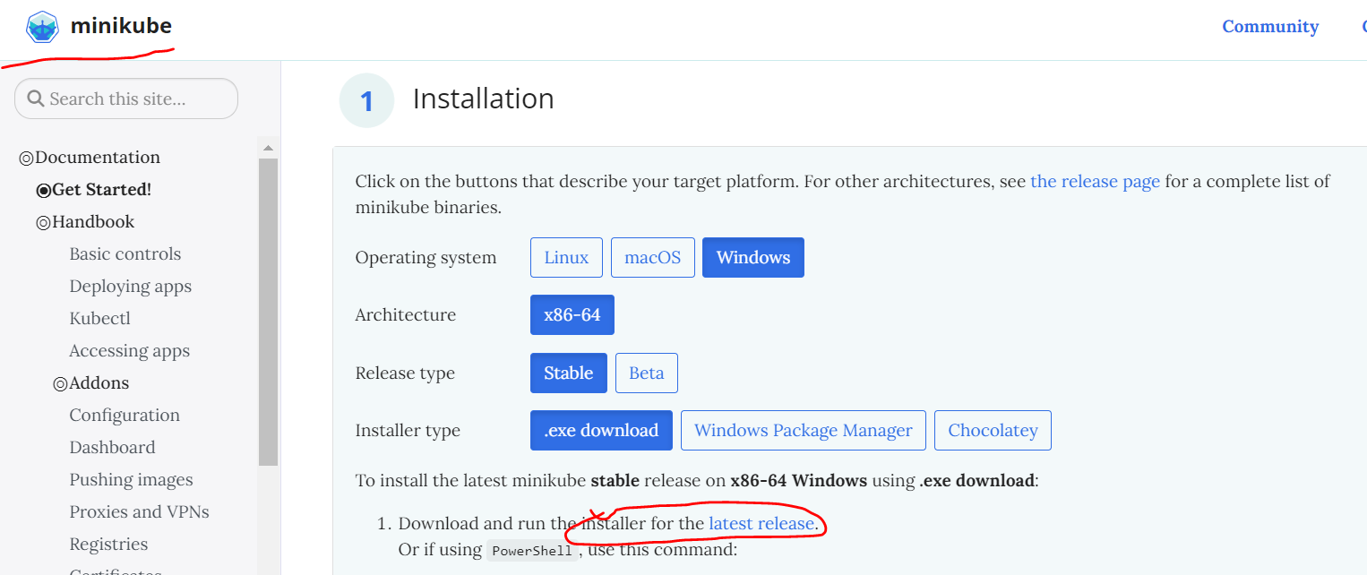

**Install Docker Desktop In your Machine.**

**Don’t enable wsl2 use Hyper-V for windows 10 for Docker Desktop**

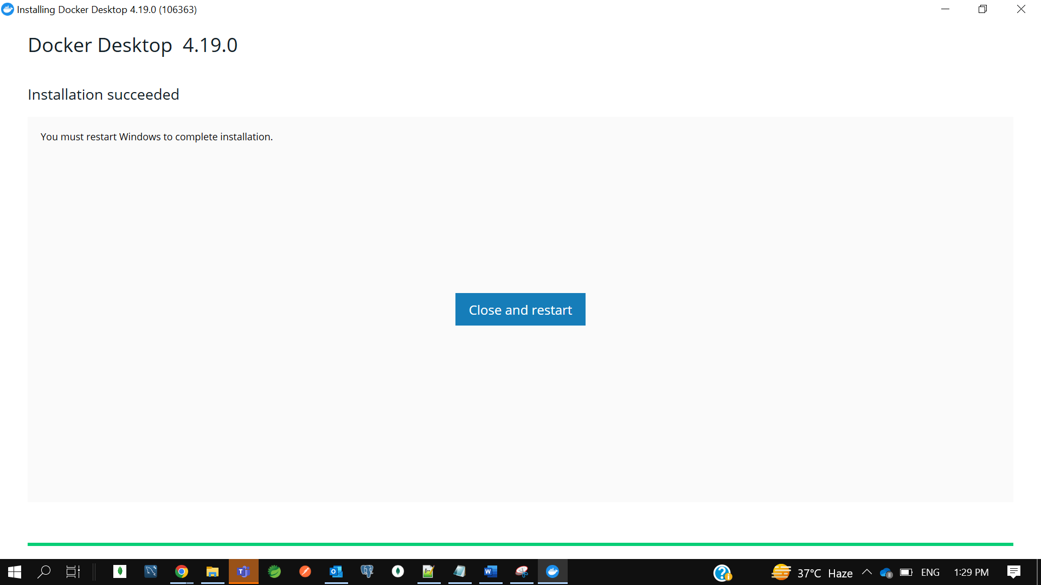

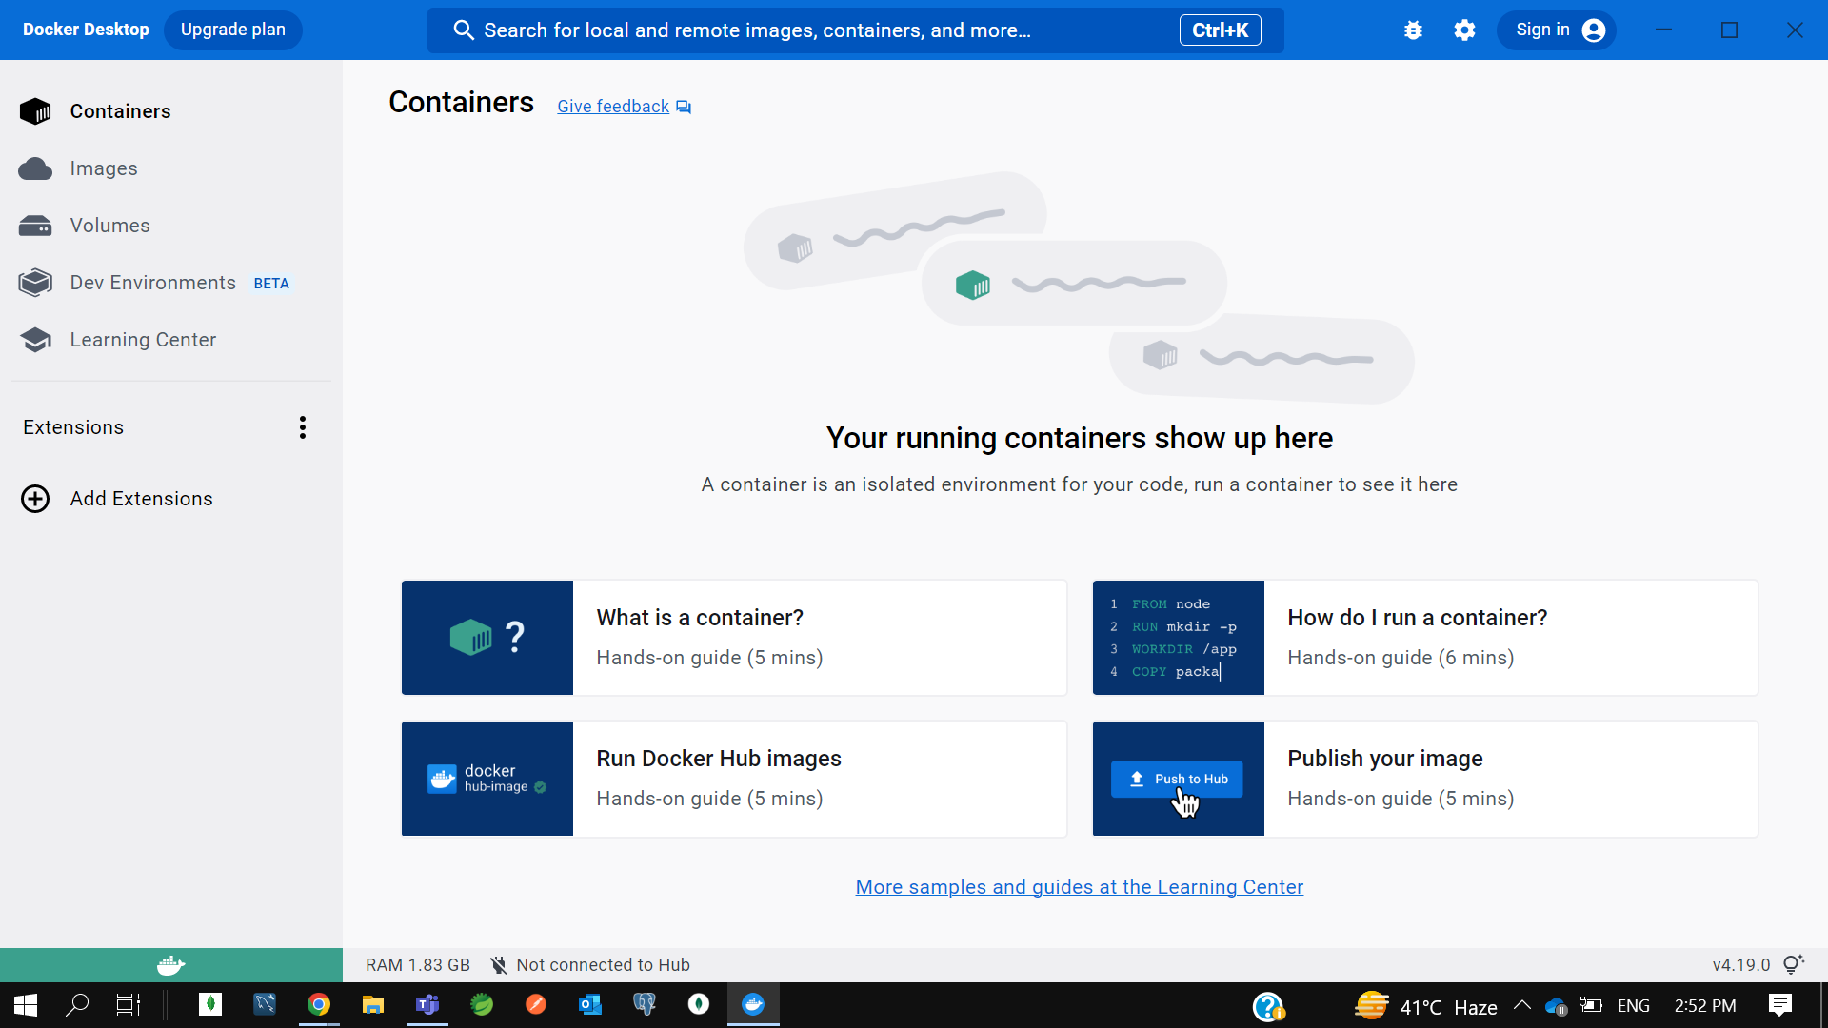

**To verify docker version---**

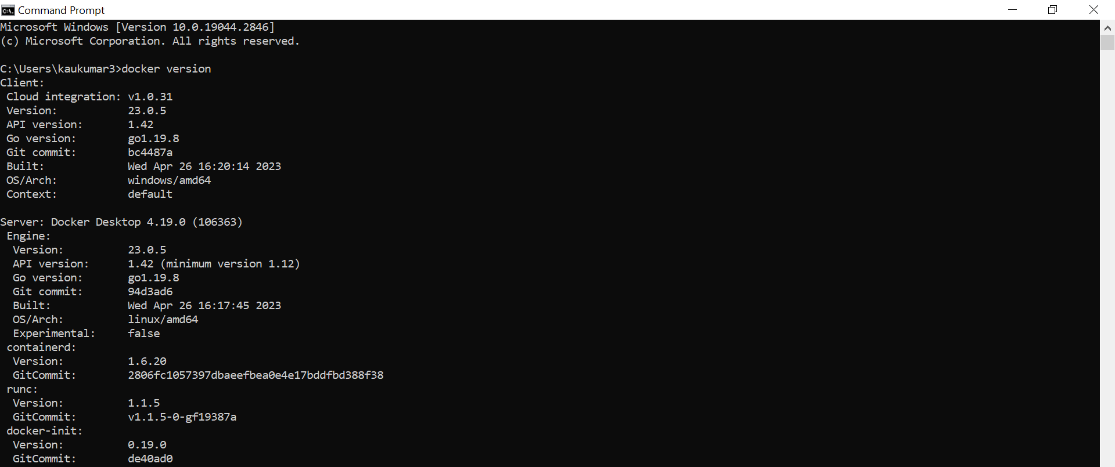

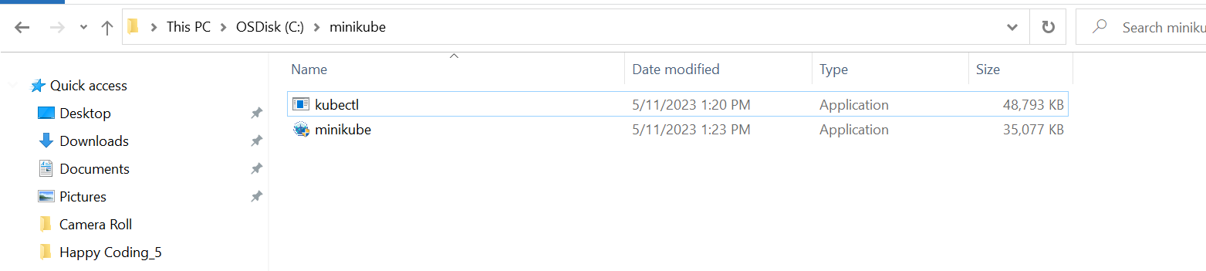

Environment-> User Variable -> Path-> C:\minikube

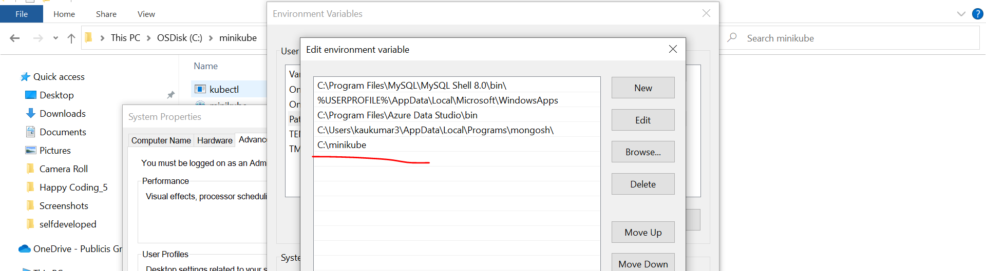

**If u verified the version using command prompt**

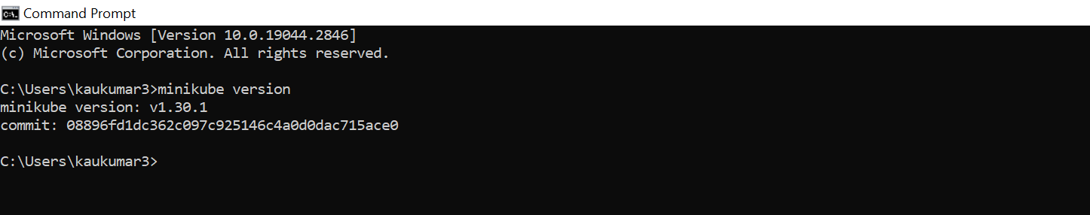

Now we have done with the Minikube setup in windows.

Now the next step, you need to start this Minikube. So, to start a Minikube, there is multiple drivers provided by Kubernetes. You can use any of them. Let me tell you all the available drivers to start a Minikube. Now if you'll go up, installing Minikube, there is a multiple driver**. You can use Hyper-V, you can use VirtualBox, or you can use Docker**. Now this Hyper-V will not applicable for all the Windows versions. If you are using Windows 10 Enterprise or Windows 10 Professional or Windows 10 Education, then only you can use this Hyper-V driver. Okay. If you want to use the VirtualBox, you should have enough space on your machine. Minimum you should have 16 GB RAM to use this VirtualBox.

Since I have installed Docker on my machine earlier, I can directly use the Docker as a driver to start the Minikube. So, to start Minikube with Docker driver, I can directly copy this command. Then I need to go to the command prompt, then paste it and then change the driver as a Docker here. Okay. But make sure Docker must need to be installed on your machine and it will up and running. Okay. Now let me run this command.

**-> minikube start --driver=docker**

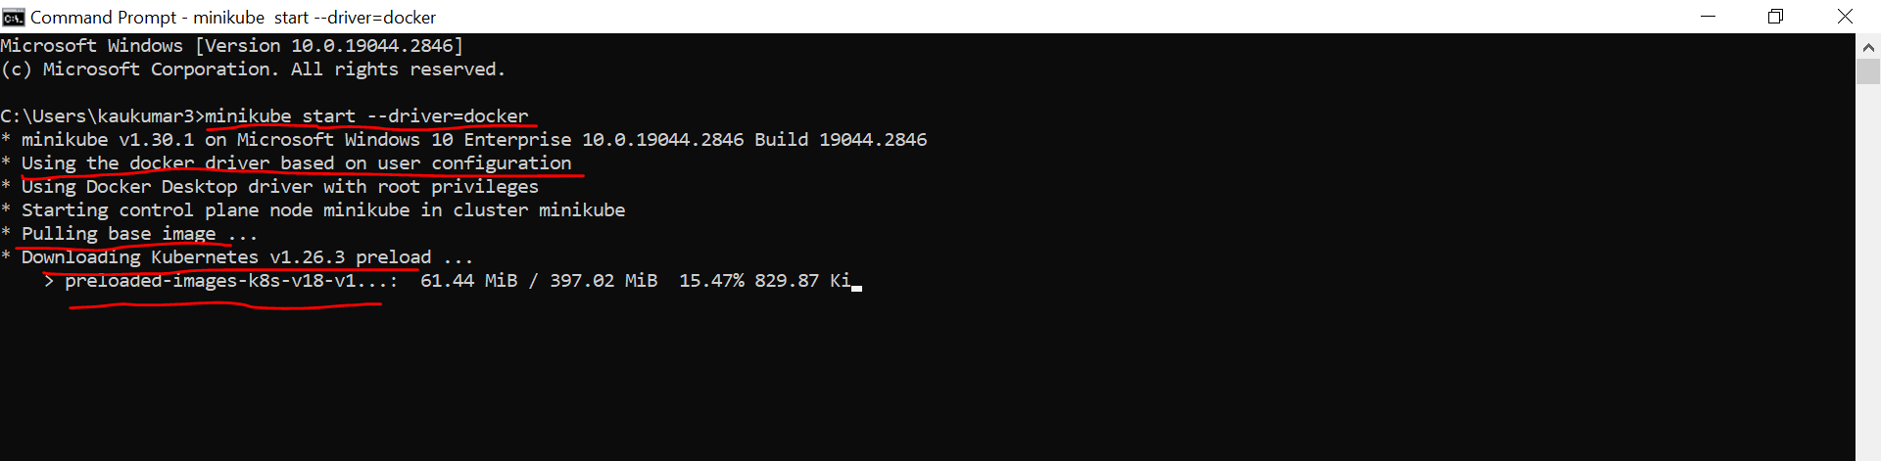

It will take few seconds or few minutes to start the Minikube. Minikube for me, it took 2 to 3 minutes when I tried it before. So, let's wait it to complete. If you observe here, preparing Kubernetes, this is what the version. Okay. On Docker 23.0.5, this is my Docker version. Okay. So, it almost took more than 3 minutes. Let's wait it to complete. So, if you observe, done. Kubectl is now configured to use Minikube cluster and default namespace by default. So, it took around 4.5 minutes for me to start this particular Minikube.

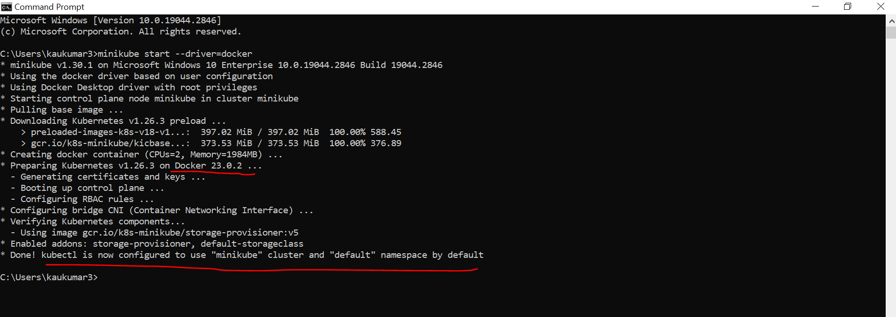

Now to verify Minikube started successfully, you can check Minikube status. Just enter it.

**-> minikube status**

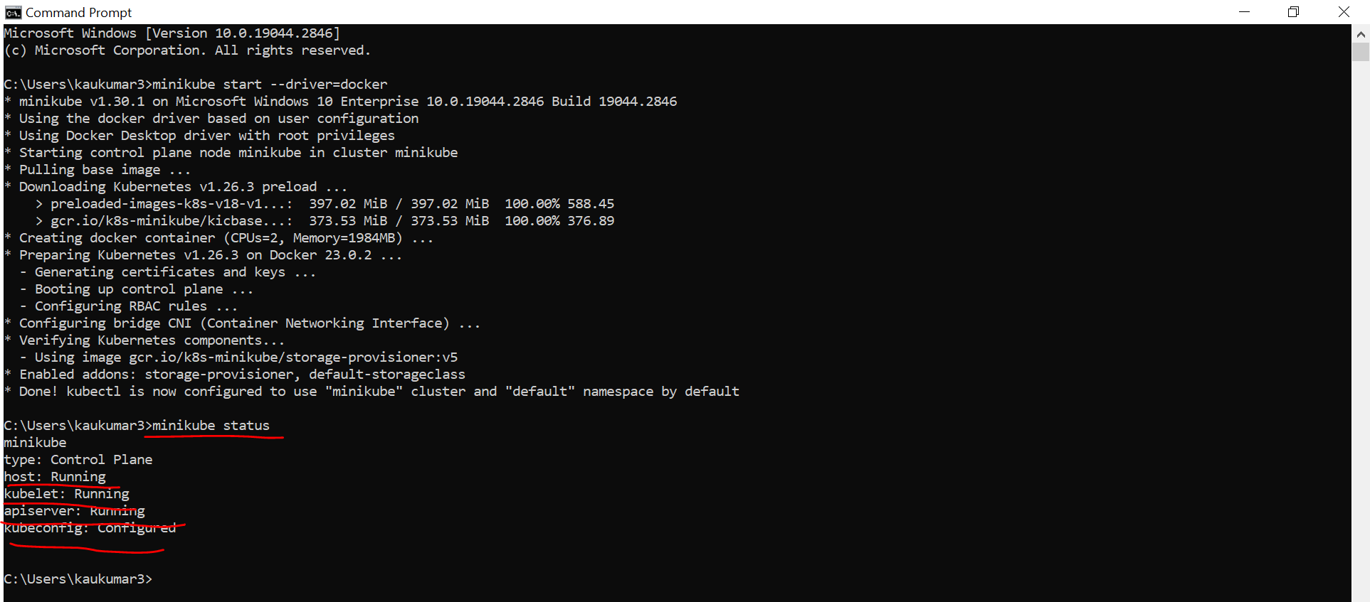

You can see here, host running, Kubelet running, API server running and kubeconfig configured. You should see this status. Okay. Then you can confirm that your Minikube started successfully without having any error or any issue. So, we are good here. We started the Minikube. Now as per the documentation, we understand once we start the Minikube, it will just create a single node cluster, right?

So, to verify that whether it created a cluster and a single node or not, what I can do, I can just type kubectl cluster info so that it will show me the information about cluster.

**-> kubectl cluster-info**

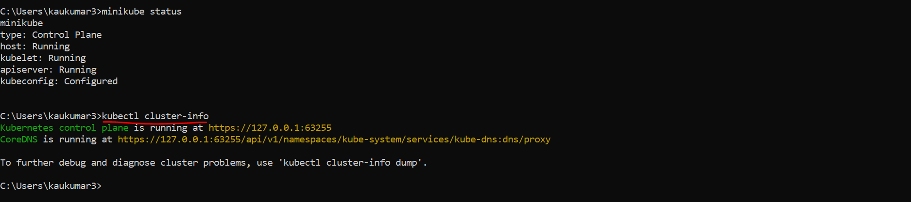

You can see here, Kubernetes control panel is running this, kube DNS is running this. This is what my cluster info. Now let's verify the node. It should provide us a single node, right? So, you can fire a command kubectl get node. You can see here, the name of the node is Minikube. Status is ready.

**-> kubectl get node**

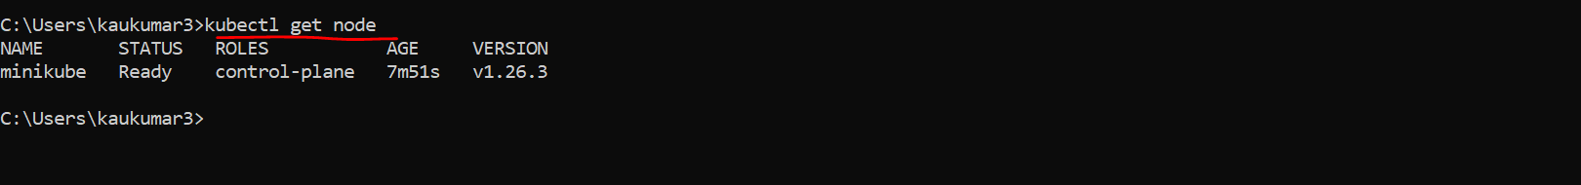

These are the roles and age. These are the version. So as per the Minikube documentation, it just provides us a single node cluster. This is what the node and this is what the cluster. Now we are done with our setup, Kubernetes setup in our local machine.

Now we are good to go with the deployment. Okay, so let's quickly create a Spring Boot project to deploy that to the Kubernetes cluster. Now let me go to my IntelliJ IDEA. Already created one small hello world kind of example where I have only one endpoint and I'm just exposing a string message here. Okay, congratulations successfully deployed your application to Kubernetes.

Application - springboot-k8s-example

Dependency - Spring Web

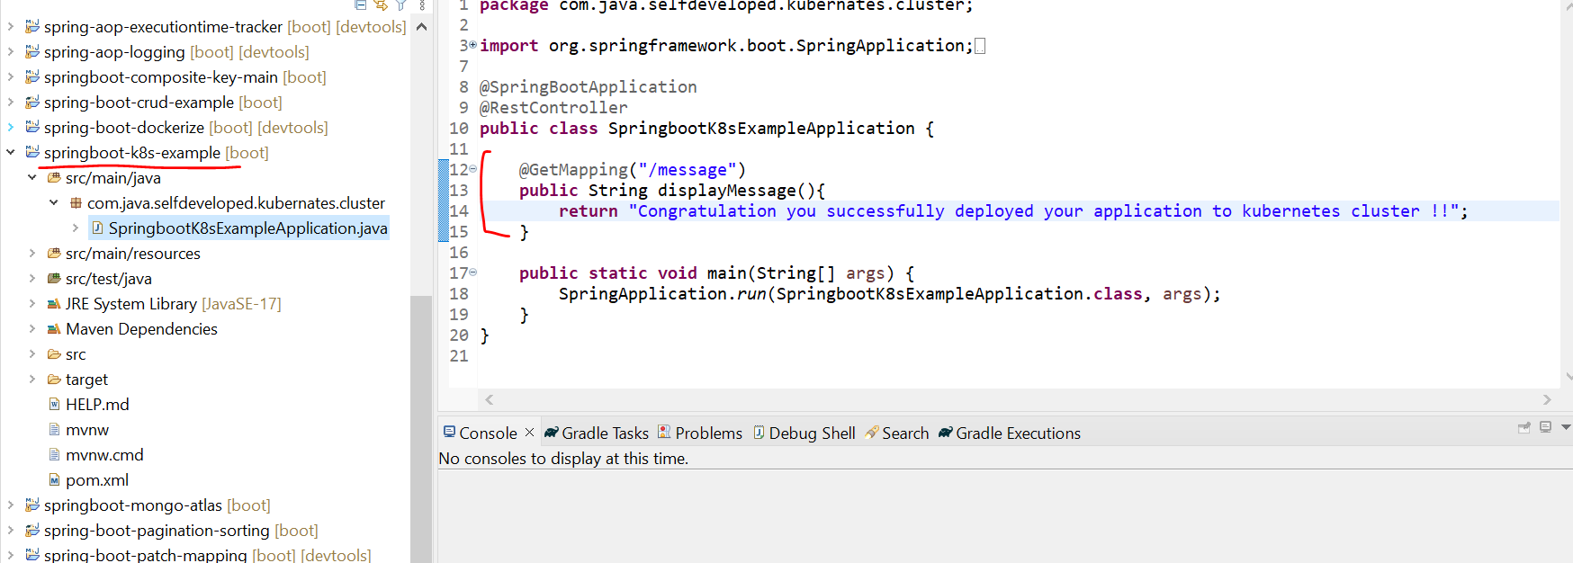

And also, If you observe, I just created a Docker file. Now the first step, I need to dockerize this particular application. Then from the Docker repo, I just need to pull this image and I just need to run it inside Kubernetes cluster. So first I need to dockerize this application.

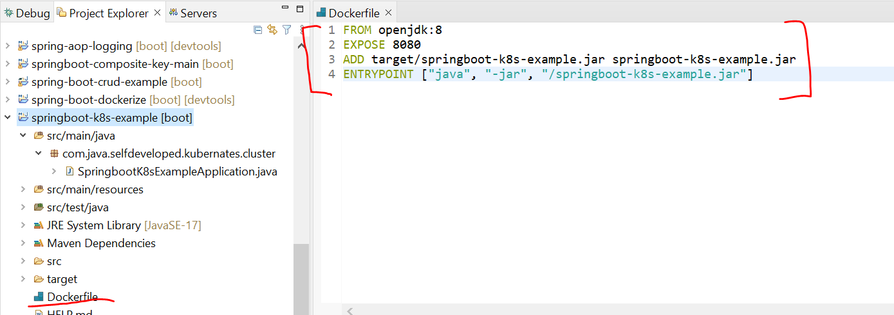

So, to allow Kubernetes to read your Docker repository, we need to run a command. We just need to fire a command Minikube and tell the environment which I am using. Okay, just enter it. Next just copy the last one and just add it, then execute it. Now Kubernetes can read your local Docker repository. Now if I type Docker images, you can see these images specific to the Kubernetes.

* **minikube docker-env**

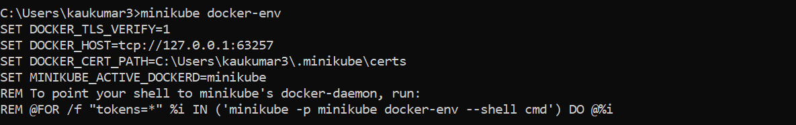

C:\Users\kaukumar3>@FOR /f "tokens=*" %i IN ('minikube -p minikube docker-env --shell cmd') DO @%i

C:\Users\kaukumar3>docker images

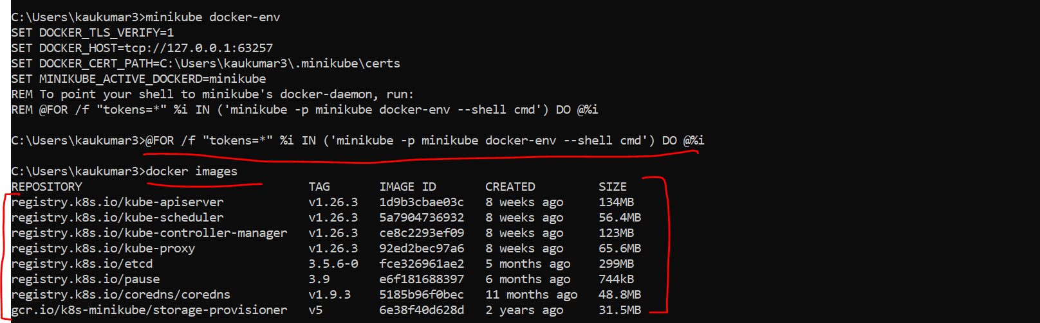

**Below are the master Node Key Components**

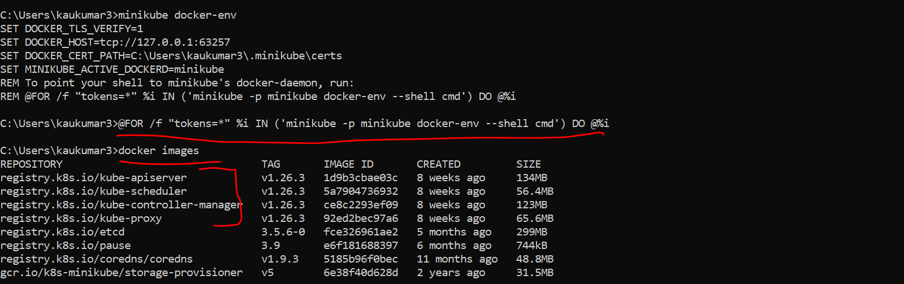

Kube proxy, Kube API server, Kube scheduler, Kube controller manager. These are the master node components, right? Then Kubernetes UI dashboard, etcd, matrix scrapper, something. There is a lot of Kubernetes images, right? Now we give permission to Kubernetes to read my Docker repository. Now we can create the Docker image of our application. So, what I'll do, I'll just move to the particular directory where I have this Docker. So, I'll just copy the path here. From here I can directly move to that particular directory. Okay, let me clear everything. Now I just need to build a Docker image of this particular application spring boot K8s demo and we have the Docker file here, right? This is the Docker file. Now let me go to the command prompt. So here **I'll just type Docker build-t then give the image name. So, I'll just give spring boot K8s demo or something like that. And I'll just specify the version 1.0 and root directory. Just enter it. It will take few seconds. It is creating the Docker image.** Yeah, so if you observe, it created the Docker image. Now to verify that you can type Docker images and you can see this image, right?

C:\Users\kaukumar3>cd C:\Happy Coding_5\springboot-k8s-example

~~C:\Happy Coding_5\springboot-k8s-example> docker build -t springboot-k8s-example:1.0~~

The above command didn’t worked for creating docker images so I tried below one which got worked

**To create the docker image we need to write the docker command**

**C:\Happy Coding_5\springboot-k8s-example>docker build -t springboot-k8s-example .**

For above one we need to add jar name

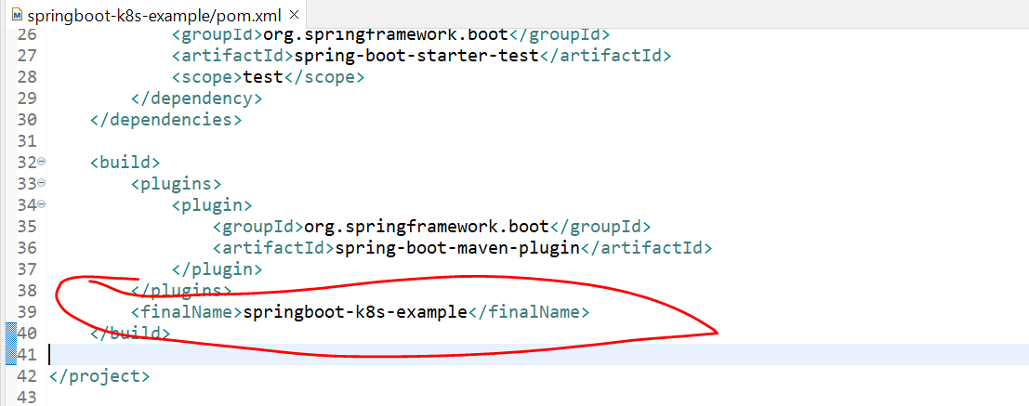

Then Run AS -> maven Install

Then **C:\Happy Coding_5\springboot-k8s-example>docker build -t springboot-k8s-example .**

To verify docker Images

**C:\Happy Coding_5\springboot-k8s-example>docker images**

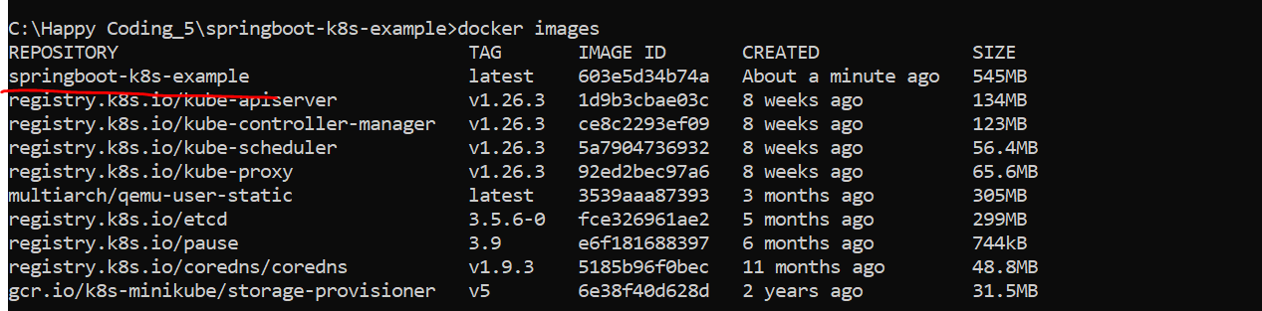

so, we have the spring boot image with us. Now we just want to run this particular image inside the pod, right? So, for that you need to create a deployment object. As you know, deployments are Kubernetes object that are used for managing the pods. We can describe deployment object details using YML file or you can directly use the command prompt. For this example, I will just use the command prompt. In my next tutorial, I will show you how you can create the deployment and service with the help of YML configuration. Okay, now let's quickly create a deployment object using t using the command prompt.he command prompt.

C:\Happy Coding_5\springboot-k8s-example>kubectl create deployment spring-boot-k8s --image=springboot-k8s-example --port=8080



So, I can directly type the command, kubectl. Okay, then create deployment, give the name of your deployment. So, I'll just give spring boot k8s. Okay, and just tell Kubernetes to read your image, which is the Docker image, right? So I can just specify image, give the name of your image, which is spring boot k8s example paste it right? And then specify the port, which is 8080. So, with the above command, we are telling to Kubernetes create a deployment with name spring boot k8s. Okay, and then read the Docker image, which is spring boot k8s example And run this inside a pod. Okay, so just enter it, it will create a deployment for you. So, you can see here deployment.apps spring boot k8s created. This is what my deployment object created.

C:\Happy Coding_5\springboot-k8s-example>kubectl get deployment

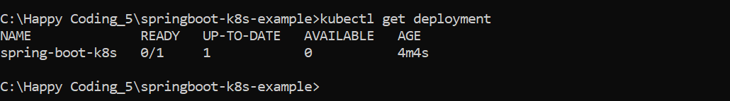

**C:\Happy Coding_5\springboot-k8s-example>kubectl describe deployment spring-boot-k8s**

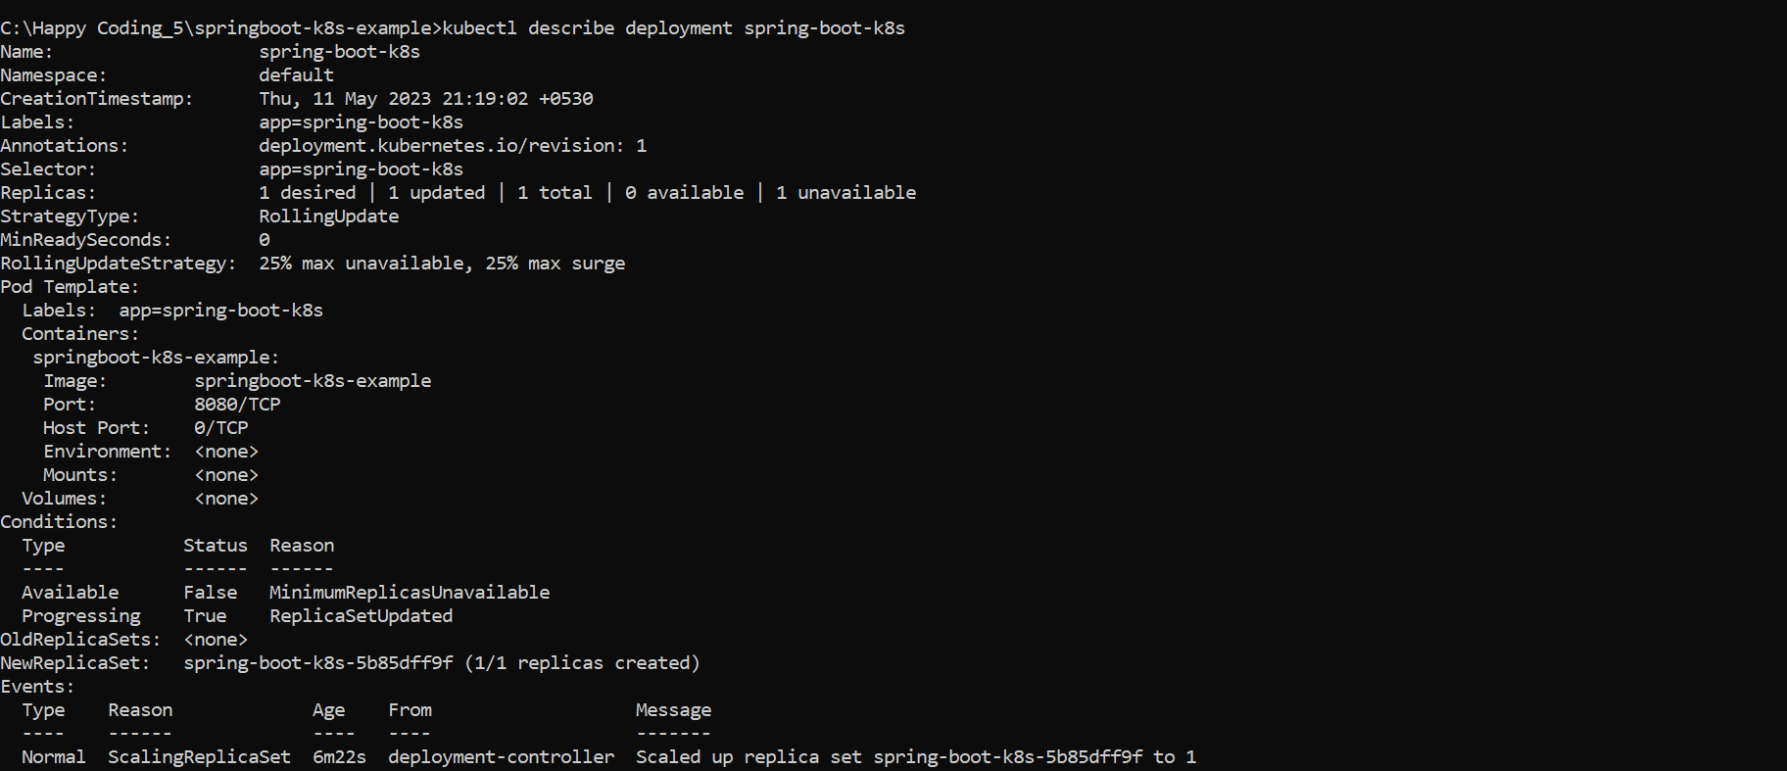

Now let me zoom this. Let's verify the deployments. Okay, so you can type kubectl get deployment. You can observe here, this is the name of the deployment and the status you can see it's in ready state. Okay, one by one, and up to date one available one, this is what the age fine. Now you can describe your deployments, you can see all the replicas and everything all the description about your deployment. So, you can just type kubectl get deployment description or kubectl describe deployment and give the name of your deployment, which is spring boot k8s. So, you can see, this is what the description of your deployment. You can see here right, new replica set one by one replica set was created because you didn't specify the replicas. And then this is what the deployment controller scaled of replica sets spring boot. This is what the pod you can say, okay, I'll show you the pod as well. Now to ensure that Kubernetes successfully pull my Docker image and run it inside a pods, we can execute a below command, kubectl get pods, you can check the status of your pods, just enter it.

**C:\Happy Coding_5\springboot-k8s-example>kubectl get pods**



**C:\Happy Coding_5\springboot-k8s-example>kubectl get deployment**

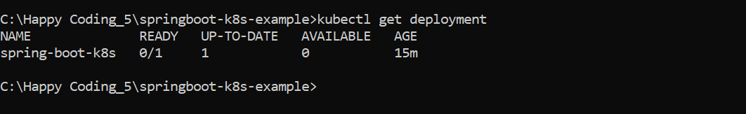

**C:\Happy Coding_5\springboot-k8s-example>kubectl expose deployment spring-boot-k8s --type=NodePort**

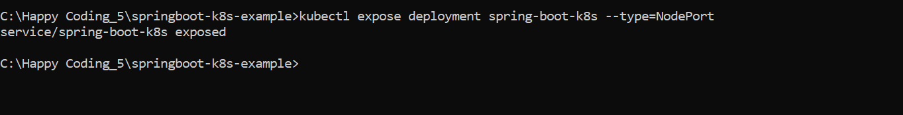

**C:\Happy Coding_5\springboot-k8s-example>kubectl get service**

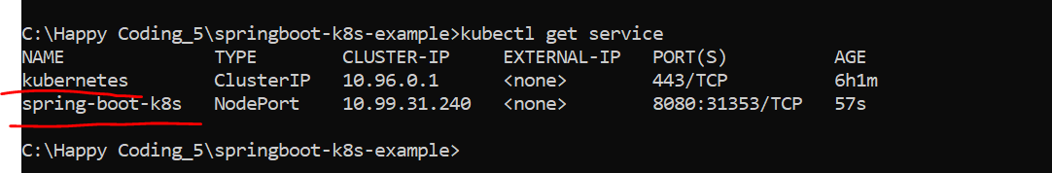

**C:\Happy Coding_5\springboot-k8s-example>minikube service spring-boot-k8s –url**

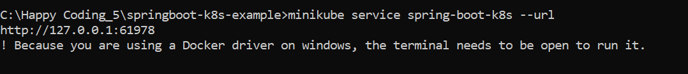

[**http://127.0.0.1:61978/message/**](http://127.0.0.1:61978/message/)

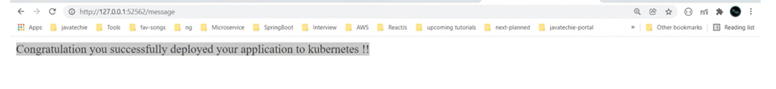

**C:\Happy Coding_5\springboot-k8s-example>minikube dashboard**

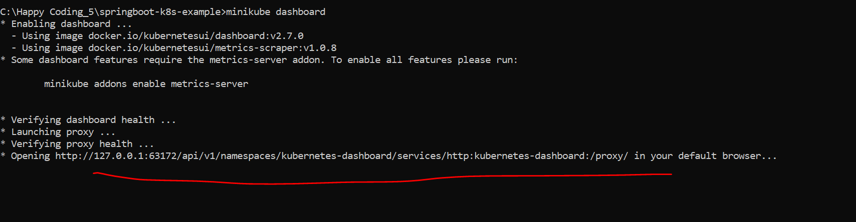

[Kubernetes Dashboard](http://127.0.0.1:63172/api/v1/namespaces/kubernetes-dashboard/services/http:kubernetes-dashboard:/proxy/#/workloads?namespace=default)

<http://127.0.0.1:63172/api/v1/namespaces/kubernetes-dashboard/services/http:kubernetes-dashboard:/proxy/>

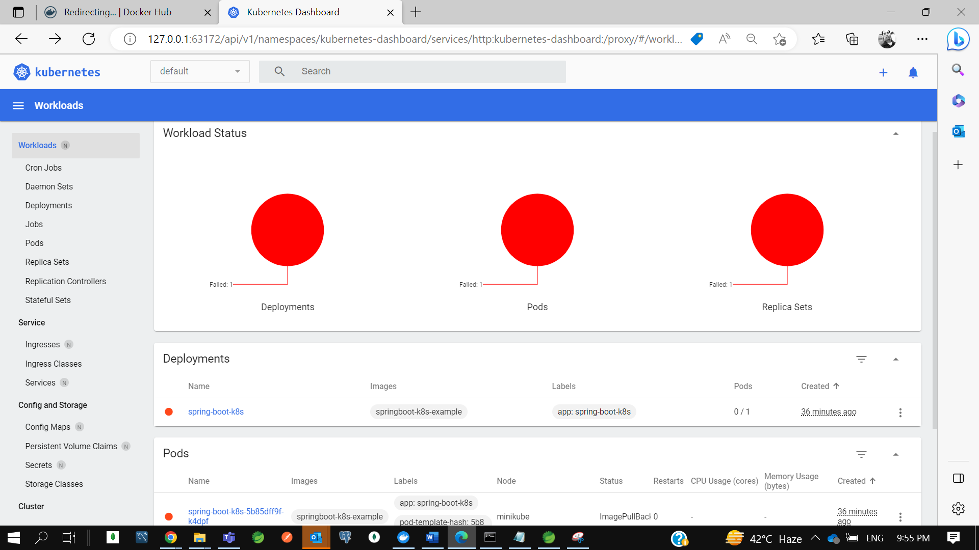

C:\Happy Coding_5\springboot-k8s-example>kubectl delete service spring-boot-k8s

service "spring-boot-k8s" deleted

C:\Happy Coding_5\springboot-k8s-example>kubectl delete deployment spring-boot-k8s

deployment.apps "spring-boot-k8s" deleted

C:\Happy Coding_5\springboot-k8s-example>kubectl get pods

No resources found in default namespace.

C:\Happy Coding_5\springboot-k8s-example>kubectl get service

NAME TYPE CLUSTER-IP EXTERNAL-IP PORT(S) AGE

kubernetes ClusterIP 10.96.0.1 <none> 443/TCP 6h24m

C:\Happy Coding_5\springboot-k8s-example>kubectl get deployment

No resources found in default namespace.

C:\Happy Coding_5\springboot-k8s-example>minicube stop

'minicube' is not recognized as an internal or external command,

operable program or batch file.

C:\Happy Coding_5\springboot-k8s-example>minikube stop

* Stopping node "minikube" ...

* Powering off "minikube" via SSH ...

* 1 node stopped.

C:\Happy Coding_5\springboot-k8s-example>minikube delete

* Deleting "minikube" in docker ...

* Deleting container "minikube" ...

* Removing C:\Users\kaukumar3\.minikube\machines\minikube ...

* Removed all traces of the "minikube" cluster.

C:\Happy Coding_5\springboot-k8s-example>